  9 | 
COUNCIL ASSESSMENT REPORT
SOUTHERN REGIONAL PLANNING PANEL

PANEL REFERENCE & DA NUMBER | PPSSTH-116 – DA.2021.1549
PROPOSAL | Subdivision of land (Googong Neighbourhoods 3, 4 & 5) into 1398 Torrens title residential lots, 14 super lots for future residential development, 5 Neighbourhood Centre lots, boundary adjustment, all associated subdivision construction works, roads, tree removal, signage and landscaping and relocation of Shearing Shed.
ADDRESS | Part of: Lot 42 DP 754881, Lot 776 DP 1230282, Lot 2 DP 1231713, Lot 3 DP 1149329, Lot 10 DP 754881, Lot 1263 of DP 1283369, Lot 7 DP 1246784, Lot 996 of DP1276892, Lot 1605 DP 1266000, Lot 12 DP 1266001, Lot 13 DP 1266001 and is commonly known as 36 Googong Road, Googong, NSW.
APPLICANT | Googong Township Pty Ltd
OWNER | Googong Township Pty Ltd (including Lot 42 DP754881 under purchase agreement from Hamson)
DA LODGEMENT DATE | 24/09/2021
APPLICATION TYPE | Development Application – Integrated Clause 4.47  (National Parks & Wildlife Act 1974, Roads Act 1993, Rural Fires Act 1997 & Water Management Act 2000)
REGIONALLY SIGNIFICANT CRITERIA | State Environmental Planning Policy (Planning Systems) 2021- Part 2.4, Schedule 6(2) of the SEPP - General Development over $30 million
CIV | $181,000,000 (excluding GST)
CLAUSE 4.6 REQUESTS | Clause 4.1 – Minimum Subdivision Lot Size – QLEP 2012
KEY SEPP/LEP | State Environmental Planning Policy  Queanbeyan Local Environmental Plan 2012  Draft Comprehensive Queanbeyan-Palerang Local Environmental Plan

TOTAL & UNIQUE SUBMISSIONS  KEY ISSUES IN SUBMISSIONS | Four (including petition with 60 signatures)  The key issues raised in the submissions related to a dilution of the master plan, traffic impacts and parking, views to and from the Montgomery Rise area of Neighbourhood 1B, and the location and noise impacts of a future proposed day care centre.
DOCUMENTS SUBMITTED FOR CONSIDERATION | Subdivision Plans, Landscape Plans, Civil Plans, Statement of Environmental Effects (SEE), Acoustic Assessment, Traffic Impact Assessment, Googong VPA BCAR.
SPECIAL INFRASTRUCTURE CONTRIBUTIONS (S7.24) | N/A
RECOMMENDATION | Approval
DRAFT CONDITIONS TO APPLICANT | Yes, draft set attached acceptable to Applicant
SCHEDULED MEETING DATE | Select Date TBA
PLAN VERSION | Refer attached plan list in draft consent document
PREPARED BY | Luceille Yeomans, Queanbeyan-Palerang Regional Council
DATE OF REPORT | 25 August 2022

Summary of s4.15 matters  Have all recommendations in relation to relevant s4.15 matters been summarised in the Executive Summary of the assessment report? | Yes
Legislative clauses requiring consent authority satisfaction  Have relevant clauses in all applicable environmental planning instruments where the consent authority must be satisfied about a particular matter been listed, and relevant recommendations summarized, in the Executive Summary of the assessment report?  e.g. Clause 7 of SEPP 55 - Remediation of Land, Clause 4.6(4) of the relevant LEP | Yes
Clause 4.6 Exceptions to development standards  If a written request for a contravention to a development standard (clause 4.6 of the LEP) has been received, has it been attached to the assessment report? | Yes
Special Infrastructure Contributions  Does the DA require Special Infrastructure Contributions conditions (S94EF)? | Not applicable
Conditions  Draft conditions to Applicant for comment? | Yes

EXECUTIVE SUMMARY
Development consent is sought for the subdivision of land at 36 Googong Road, Googong (‘the site’). The site comprises 11 lots over approximately 235 hectares and will provide for Neighbourhoods 3, 4 and 5 of the Googong Township development.
Specifically, the application seeks consent to create 1398 residential lots, 14 superlots for future residential development, 5 Neighbourhood Centre superlots and all associated subdivision works, landscaping and relocation of an existing Shearing Shed.
The subject site has an irregular shaped landform, consistent with grazing. The site contains several farm dams and paddocks and is currently grazed by livestock including sheep, goats, horses and other livestock. The land contains a series of ridges and gullies, a scattering of mature trees and a few rural structures including a shearing shed.
The land is zoned R1 General Residential, RE1 Public Recreation, R5 Large Lot Residential and C2 Conservation zone under the Queanbeyan Local Environmental Plan 2012.
Subdivision is a permissible use under Clause 2.6 of the Queanbeyan Local Environmental Plan 2012.
The site is bound by Neighbourhood 1 and 2 of Googong to the north of the site, by rural land to the south and conservation and R5 zoned land and Googong Dam Foreshore to the east and southeast. The development site is bound by Old Cooma Road along its entire western portion.
Googong Neighbourhoods 3, 4 and 5 are the final three stages of the Googong Township Development. The design includes a neighbourhood centre in each neighbourhood for future retail and commercial uses, an interface with Googong Common designated for conservation, open space and recreational activities, Pink- tailed Worm Lizard (PTWL) Conservation Areas and Googong Foreshore Interface to the east and southeast of neighbourhoods 4 & 5.
The local area has the potential to accommodate (2) Environment Protection and Biodiversity Conservation Act (Commonwealth) listed threatened ecological communities being Natural Temperate Grasslands of the South Eastern Highlands and White Box – Yellow Box – Blakely’s Red Gum Grassy Woodland and Derived Native Grassland. A previous assessment of the subject land determined that they were not present on the land owned by GTPL however had not covered land owned by Hamson which is now included in the land subject to this application. Capital Ecology found that none of the vegetation on the Hamson property meets the listing criteria for the EPBC Act listed threatened ecological communities.
The site is subject to a Biodiversity Certification Agreement under the Biodiversity Conservation Act. This is only the second of its kind currently operating in NSW. An Order was gazetted on 15 July 2022 by the Minister for Environment and Heritage which outlines biodiversity conservation measures agreed between the parties. Compliance with the Order and associated Agreement are sought through a condition of consent.
The Biodiversity Certification Agreement relies on a Biodiversity Certification Assessment Report (BCAR) by Capital Ecology. The BCAR proposes the following measures to be the Approved Conservation Measures:
- The retirement of 136 PCT 999 (Norton's Box - Broad-leaved Peppermint open forest on foot slopes, central and southern South Eastern Highlands Bioregion) Biodiversity Credits and 900 PCT 1334 (Yellow Box grassy woodland of the northern Monaro and Upper Shoalhaven area, South Eastern Highlands Bioregion) Biodiversity Credits (total 1036 credits) (or any equivalent PCT classification it may be known by in the future); and
- The retirement of 48 Pink-Tailed Legless Lizard Species Credits.

In addition to the Approved Conservation Measures, the BCAR recommends entering into a Biodiversity Certification Agreement to, among other things, ensure the Avoided Land is conserved and enhanced in perpetuity as a measure to reduce impacts on Biodiversity values.
Within the area to be developed the Applicant has identified 5 trees classified as having ‘exceptional quality’. The design ensures they are retained. Also, there are 19 ‘high quality’ trees identified with seven (7) proposed to be removed in order to deliver the estate.
The Googong Local Planning Agreement (LPA) applies to the subject development. Facilities required to be delivered under the LPA are required to be provided in accordance with timing provisions under the LPA.
Standard lots are proposed to have an area of 337m² – 1093m². The application seeks a variation under Clause 4.6 - Exception to Development Standards - to the minimum lot size Clause 4.1 of the Queanbeyan Local Environmental Plan 2012 for 81 lots. The subject lots are located on the southern boundary of Neighbourhood 3. The variation seeks to reduce lot sizes from a minimum of 600m² to 330m². The variation is supported by Council officers.
The application is to be determined by the Joint Regional Planning Panel – Southern Region (SRPP) as the Capital Investment Value of the proposed development exceeds $30 million.
The application was nominated as an Integrated Development requiring approvals under National Parks and Wildlife Act 1974, Rural Fires Act 1997, and Water Management Act 2000. All the required General Terms of Approval have been issued. Department of Primary Industries (Fisheries) confirmed the proposal does not trigger the Act so no GTA’s were provided.
The submissions from government agencies have been considered and conditions recommended where appropriate. All agencies have provided their support for the proposed development.
Key issues raised during the assessment relate to:
- Suitable road widths and type including the use of laneways,
- Biodiversity impacts including tree removal and tree retention,
- Proposed residential allotments within C2 – Environmental Conservation Zone,
- Contamination issues
- Potential noise impacts
- Impact on a heritage item
- Location of the proposed Shearing Shed to avoid area of high biodiversity value
In terms of the heritage item, Council has recently agreed to de-list the structures which are currently identified in the Queanbeyan Local Environmental Plan as having heritage significance. Further, to support the relocation of the Shearing Shed into public reserve for its reuse as a feature of that park.
The application was notified to adjoining neighbours and advertised in the newspaper. Four (4) public submissions were received including a petition with 60 signatures. Key issues raised include;
- Dilution of the vision for Googong,
- Views from Montgomery Rise area,
- Traffic impacts and traffic volumes,
- Parking,
- Location of a future childcare centre, and
- Plan inconsistencies.
The applicant advises that they worked with submitters through their plan amendment process. Further, that they understand the issues to be resolved to their satisfaction. Specifically changing the location of the future proposed childcare centre, increasing lot sizes south of Montgomery Rise and addressing issues raised regarding road traffic noise and traffic impacts.
An assessment under Section 4.15 of the Environmental Planning and Assessment Act 1979 has been undertaken. The proposed subdivision of Neighbourhoods 3, 4 & 5 with ancillary development as sought in this application is recommended for approval subject to the imposition of conditions.
- THE SITE AND LOCALITY
  - The Site
Googong Township is a 25 year major urban release area being developed in partnership by Peet and Mirvac, operating as Googong Township Pty Ltd (GTPL). The emerging township is located in Southern NSW, 8km from Queanbeyan and 15km from Canberra. The Googong master plan is embedded in Queanbeyan-Palerang Regional Council’s (QPRC) Googong Development Control Plan and provides the overarching structure for the township. It has been planned and is being developed as a freestanding township with five neighbourhoods, around 6,600 dwellings and a population of over 18,000 people.
The NH3-5 site has an irregular shaped landform, consistent with grazing. The site contains several farm dams and paddocks, currently grazed by livestock including sheep, goats, cattle, horses and other livestock.
There is a cluster of buildings on site including a shearing shed and associated rural outbuildings. The site is primarily cleared with scattered mature trees and some areas retain a high cover and diversity of native groundcover species and lower cover of exotic weeds.
Continuous grazing has removed the midstrata and entirely prevented regeneration of the canopy species. The site is traversed by unsealed vehicle tracks and 11kV and 132kV powerlines.
The existing slope of the land varies with slopes of between 0% and 15%. The proposal involves site preparation with the lots able to be less than the maximum slope of 20% included in the Googong DCP. Site works will be assessed further as part of the detailed design process.
Various views of the site are shown in Figures 1 to 10 below.

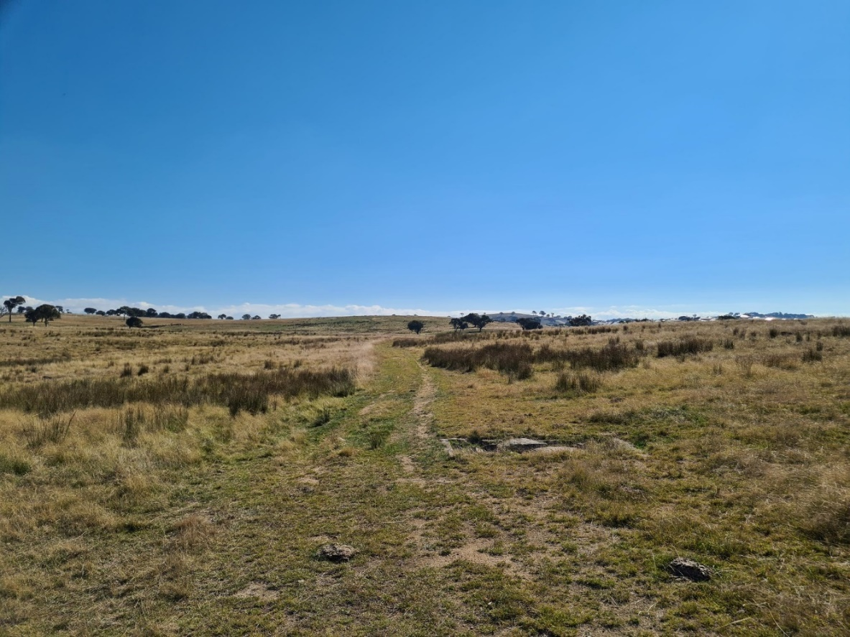
Figure 1
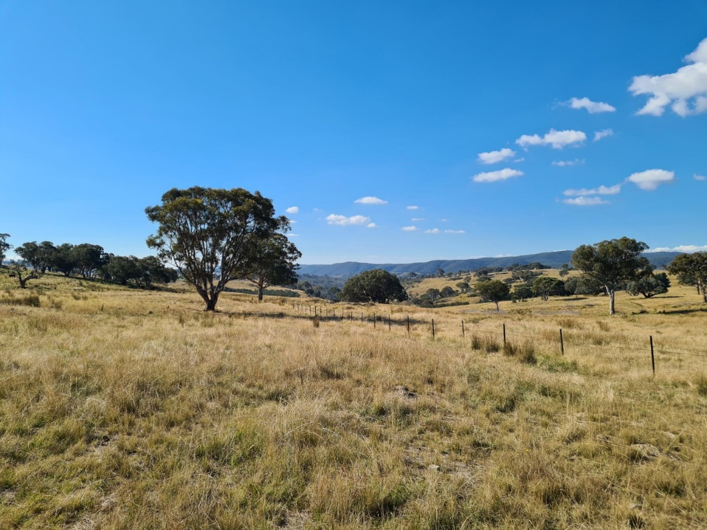
Figure 2

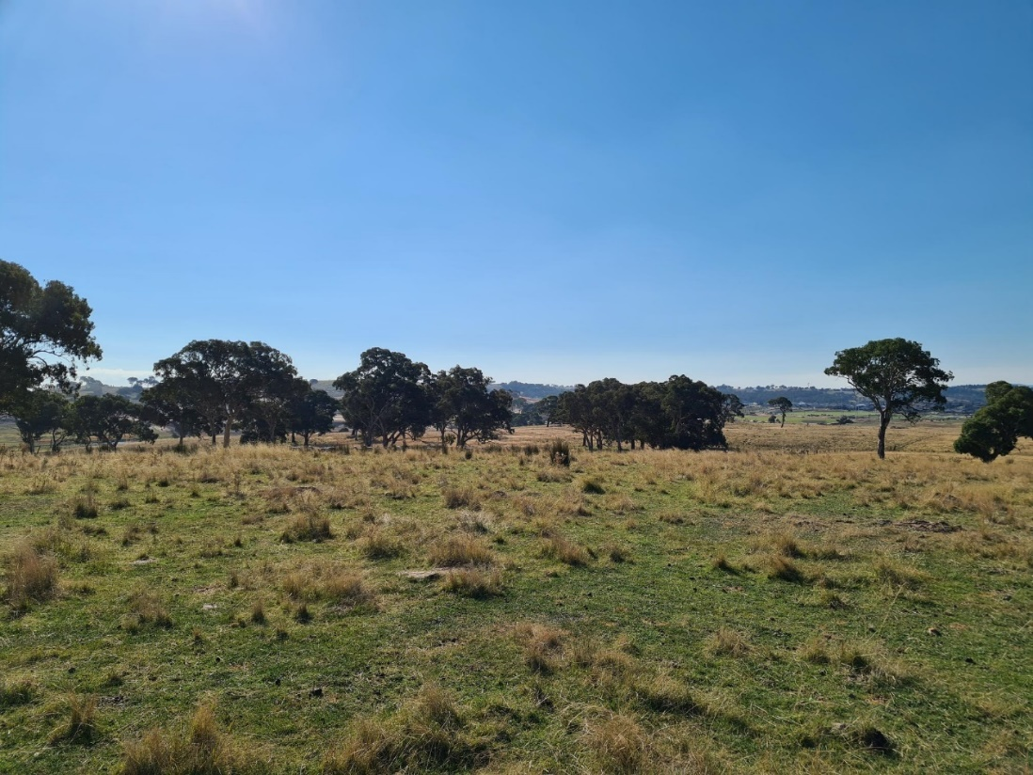
Figure 3
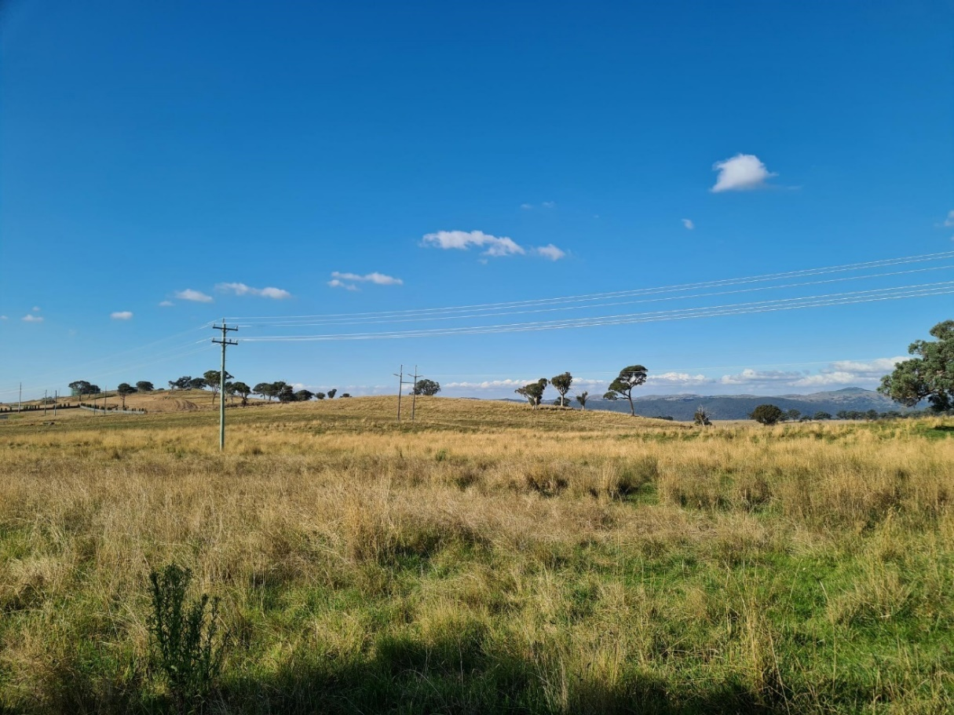
Figure 4

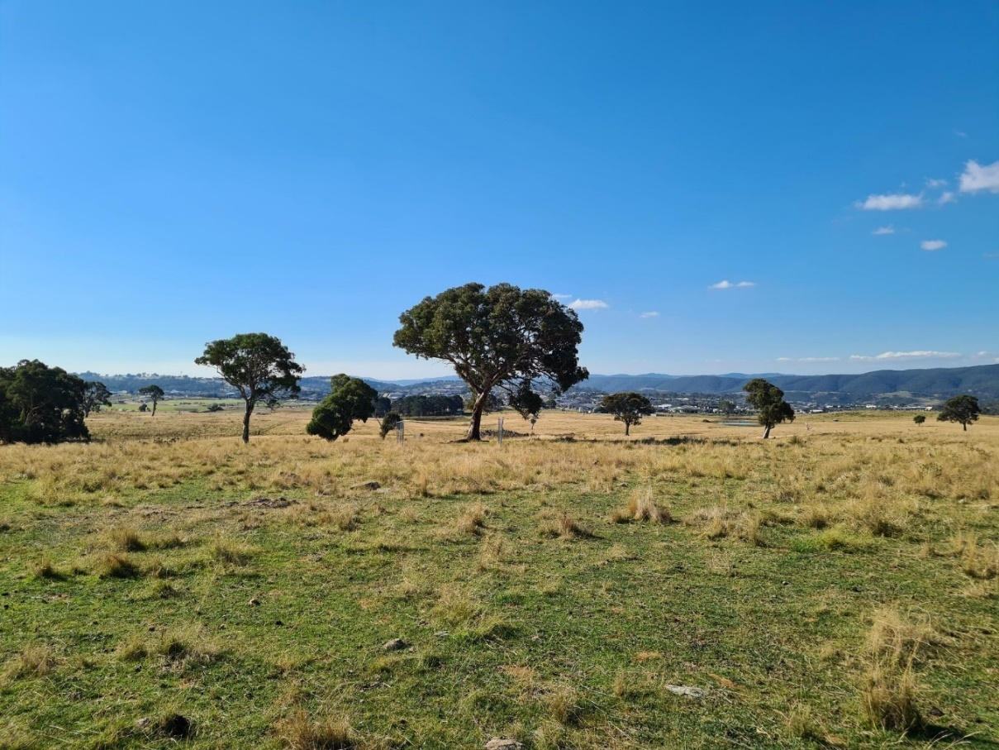
Figure 5
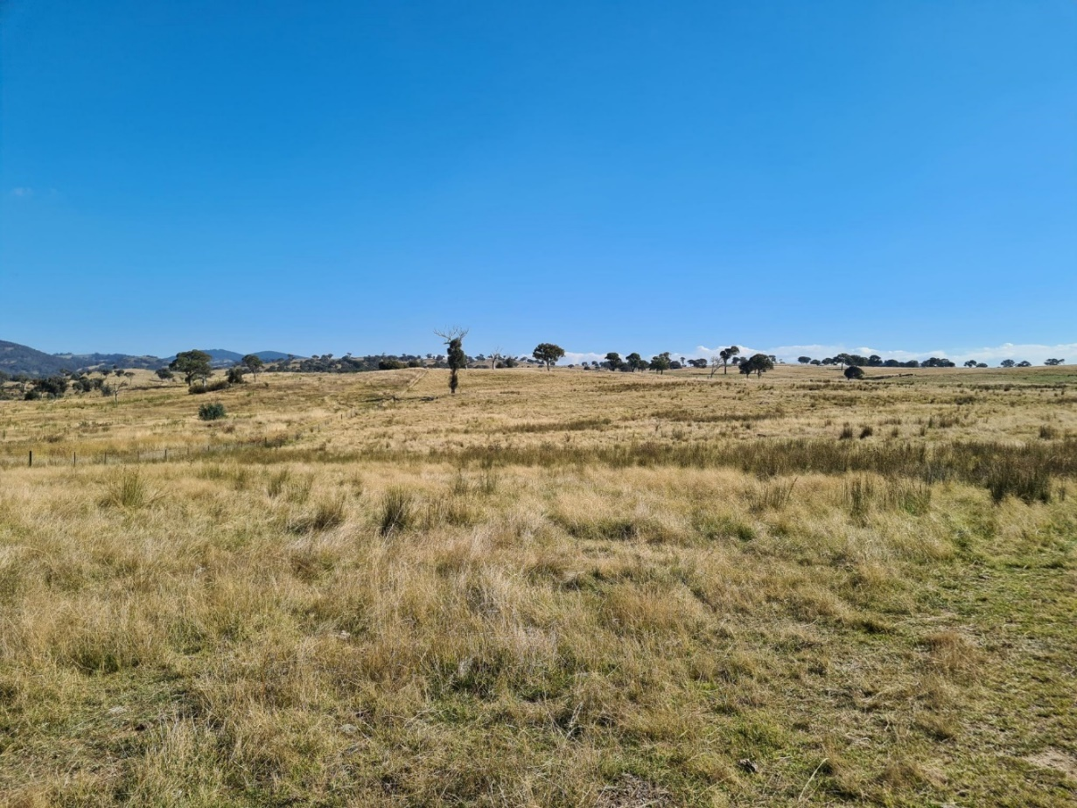
Figure 6

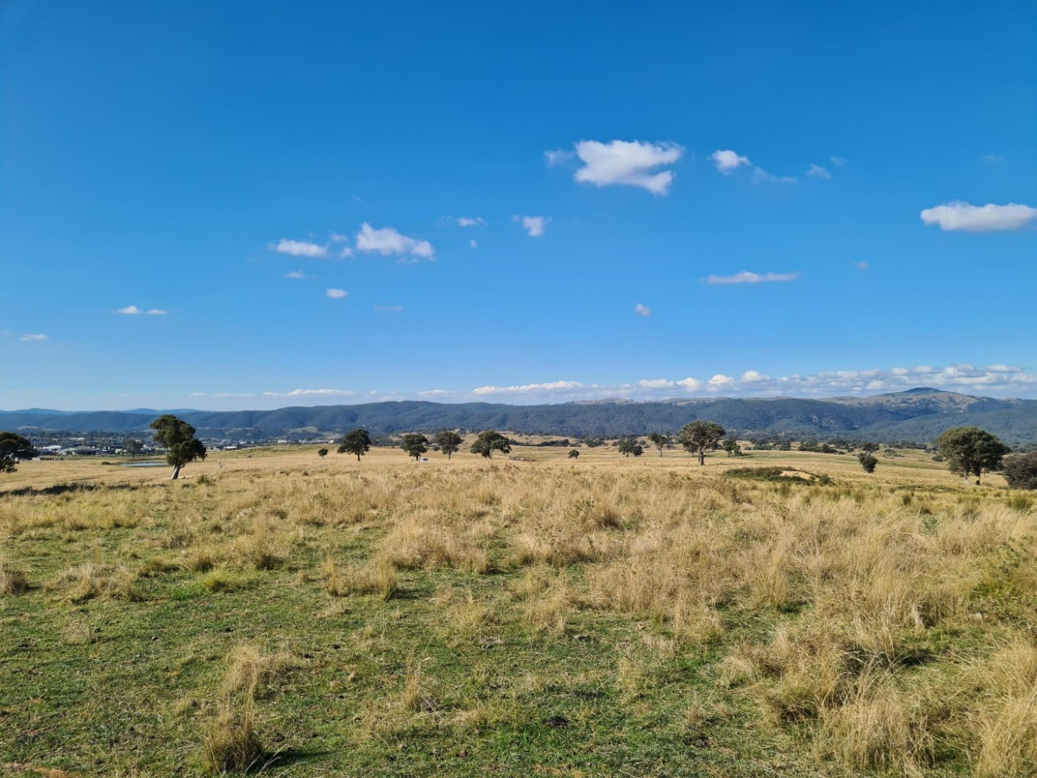
Figure 7
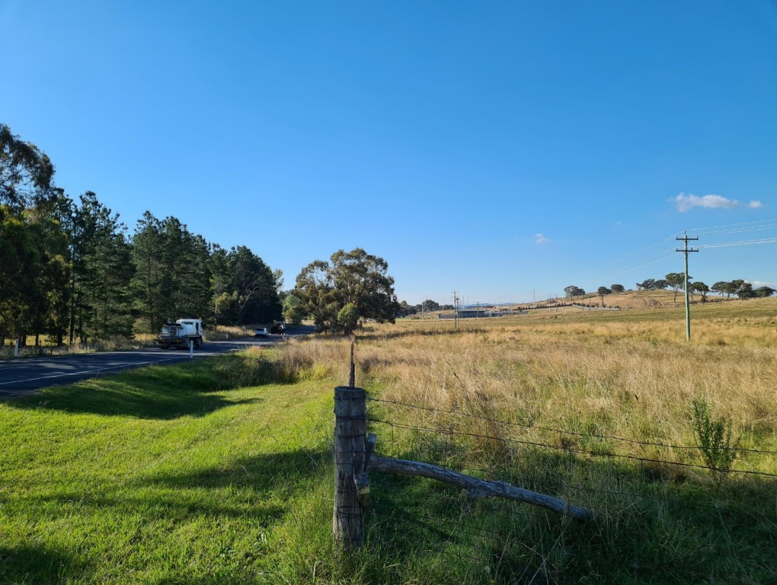
Figure 8

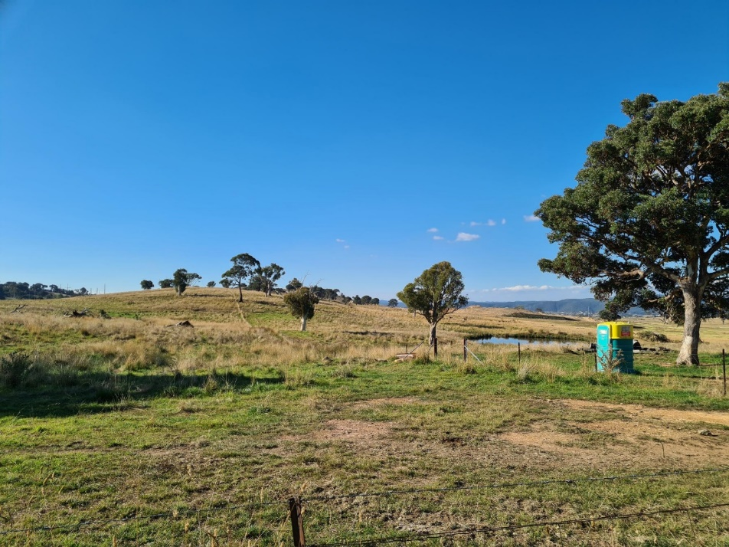
Figure 9
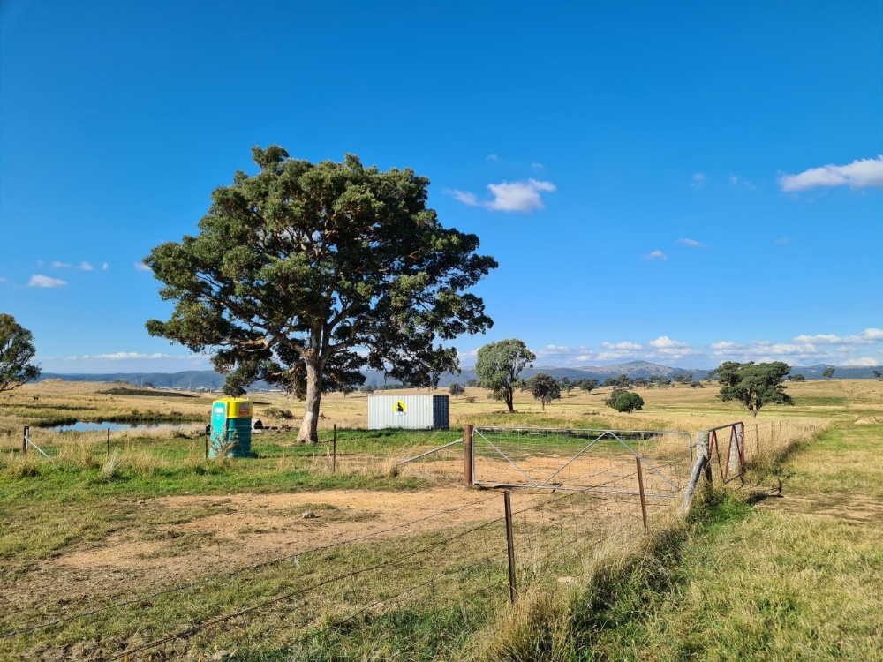
Figure 10

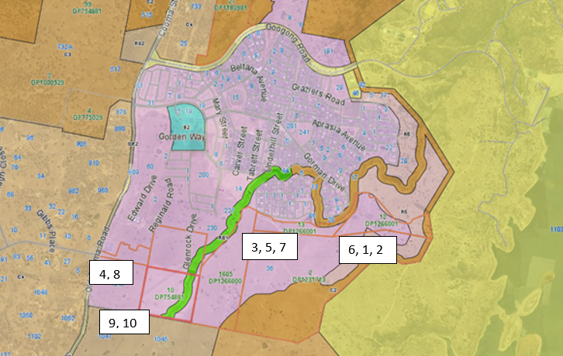
Figure 11 – Approximate Location of Each Site Photo
1.2 The Locality
Googong site in the context of the Canberra Region. The site of the Googong Township is 8km south of the Queanbeyan CBD. The surrounding area is characterised by a variety of land uses including, nature reserves, low intensity forestry, rural residential development, cattle and sheep grazing and recreation. Googong Dam and the Googong Foreshores (owned by the Commonwealth Government and leased to the Australian Capital Territory Government) is immediately east of the site and an operating quarry is located northwest of the site on the western side of Old Cooma Road.
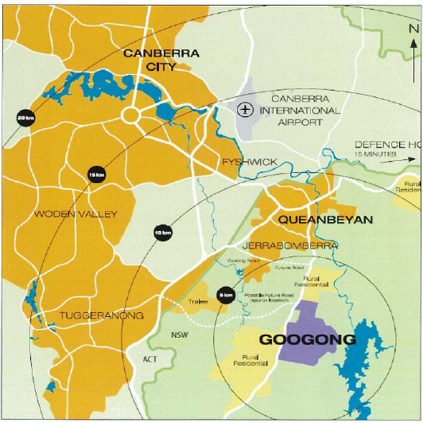
Figure 12– Locality Plan

Neighbourhood 3,4 & 5 is the southern part of Googong and is bounded by:
- Neighbourhoods 1 and 2 of Googong Township to the north;
- Googong Foreshores to the east;
- Land zoned for environmental management to the south-east;
- Agricultural land to the south-west; and
- Old Cooma Road to the west, beyond which lies land zoned for environmental living.
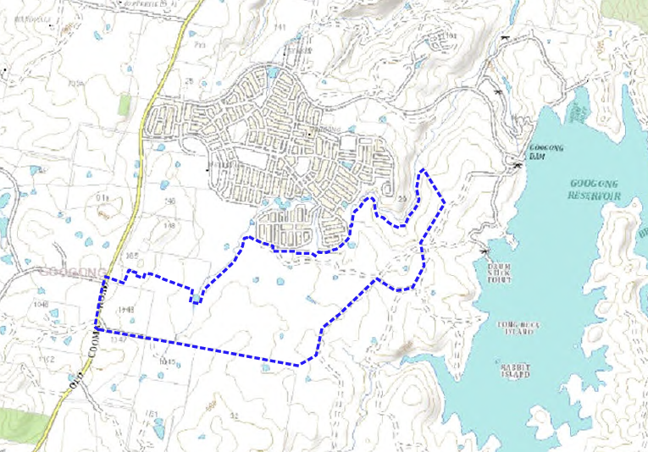
Figure 13 – Location of Neighbourhood 3, 4 & 5 Within the Vicinity of Existing Development
The development of the site at Googong is driven by future demand for housing in Queanbeyan. The Googong Master Plan (Refer to Figure 3 below) broadly sets out the ultimate development outcomes for Googong which envisages some 6,600 homes, accommodating a population of approximately 18,000 people. Business opportunities, recreation, significant open space, schools and community facilities are also provided for over the next 25 years.
An area of 166ha representing 21% of the total area is to be set aside for open space not only delivering lifestyle amenity for residents but also protecting important habitats. All development seeks to protect landscape features, threatened species’ habitats and the catchment of the adjacent Googong Dam.

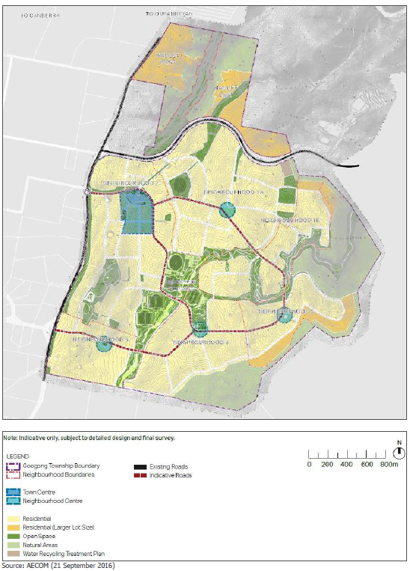
Figure 14 – Googong Master Plan
Googong Township is being developed as a series of neighbourhoods, five in total, broken down into smaller development stages. Figure 4 below shows the overall Googong Neighbourhood Plan. Each is governed by a broader Neighbourhood Structure Plan embedded in the DCP that translated the Master Plan to a level of detail that shows the general location of developable areas, areas of open space and road layouts for each neighbourhood.

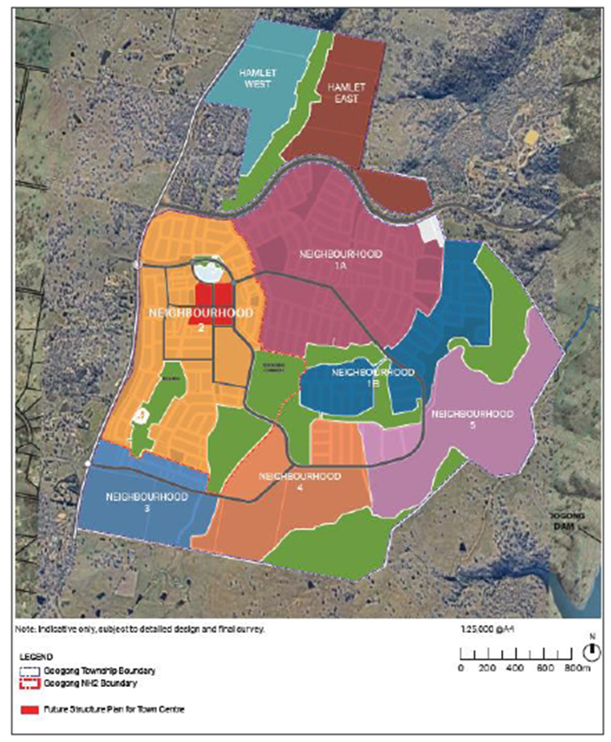
Figure 15 – Googong Neighbourhood Plan 3, 4 & 5
The Googong DCP requires that a ‘Neighbourhood Structure Plan’ be prepared and approved prior to the subdivision and development of the land. A Structure Plan for Neighbourhoods 3, 4 & 5 was prepared and submitted to Council in May 2016 and was adopted on 14 December 2016 as part of the amendment to Googong DCP. Refer to Figure 5 - Neighbourhood 3, 4 & 5 Structure Plan below.
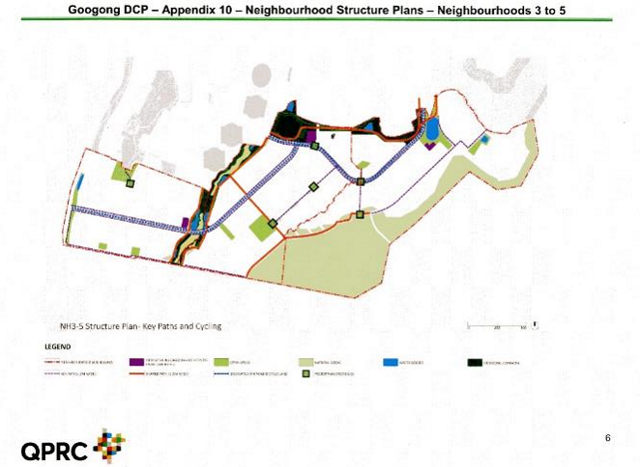
Figure 16 – Neighbourhoods 3 -5 as Proposed Generally Consistent with Neighbourhood Structure Plan

- THE PROPOSAL AND BACKGROUND
  - The Proposal
Subdivision of Land
The proposed subdivision of land incorporates
- 1398 residential
- 14 superlots for future higher density residential development
- 5 Neighbourhood Centre lots for future commercial and / or community facilities
- Public reserves including, local parks, recreation area within Googong Common including sports field and carparking (proposed Community Facility will be subject to a future DA),
- Relocation of an existing Shearing Shed for reuse
- Public roads and drainage reserves
- Boundary adjustment
- All subdivision works to prepare the land for the future development comprising site preparation and grading, stormwater and drainage works, road construction, tree removal, and utilities provision
- All landscaping works and associated works to create and embellish all open space and the public domain. This includes the erection of entry sign, park structures including outdoor table tennis and chess, playground equipment, bench seat, decks, shelter with seat, barbeque shelters, dog park equipment, terrace walls, feature walls, weir walls, gabion walls, timber jetty and pedestrian bridge.
- The works will also include the construction of three (3) new intersections with external roads
The proposed subdivision is not a 'staged development application' for the purposes of the Environmental Planning and Assessment Act 1979. One consent will be issued for the entire subdivision, which will be developed over time.
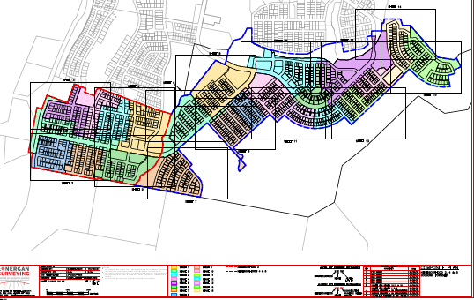Figure 17 – Developer Staging Plan
The estate is proposed to be developed over 23 stages across the 3 Neighbourhoods. The table below outlines the standard residential lots, medium density lots and neighbourhood centre lots subject to this application.
Neighbourhood | Stage | Standard  Residential Lots | Medium Density Lots | Neighbourhood Centre Lots
3 | 1 | 60 | 2 | 2
 | 2 | 53 | 1
 | 3 | 92
 | 4 | 45
 | 5 | 69
 | 6 | 52 | 2
 | 7 | 67
 | 8 | 70
NH3 Total |  | 508 | 5 | 2
4 | 1 | 68 | 1
 | 2 | 61 | 1
 | 3 | 59 | 3 | 2
 | 4 | 68 | 3
 | 7 | 85 | 1
 | 8 | 61
 | 9 | 75
NH4 Total |  | 477 | 8 | 2
5 | 5 | 48
 | 6 | 37
 | 10 | 49
 | 11 | 58
 | 12 | 49
 | 13 | 51
 | 14 | 61
 | 15 | 60
NH5 Total |  | 413 | 1 | 1
NH3, 4 & 5 Total |  | 1398 | 14 | 5
Table 1 - Lot Number and Type by Stage.

The majority of the estate will be developed for standard residential development. The proposed residential lots have been designed to respond to the topography, view opportunities, solar access and open space connections.
There are 10 open space areas provided within the NH3-5 development area. These include an extension to Googong Common, extension to Nangi Pimble open space, sportsfields, neighbourhood parks, local parks and Googong Dam Catchment Protection Reserve. The Applicant has entered into a Local Planning Agreement which specifically includes commitments for the delivery of open space within the estate. They have been progressively provided over the delivery of the estate. The proposed open commitments are generally in accordance with the strategic vision for open space outlined in the Open Space Structure Plan within the LPA.
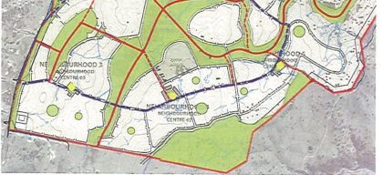
Figure 18 – Googong Open Space Structure Plan
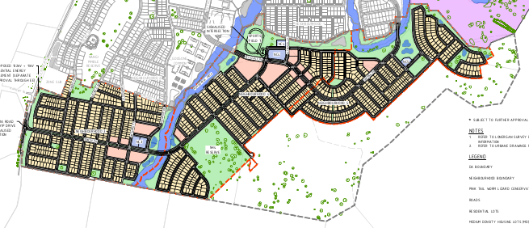
Figure 19 – Proposed open space delivery

Landscape embellishments to Old Cooma Rd will create a sense of arrival to the new township. In addition to feature planting, public art and signage will also be established consistent with the existing estate.
The proposal will extend the Googong Common which will provide an extensive open space resource within the estate. The majority of the Googong Common is within NH2 and contains sporting and recreational facilities for the entire estate.
The Yellow Box Reserve will be provided to preserve and enhance an area of Yellow Box Grassy woodland. A neighbourhood park with playground is proposed to be integrated with Nangi Pimble (south), a high point within the estate.
Boundary Adjustment
The application includes a boundary adjustment to ensure lots are wholly within GTPL or Hamson’s land.
Lot 42 on DP 754881 is owned by the Hamson’s and is 22.22ha with the remaining lots subject to this application owned by Googong Township Pty Ltd. The boundary of Lot 42 does not currently align with the proposed new lot boundaries. A boundary adjustment is included in this application to ensure the new lots correspond precisely with the existing lot boundaries and the land held by each owner. The proposed new lots will then be wholly owned by either GTPL or the Hamsons assisting with contractual arrangements between the owners.
The Land Swap Plan below provides the background to the proposed boundaries in the Boundary Adjustment Plan. The individual parcels shown on the plan to be “swapped” would never actually be created and swapped but rather both parties will consent to the subdivision that creates Superlots 1 and 2. The Land Swap Plan images are provided for information only and does not form part of the consent. The Boundary Adjustment Plan is listed as a plan to be an approved plan in the consent.
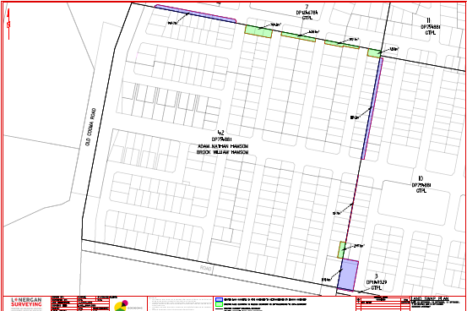
Figure 20 – Land Swap Plan for Information Purposes

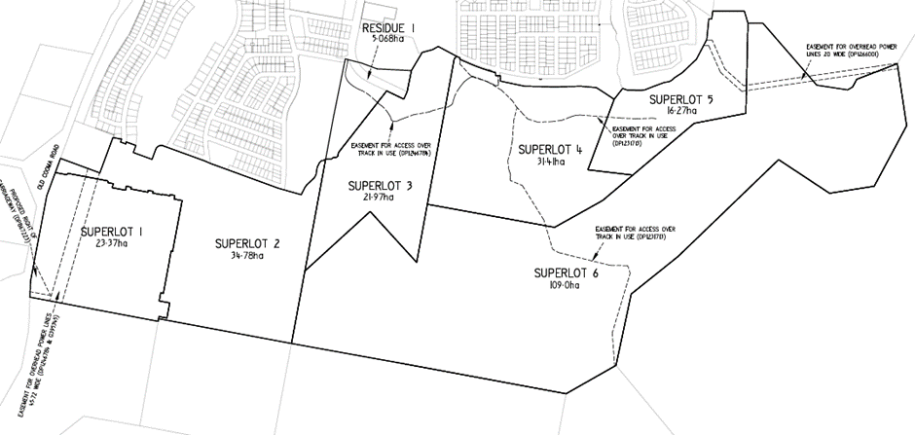Figure 21 – Boundary Adjustment Plan
Shearing Shed
The site contains a Shearing Shed Complex which is included in the QLEP 2012 heritage schedule following a 2003 study by Navin Officer Heritage Consultants. At that time the complex comprised, the shearing shed that is still standing, sheep yards (still standing), a large sheep shelter, old rural farm items (some still surviving), a small, corrugated iron shed (still standing) and 200m from the shearing shed, a shearer’s quarters, kitchen cottage and a meat house (only the meat house survives).
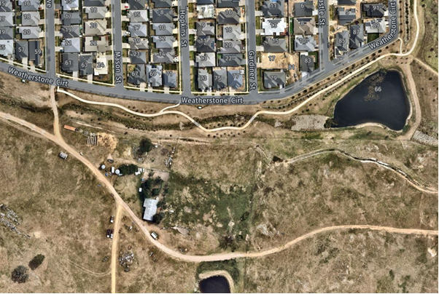
Figure 22 – Location of Shearing Shed Complex

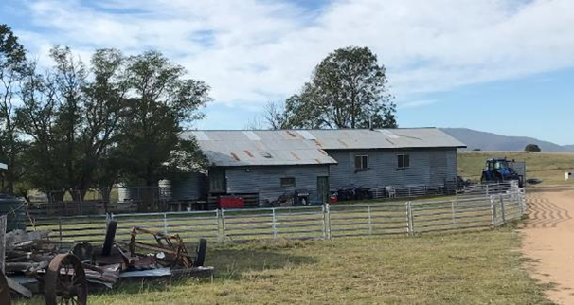
Figure 23 – Existing Shearing Shed
With the loss of cottage and quarters, and conversion of most of the open grassland to residential streets, the context of the initially listed area has changed. In regard to the shearing shed, the southern end has been altered, with the interior partitioned and clad with plasterboard sheeting, and modern aluminium windows added to the exterior. The meat house is in relatively good condition but is not rare and now is isolated from the shed. The small, corrugated iron building is not individually significant and some distance from the shed. Some of the old farming implements are still on the ground in the area.
While the overall shearing complex has lost its integrity, the shearing shed itself has some heritage value. Its materials of corrugated galvanised iron and rough sawn Australian hardwood provide a tangible link to the past. Due to its fabric and form, the shearing shed has the potential to provide a historic and aesthetic ‘sense of place’ for new and future residents in Googong.
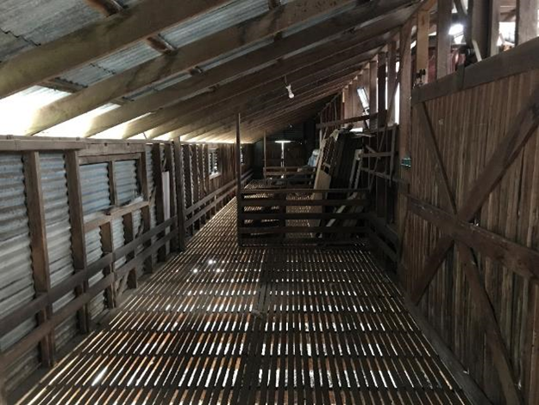
Figure 24 – Interior of Northern End of Shearing Shed

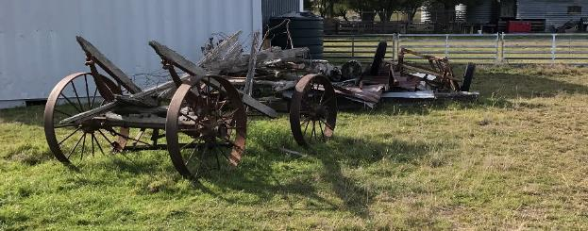
Figure 25 – Farm Machinery
Council’s Heritage advisor confirms that the item has lost most of its significant attributes and context. Accordingly, on 13 July 2022 Council resolved to support the dismantling, relocation and redevelopment of the Googong Shearing Shed and delisting it as a local heritage item.
Given the shed is in good condition, Council and the applicant agree that the shearing shed should be relocated to the nearby park and adapted as a functional facility. An interpretative feature is to be located in the Common close to the current position of the shearing sheds and yards.
A revised location has been proposed which will be in a 2400m² public reserve lot immediately south of the Yellow Box Reserve as shown below.
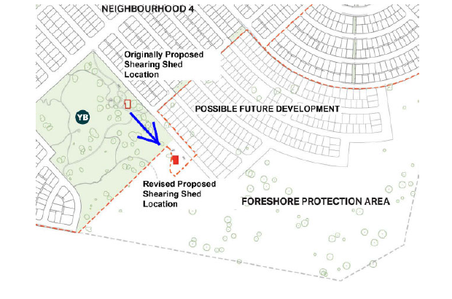
Figure 26 - Proposed Revised Location of Shearing Shed

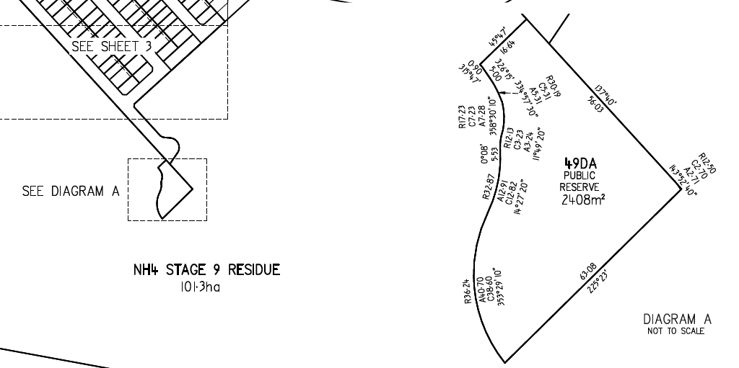Figure 27 - Proposed New Lot to Accommodate Shearing Shed
The shed will be located within the C2 zone which permits “Information and education facilities”, defined in the LEP as “a building or place used for providing information or education to visitors, and the exhibition or display of items, and includes an art gallery, museum, library, visitor information centre and the like”.
The Shearing Shed structure will be adapted to be used as an educational play element that is themed around farming, sheep shearing and showcasing the European history from the local area. The intent is to keep the overall character and materiality of the building both internally and externally, with much of the internal structure, floors and machinery retained or reused. It is proposed that the overhead gear be kept in its original state and made safe as well as showcasing the wool press in a safe way, that could be viewed for visitor information and educational purposes. It is also proposed to adapt the existing sheep chutes into slides with surrounding sculptural sheep play and fun interpretive signage relating to sheep shearing.
The revised Shearing Shed location complements the overall farming theme, given its proximity to the Yellow Box Reserve and surrounding land which mimics that of a farm like setting. It will also be within a new lot of approximately 2408m² which exceeds the minimum of 1500m².
Council’s Environmental Health Officer notes that Shearing sheds are known sources of potential contamination due to historical use of chemicals. A contamination report for the shearing shed has been submitted with the application (Peak Consulting of 19 April 2022). The report found levels of contaminants to be below the NEPM level for proposed land use of Recreational-C. However, elevated levels of lead (still below NEPM Guidelines) were discovered in the paint on one of the doors.
Given that it is undetermined which parts of the structure will be reused it is appropriate to require an additional report confirming the structure is suitable for use. This will be assessed as part of a future application for the use.
The proposed relocation and reuse of the shearing sheds is supported by Council. The amended location of the regional playground and inclusion of the relocated shearing shed will require an amendment to the voluntary planning agreement which has been sought by a condition of consent.

Aboriginal Heritage
An Aboriginal Cultural Heritage Assessment Report dated September 2021 was prepared by Navin Officers in support of the proposal. The report notes that part of the site has previously been approved in terms of Aboriginal Heritage Impacts associated with Neighbourhood 1B
– Remaining Areas (AHIP no.C0000573 and AHIP no.C0001258) and Neighbourhood 2 (AHIP no. C0003603). Figure 29 shows the area now subject to this application and excludes the area hatched.
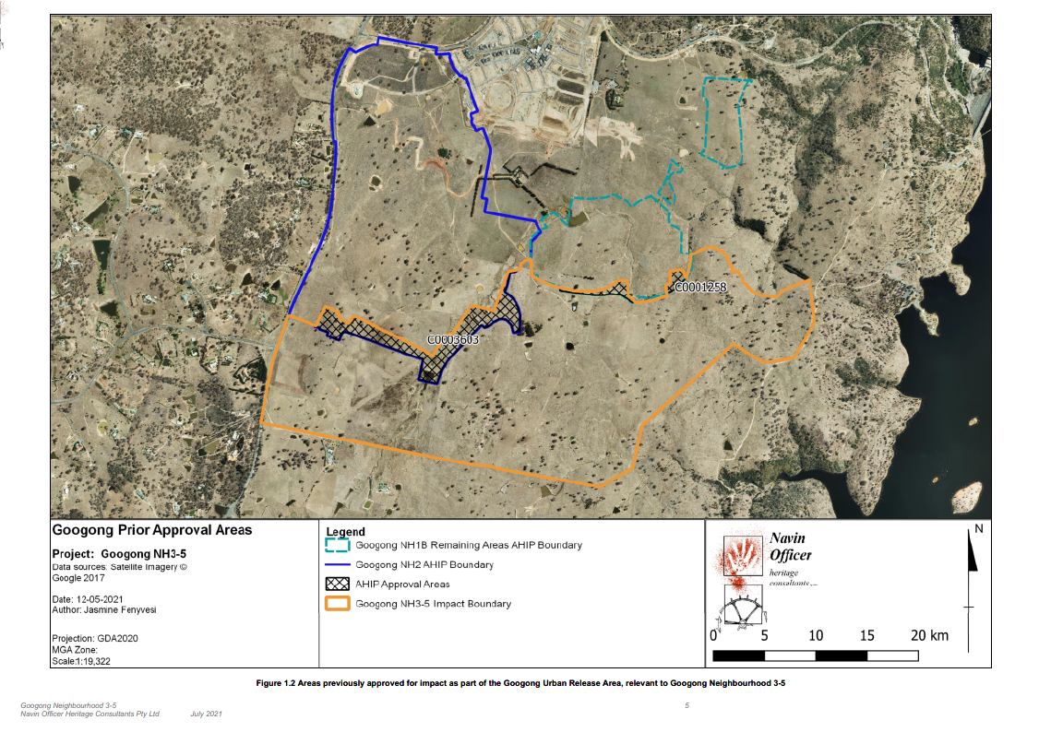
Figure 28 - Previously Approved Areas Within N3, 4 & 5 (hatched)
The assessment found:
- Eight previously unrecorded Aboriginal sites were located during the survey of the study area (refer prefix GNH3-5),
- Five previously recorded sites were again identified during the current investigation (refer prefix GA),
- 15 previously recorded items were not located on site in the 2021 survey (refer prefix GRW), and
- Three (3) previously recorded Potential Archaeological Deposits are within the subject site (refer prefix PAD) however no artefacts were recorded in these locations in the 2021 survey.

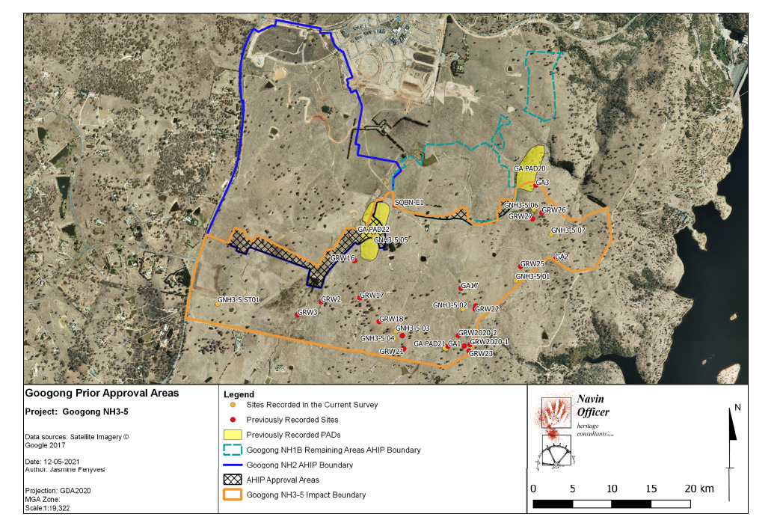
Figure 29 - Recorded Potential Archaeological Deposits
The conservation area will protect 17 Aboriginal sites identified in the current study area (GA1, GA2, GA3, GA18, GRW18, GRW21, GRW22, GRW23, GRW24, GRW2020-1, GRW2020-2, GRW Cultural Feature, GNH3-5 01, GNH3-5 02, GNH3-5 03, GNH3-5 04 and GA PAD21).
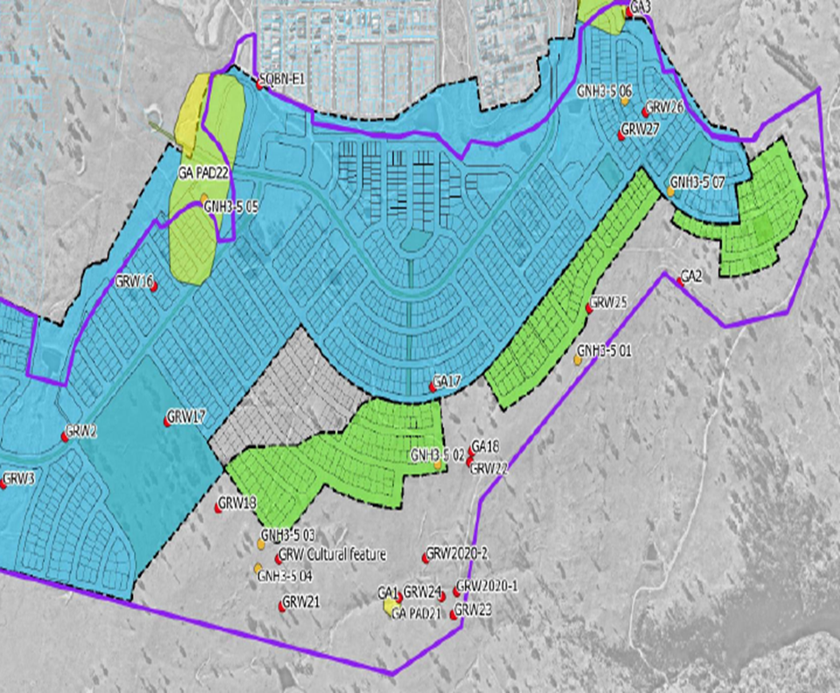
Figure 30 – Conservation Area Shown Grey (no colour)
Inclusion of these sites in the conservation area will ensure that these archaeological sites and areas are conserved into the foreseeable future. This represents a positive conservation outcome for heritage items within the urban release area.

All sites identified have been included on the constraints plan (Drawing 308534CA020).
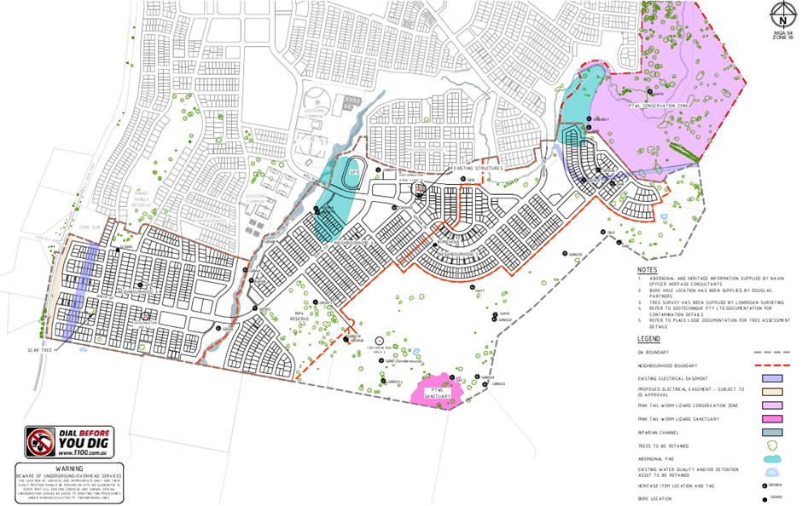
Figure 31 - Aboriginal Sites Mapped Throughout N345
Following the September 2021 report by Navin Officers, Council has been informed that one of the items of interest was damaged by the landowner. Item GNH3-5 ST01 is identified as a ‘scarred tree’ and is located within a proposed residential area.
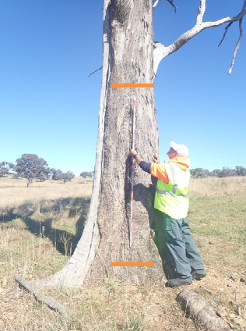
Figure 32 - Intact tree with scar identified by Navin Officers

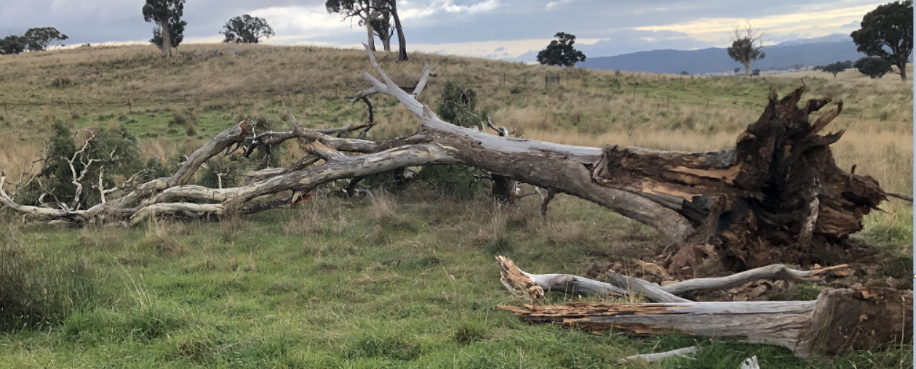
Figure 33 - Damaged Tree
It is anticipated that the landowner will continue to work with Heritage NSW and the local Aboriginal community to develop a culturally appropriate way to display the values of the tree and preserve it in place. A condition has been imposed to ensure this occurs prior to the issue of the Subdivision Certificate for the relevant stage (Neighbourhood 3).
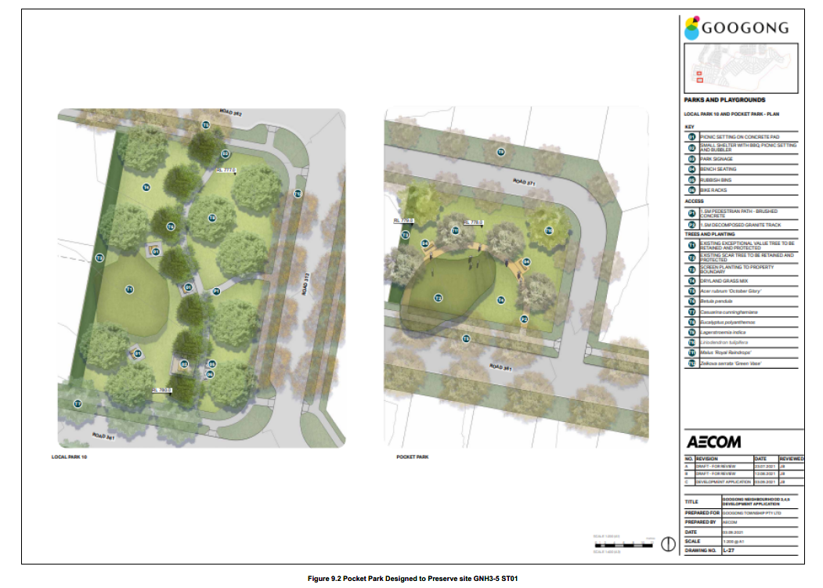
Figure 34 - Local Park 10 Neighbourhood 3
The assessment found that the 17 Aboriginal sites identified are not remarkable or unique in any obvious way. It can be inferred that the region contains a large population of similar sites, which are currently being passively conserved on undeveloped land. As a consequence, the cumulative impact of the destruction of the sites discussed in this report compared to the overall archaeological resource of the region is assessed as being low.
National Parks and Wildlife have considered the impact of the proposed development on Aboriginal Heritage and have issued their general terms of approval.

Ancillary development
The proposal also includes site levelling, earthworks, road work including access and car parking for the sportsfield, landscaping and signage and relocation of the Shearing Shed. The community facilities building shown on the Neighbourhood 4 plans will be subject to a future DA.
Control | Proposal
Site area | 235ha
Proposed number lots – residential | 1398 residential lots
Proposed number lots – future development | 14 (residential)  5 (Neighbourhood Centre)
Stages | 3 neighbourhoods over 23 stages
Clause 4.6 Requests | Yes – variation to Minimum Lot Size
Table 2 - Development Data
Standard lots are proposed to range from 337m² – 1093m². The areas of the proposed superlots are outlined below:

Neighbourhood | Stage | Area (sqm)
NH3 | Stage 1 | 8,658
 |  | 3,299
 |  | 3,288
 |  | 2,170
 | Stage 2 | 2,151
 | Stage 6 | 8,142
 |  | 7,179
NH4/5 | Stage 1 | 16,320
 | Stage 2 | 3,405
 | Stage 3 | 6,920
 |  | 2,525
 |  | 2,855
 |  | 1,812
 |  | 2,208
 | Stage 4 | 15,260
 |  | 1,954
 |  | 2,246
 | Stage 5 | 5,151
 | Stage 10 | 2,555
Table 3 - Superlot areas
The applicant anticipates that once further subdivided, the future residential superlots will be able to cater for` another 300 - 320 dwellings.

Assessment Reports
The following reports have accompanied the development application and were used throughout the planning assessment:
- Statement of Environmental Effects prepared by Elton Consulting dated September 2021.
- Infrastructure & Utilities Plans prepared by Spiire of 9 September 2021, Landscaping & Open Space by AECOM of 10 September 2021, Tree Management Plan by Place Logic od 1 September 2021, Block Typology Plan by Urbane Studio of 15 September 2021 and Subdivision plans by Lonergan Surveying of 15 September 2021
- Aboriginal Cultural Heritage Assessment prepared by Navin Officer dated 10 September 2021,
- Biodiversity Certification Assessment prepared by Capital Ecological dated 30 April2021 (amended 2 October 2021)
- Bushfire Assessment prepared by Ember Consulting dated 14 September 2021,
- Civil Infrastructure Design Report prepared by Spiire dated 10 September 2021
- Landscaping Design Report prepared by AECOM dated 10 September 2021,
- Road Traffic Noise Assessment prepared by SLR Global Environmental Solutions dated 7 September 2021,
- Site Contamination Assessment Report by GeoTechnique dated September 2021
- Stormwater Report prepared by Spiire dated 8 September 2021,
- Traffic, Transport & Access Assessment prepared by SCT Consulting dated 10 September 2021.
A number of plans and reports have been amended through the application assessment process. Final plans are listed in the draft consent and relevant reports which are to form part of the consent are included in conditions.
2.2 Background
A range of meetings have been held with Council prior to lodgement of the DA. The proposed development subject of this DA was considered at several of Council’s Development Coordination Review (DCR) Panel (pre-DA) meetings. Each of the issues raised at the DCR meetings has been addressed.
16/12/2020 | Googong NH345 DA - Preliminary context | Planning staff and PEET
29/01/2020 | Googong NH345 Discussion | Planning, Engineering, Strategic Planning & Management and PEET
26/02/2021 | Googong NH345 Traffic Workshop | Engineering staff, Planning & Management, Spiire, SCT Consulting, PEET
15/04/2021 | Shearing Shed - Heritage | Strategic Planning, Heritage Advisor, PEET
4/06/2021 | Googong Neighbourhood 3, 4 & 5  SPS & Stormwater Pond | Engineering, PEET
15/06/2021 | Traffic issues | Engineering, PEET

28/06/2021 | Shearing Shed inspection | Planning, Heritage Advisor, Heritage Advisory Committee, Major & PEET
12/08/2021 | Shearing Shed relocation and repurposing concept | Engineers, PEET, Council
Table 4 – Matters Raised in DCR
The development application was lodged on 24 September 2021. A chronology of the development application since lodgement is outlined below including the Panel’s involvement (briefings, deferrals etc) with the application:
Date | Event
24 September 2021 | DA lodged
22 October 2021 | Exhibition of the application (Integrated)
22 October 2021 | DA referred to external agencies
28 March 2022 | Request for Information from Council to applicant
5 April 2022 | Panel briefing
16 June 2022 | Amended plans lodged 16 June 2022
June / July 2022 | Minor plan amendments
13 July 2022 | Council determines to de-list Heritage Item (Shearing Shed)
15 July 2022 | Biodiversity Certification Order gazetted
Table 5 - Chronology of the DA

- STATUTORY CONSIDERATIONS

Commonwealth Legislation

Environment Protection and Biodiversity Conservation Act 1999
The Commonwealth Environment Protection and Biodiversity Conservation Act 1999 (EPBC Act) requires the approval of the Commonwealth Government for actions that may have a significant impact on Commonwealth Land such as Googong Foreshore or matters of national environmental significance and its habitat.
The development of the majority of Googong Township was subject to a Commonwealth Environment Protection and Biodiversity Conservation Act 1999 referral (EPBC Act Ref: 2011/5859) and corresponding EPBC Act approval.
In relation to the subject site, all areas except for a small section in the southwest (owned by Hamson) were included in the EPBC Act referral. The areas previously assessed and approved under the EPBC Act do not require additional review. Accordingly, the biodiversity assessment submitted in support of this development application only considered Matters of National Environmental Significant pursuant to the Act for the Hamson property. Any development of the subject land outside the Hamson property must occur in accordance with the existing EPBC Act approval and associated conditions.
The BCAR study area has been substantially modified by its current and past land uses, which have primarily been for livestock grazing (sheep and cattle). The original woody vegetation was historically cleared across much of the study area to promote the pastoral productivity of the land.
The relatively small areas which retain some of the original canopy trees have still undergone substantial historic thinning. The prolonged period of high intensity stock grazing has prevented regeneration of the overstorey and midstorey and depleted the native species diversity in the groundstorey.
The resulting vegetation across the majority of the study area is characterised by an absent or low-density canopy of old eucalypts, an absent midstorey and shrubstorey, and a low diversity groundstorey dominated by disturbance tolerant native grasses. The paddock in the eastern extent of the study area is the only location where some canopy regeneration has been permitted to establish.
Three plant community types (PCTs) and habitat for multiple threatened entities were identified in the assessment area during the BCAR assessment process:
- PCT 999 - Norton's Box - Broad-leaved Peppermint open forest on foot slopes, central and southern South Eastern Highlands Bioregion (PCT 999 Norton’s box – broad-leaved peppermint open forest) divided into six vegetation condition zones.
- PCT 1110 – River Tussock – Tall Sedge – Kangaroo Grass moist grasslands of the South Eastern Highlands Bioregion (PCT 1110 tussock and sedge moist grasslands) within a single low quality vegetation condition zone.
- PCT1334 – Yellow Box grassy woodland of the northern Monaro and Upper Shoalhaven area, South Eastern Highlands Bioregion (PCT 1334 yellow box grassy woodlands). This PCT meets the criteria for the BC Act listed critically endangered ecological community (CEEC) and Serious and Irreversible Impact entity White Box – Yellow Box – Blakely’s Red Gum Woodland (Box-gum Woodland).
- PTWL habitat (BC Act and EPBC Act vulnerable) found within both PCT 999 & 1334.

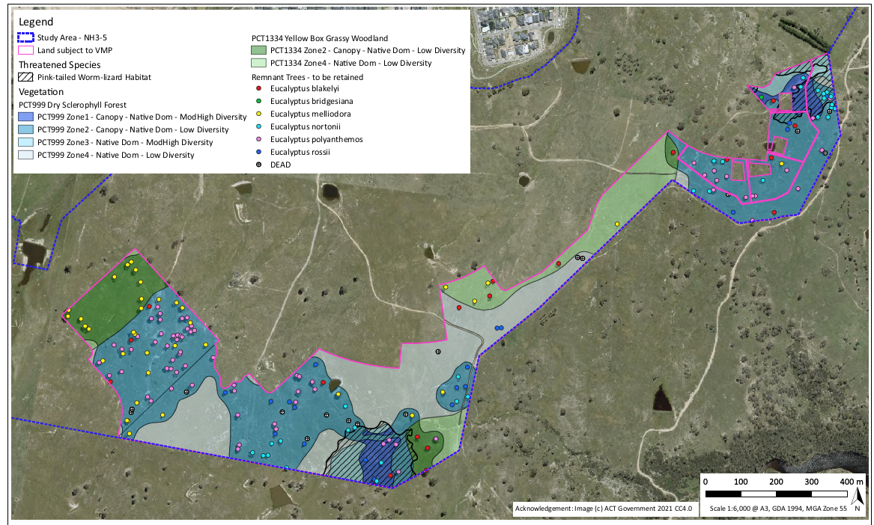Figure 35 – Key Biodiversity Value Areas (Capital Ecological)
NSW Legislation
Biodiversity Conservation Act 2016
There have been several ecological studies undertaken to inform the development and planning of Googong Township as well as Neighbourhood 2 dating back to 2004. More recently, an Ecological Values and Constraints Assessment was undertaken for Neighbourhoods 2-5 (Biosis, 2015) under the Commonwealth Environment Protection and Biodiversity Conservation Act 1999 (EPBC Act) and NSW Threatened Species Conservation Act 1995 (TSC Act).
In 2016 the Biodiversity Conservation Act 2016 replaced the Threatened Species Conservation Management Act 1995.
In December 2019, Googong Township Pty Ltd submitted an application to the Biodiversity and Conservation Division South East Planning team (BCD) for biodiversity certification for the 261.43ha of land on which Stages 3-5 would be built. The application includes a Biodiversity Certification Assessment Report (BCAR).
The effect of biodiversity certification, for development under Part 4 of the Environmental Planning and Assessment Act 1979, is that assessment of the likely biodiversity impacts is not required under Part 7 of the Biodiversity Conservation Act. This means the Biodiversity Offsets Scheme will not apply. The agreement with the landowner has been made under Part 8 of the Biodiversity Conservation Act.

The Biodiversity Certification Assessment Report proposes the following measures to be the Approved Conservation Measures:
- The retirement of 136 PCT 999 (Norton’s Box – Broad leaved Peppermint open forest on foot slopes, central and southern South Eastern Highlands Bioregion) Biodiversity Credits and 900 PCT 1334 (Yellow Box grassy woodland of the northern Monaro and Upper Shoalhaven area, South Eastern Highlands Bioregion) Biodiversity Credits (total 1036 credits); and
- The retirement of 48 Pink–Tailed Legless Lizard Species Credits
Biodiversity credits, as the approved conservation measure, will be retired in stages. A condition has been suggested that confirms the credits have been retired before a Construction Certificate for the relevant stage is issues.
In addition to the Approved Conservation Measures, the BCAR recommends Googong Township Pty Ltd entering into a Biodiversity Certification Agreement (BCA) to, among other things, ensure the Avoided Land of 56.73ha is conserved and enhanced in perpetuity as a measure to reduce impacts on Biodiversity values.
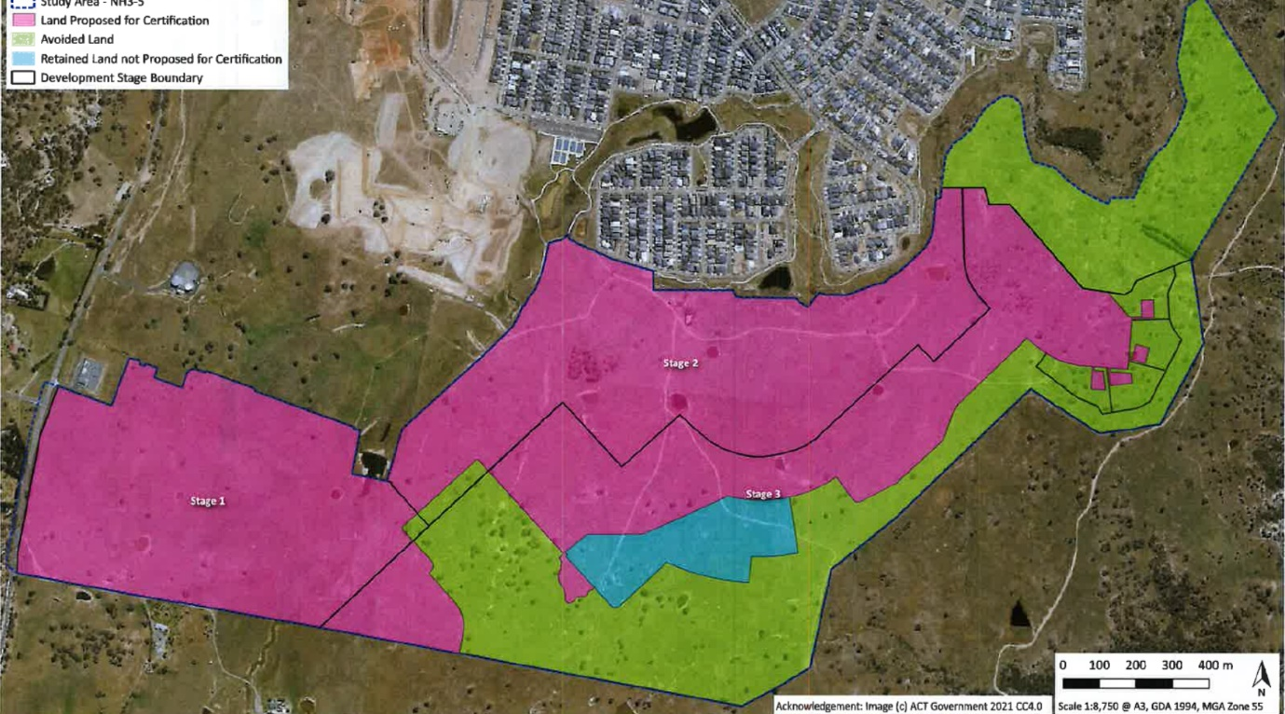
Figure 36 - Avoided Land (green)
The proposal has been designed to focus the impacts of the development into the areas which have the lower conservation value. The Department worked with the developer to ensure the areas with high biodiversity values were being avoided by development. Further, the following additional avoidance measures will be imposed via a Biodiversity Stewardship Agreement:
- Enhancement and protection of a 10.96ha Yellow Box Woodland Reserve
- 40.39ha of land zoned C2 (Environmental Conservation) will be managed under a Vegetation Management Plan (VMP)
- Direct impacts to 5.38ha within the proposed large lots will be avoided using specific management actions to protect their habitat values.

Avoiding and minimising the impact on the Yellow Box Grassy Woodland will supplement the measures previously established for the Googong Township development (Stages 1-2). The conditions of approval under the Environment Protection and Biodiversity Conservation Act 1999 (Cth) (EPBC Act) required:
- establishing a Pink Tailed Worm Lizard (PTWL) Conservation area comprising 54 ha, and
- creating the Googong Foreshores Interface Management Strategy (GFIMS), which outlines how the remainder of the PTWL habitat is managed.
The Department of Planning and Environment determined that the proposal is now suitable for biodiversity certification under section 8.2 of the Biodiversity Conservation Act 2016 (BC Act), as the proposed conservation measure, being the retirement of 1086 biodiversity credits, will be adequate to offset the impact on biodiversity values of the proposal.
On 15 July 2022 a Biodiversity Certification Order was gazetted by the Minister for Planning and Environment. The Order and associated Agreement have now taken effect and a condition has been included in this consent to ensure their compliance.
Environmental Planning and Assessment Act 1979
This proposal is captured under Part 4 of the Act and the relevant sections for the assessment and determination of the application have been considered. This includes the Integrated Development provisions under Section 4.46 and Section 4.15 evaluation matters.
Section 4.46 - Integrated Development
This section sets out the procedures for integrated development. It states that integrated development requires consent under the applicable acts listed in the Clause.
This application is integrated under the following Acts:
Act | Provision | Approval | Consent Authority
National Parks and Wildlife Act 1974 | s90 | Grant of Aboriginal Heritage Impact Permit (AHIP) | Premier and Cabinet
Rural Fires Act 1997 | s100B | Authorisation under Section 100B in respect of bushfire safety of subdivision of land that could lawfully be used for residential  purposes or development of land for special fire protection purposes | NSW Rural Fire Service
Water Management Act 2000 | s90 | Water use approval, water management work approval or activity approval under Part 3 of Chapter 3 | Department of Primary Industries – Water
Fisheries Management Act | s144 | Department of Primary Industries (Fisheries) confirmed the proposal does not trigger the Act so no GTA’s were provided. | Department of Primary Industries (Fisheries)
Table 6 – Integrated Matters

National Parks and Wildlife Act 1974
Section 90 of the National Parks and Wildlife Act 1974 requires that an Aboriginal Heritage Impact Permit (AHIP) be granted for certain works that may harm or potentially harm Aboriginal objects or places.
An Archaeological Assessment and Aboriginal Cultural Heritage Assessment (ACHAR) prepared by Navin Officer dated September 2021 was submitted. The application was referred to the Department of Premier and Cabinet for their advice.
General Terms of Approval were issued by Department of Premier and Cabinet dated 25 January 2021 for an Aboriginal Heritage Impact Permit (AHIP) under the National Parks and Wildlife Act.
Item GNH3-5 ST01 is identified as a ‘scarred tree’ located within a proposed residential area. Following the date of issue one of the items of interest was knocked over by the landowner.
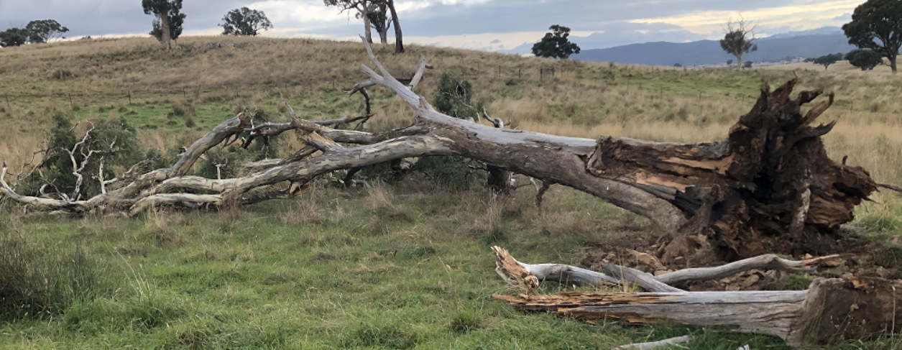
Figure 37– Scarred Tree Damaged in Situ
The Applicant advises the truck and scar are intact. It is anticipated that the landowner will continue to work with Heritage NSW and the local aboriginal community to develop a culturally appropriate way to display the values of the tree and preserve it in place. A condition has been suggested to ensure this occurs prior to the issue of the Subdivision Certificate for that stage (Neighbourhood 3).

Rural Fires Act 1997
The land is mapped as being bushfire prone.
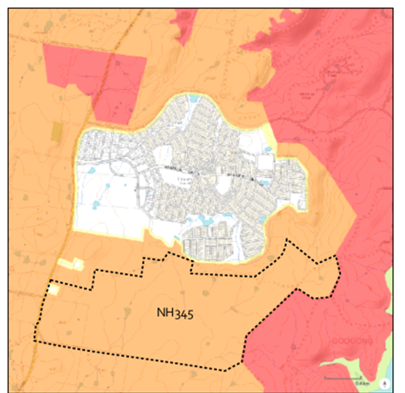
Figure 38 – Bushfire Zones
Section 100B of the Rural Fires Act 1997 requires authorisation for bush fire safety where subdivision of bush fire prone is proposed for residential or rural residential purposes.
The proposed development was referred to the RFS as integrated development requesting the issue of a Bush Fire Safety Authority under section 100B of the Rural Fires Act 1997. General Terms of Approval (GTA) have been issued and the GTA will form part of the conditions of consent.
Water Management Act 2000
The referral to the DPI Water was triggered as the proposed subdivision works are defined as a controlled activity under Section 91 of the Water Management Act 2000, being works on waterfront land (Montgomery Creek). Works cannot commence until the applicant applies for and obtains a controlled activity approval.
The Department of Primary Industries Water is the approval body. They issued their General Terms of Approval for works requiring a controlled activity approval under the Water Management Act 2000 on 7 February 2022.
The DPI Water stated that the GTA issued do not constitute an approval under the Water Management Act 2000. Also, the applicant must apply for a controlled activity approval after consent has been issued and before the commencement of any work or activity on waterfront land. Their advice will be attached to any consent with appropriate conditions.

Section 4.15 - Evaluation
When determining a development application, the consent authority must take into consideration the matters outlined in Section 4.15(1) of the Environmental Planning and Assessment Act 1979 (‘EP&A Act’). These matters as are of relevance to the development application include the following:
(a) the provisions of—
(i) any environmental planning instrument, and
(ii) any proposed instrument that is or has been the subject of public consultation under this Act and that has been notified to the consent authority (unless the Planning Secretary has notified the consent authority that the making of the proposed instrument has been deferred indefinitely or has not been approved), and
(iii) any development control plan, and
(iiia) any planning agreement that has been entered into under section 7.4, or any draft planning agreement that a developer has offered to enter into under section 7.4, and
(iv) the regulations (to the extent that they prescribe matters for the purposes of this paragraph),
(b) the likely impacts of that development, including environmental impacts on both the natural and built environments, and social and economic impacts in the locality,
(c) the suitability of the site for the development,
(d) any submissions made in accordance with this Act or the regulations,
(e) the public interest.
These matters are further considered below.
  - Section 4.15(1)(a)(i) – Provisions of Environmental Planning Instruments
The following planning instruments have been considered in the planning assessment of the subject development application:
- State Environmental Planning Policy (Planning Systems) 2021
- State Environmental Planning Policy (Resilience & Hazards) 2021
- State Environmental Planning Policy (Transport & Infrastructure) 2021
- State Environmental Planning Policy (Biodiversity & Conservation) 2021
- State Environmental Planning Policy (Industry & Employment) 2021

A summary of the key matters for consideration arising from these State Environmental Planning Policies are outlined in Table 6 and considered in more detail below.
EPI | Matters for Consideration | Comply (Y/N)
SEPP Planning Systems | - Chapter 2 identifies the development as State significant with the Independent Planning Commission as consent authority. | Y
SEPP Resilience & Hazards | - Chapter 4 seeks the assessment consider the remediation of contaminated land. Contamination and remediation has been considered in the Contamination Report and the proposal is satisfactory subject to conditions. | Y
SEPP Industry & Employment | Signage generally consistent with SEPP and subject to further assessment prior to release of Construction Certificate | Y
SEPP Biodiversity & Conservation | The Biodiversity Certification Assessment report prepared by Capital Ecological dated April 2021 has confirmed there is no Koala habitat onsite. | Y
SEPP Transport & Infrastructure | Part 2.48 (Determination of development applications—other development) – electricity transmission – the proposal is satisfactory subject to conditions.  Part 2.119 – Development fronting a classified road  Part 2.220 – Development subject to road traffic noise  Part 3.58 Traffic generating development | Y
Table 6 - Summary of Applicable State Environmental Planning Policies

State Environmental Planning Policy (Planning Systems) 2021
The aims of this Policy are as follows:
  - to identify development that is State significant development,
  - to identify development that is State significant infrastructure and critical State significant infrastructure,
  - to identify development that is regionally significant development.
Chapter 2 – State and Regional Development
Clause 2.6 designates development to be State significant development where the capital investment value of the development exceeds $30 million. The Independent Planning Commission is to be the consent authority for State significant development under Clause 2.7.
The capital investment value (CIV) for the proposed development is $181 million which exceeds the threshold of $30 million. Therefore, this application is to be determined by the Joint Regional Planning Panel – Southern Region.
State Environmental Planning Policy (Resilience and Hazards)2021
Chapter 4 – Remediation of and
The objectives of this Chapter are:
- To provide for a statewide planning approach to the remediation of contaminated land; and
- to promote the remediation of contaminated land for the purpose of reducing the risk of harm to human health or any other aspect of the environment—
- by specifying when consent is required, and when it is not required, for a remediation work, and
- by specifying certain considerations that are relevant in rezoning land and in determining development applications in general and development applications for consent to carry out a remediation work, and
- by requiring that a remediation work meet certain standards and notification requirements.
- Pursuant to the Clause 4.6 of this Policy – Contamination and remediation to be considered in determining development application, the consent authority must consider:
- Whether the land is contaminated; and
- If the land is contaminated, whether it is satisfied that the land is suitable in its contaminated state (or will be suitable, after remediation) for the proposed use, and
- if the land requires remediation to be made suitable for the purpose for which the development is proposed to be carried out, it is satisfied that the land will be remediated before the land is used for that purpose.
The subject land has previously been used for agricultural and ancillary purposes which had the potential to cause contamination of the land and impact on the future potential use of the land for sensitive land uses. As such an assessment of potential contamination of the site was required.

A site contamination assessment report (GeoTechnique, dated September 2021) was submitted with the application. In summary the report found that:
- Demolition and removal of historical infrastructure is required (5 above ground storage tanks and associated infrastructure, sheds, sheep yards and hard stand areas)
- Further testing and assessment of contamination will be required after demolition and removal
- Contaminated soils/materials were identified and classified for offsite removal
- Remediation and validation of the site are required
The consultant states that the site can be made suitable for the proposed redevelopment subject to the following recommendations:
- Further assessment of areas of concern following demolition or removal
- Preparation of a Remedial Action Plan
- Site Validation
A condition of consent has been proposed requiring works to be undertaken in accordance with the recommendations of the report. Validation of remediation works will be required prior to release of a Subdivision Certificate.
Shearing sheds are known sources of potential contamination due to historical use of chemicals. A contamination report for the shearing shed has been submitted with the application. The report found levels of contaminants to be below the NEPM level for proposed land use of Recreational-C. However, elevated levels of lead (still below NEPM Guidelines) were discovered in the paint on one of the doors.
Given that it is undetermined which parts of the structure will be reused it is appropriate to require an additional report prior to release of the subdivision certificate indicating that the structure is suitable for use.
State Environmental Planning Policy (Industry and Employment) 2021
State Environmental Planning Policy (Industry and Employment) 2021 is relevant to the proposed development as it involves the construction of park signage, orientation signage, interpretive signage and wall signage.
These new signs are similar to the existing approved signs in Neighbourhoods 1 & 2 including:
- Park Signage – Located at prominent park corners or entry points to identify Local and Neighbourhood parks, information and safety signs.
- Orientation Signage – To aid in the legibility of the Googong network of paths and open spaces, located at key decision points or nodes.
- Interpretive Signage – To provide information to help explain points of environmental or historical significance.
- Wall signage – To provide park naming at key arrival points, in addition to or as an alternative to park signage.
The land is in Zone R1 General Residential, RE1 Public Recreation and C2 Conservation zone. The majority of the proposed signs are located within R1 and RE1 zones. Signage is not listed as development permitted with consent within the R1 and RE1 zones however it will be ancillary to the residential and recreational areas proposed and able to be approved on that basis.

Part 3.1 – Aims, Objectives etc
(1) This Policy aims:
(a) to ensure that signage (including advertising):
(i) is compatible with the desired amenity and visual character of an area, and
(ii) provides effective communication in suitable locations, and
(iii) is of high quality design and finish, and
(b) to regulate signage (but not content) under Part 4 of the Act, and
(c) to provide time-limited consents for the display of certain advertisements, and
(d) to regulate the display of advertisements in transport corridors, and
(f) to ensure that public benefits may be derived from advertising in and adjacent to transport corridors.
Provided appropriate recommended conditions of consent are complied with, the proposed development is considered generally satisfactory with respect to the prescribed aims and objectives of the SEPP. The proposed signs are compatible with the amenity and visual character of the area and provide effective communication in a suitable location. The graphics and content are to be designed to be in accordance with the corporate logo of the company.
Part 3.2 – Definitions
In terms of the definition the signs are considered as building identification signs.
Building identification sign means a sign that identifies or names a building, and that may include the name of a business or building, the street number of a building, the nature of the business and a logo or other symbol that identifies the business, but that does not include general advertising of products, goods or services.
Part 3.6 – Granting of consent to signage
Under this clause a consent authority must not grant development consent to an application to display signage unless the consent authority is satisfied:
(a) that the signage is consistent with the objectives of this Policy as set out in clause 3(1)(a)
Provided appropriate recommended conditions of consent are complied with, the proposed development is considered able to satisfy the objectives of the Policy.
(b) that the signage the subject of the application satisfies the assessment criteria specified in Schedule 1.
Schedule 5 Assessment Criteria
- Character of the area – The signage is consistent with the particular theme for outdoor advertising as approved in NH1 and NH2. The proposed signage is not considered to be out of context with surrounding future residential properties and rural land.
- Special areas – It is considered that the proposed signs do not detract from the amenity or visual quality of any environmentally sensitive areas, heritage areas, natural or other conservation areas, open space areas, waterways, rural landscapes or residential areas. Views and vistas – The proposed signs do not obscure or compromise important views, nor do they dominate the skyline. They will be below the height of the streetlights within the estate.

- Streetscape, setting or landscape – The proposed signs satisfy this criterion. The scale, proportion and form is considered appropriate for the current and future streetscape. The proposal contributes to the visual interest of the streetscape, setting and landscaping on site. The proposal does not create or add to the visual clutter of the setting.
- Site and building – The proposed signs are considered to be compatible with the scale, proportion and other characteristics of the site. The signs are informative, contemporary and well suited for the purpose and to the location in which they are proposed.
- Associated devices and logos with advertisements and advertising structures – The signs will not contain any flashing devices. The signs also do not contain any variable message or moving parts. The graphic/content is designed to be in accordance with the corporate logo of the company.
- Illumination – No illumination is proposed.
- Safety –The safety of road users and pedestrians will not be compromised by the sign. This is achieved through the separation between the signage and the footpath.
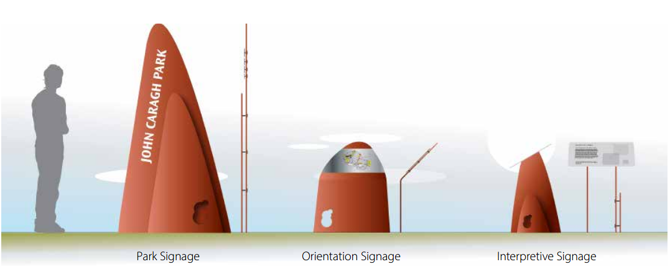Figure 39: Image of Type of Signs Used in Googong to be Replicated
Details of the proposed public domain signage are to be shown in applications for Subdivision Construction Certificates and must be consistent with the guidelines for public domain signage outlined in the Googong Landscape and Open Space Strategy. This is sought in a condition.
Provided appropriate recommended conditions of consent are complied with, the proposed development is considered generally satisfactory with respect to the SEPP.
State Environmental Planning Policy (Transport and Infrastructure) 2021
This Policy provides a planning regime for the provision of services and infrastructure in NSW, outlines requirements for consent authorities to consult with relevant public authorities during the assessment of development applications and outlines provisions for various types of exempt and complying development.

Part 2.48 – Determination of development applications – other development
The clause states that before determining a development application for development comprising or involving any of the following, the consent authority must give a written notice to the electricity supply authority for the area in which the development is to be carried out, inviting comments about the potential risks and take into consideration any response to the notice that is received within 21 days after the notice is given.
  - the penetration of ground within 2m of an underground electricity power line or an electricity distribution pole or within 10m of any part of an electricity tower,
  - development carried out:
  - within or immediately adjacent to an easement for electricity purposes (whether or not the electricity infrastructure exists), or
  - immediately adjacent to an electricity substation, or
  - within 5m of an exposed overhead electricity power line,
The development site is immediately adjacent to an easement for electricity purposes and within 5m of an exposed overhead power line. Therefore, the application was referred to the electricity supply authority (Essential Energy) for comment who provided general comments on 11 November 2021, including:
      - If the proposed development changes it is recommended that Essential Energy is consulted for further comment.
      - Any existing encumbrances in favour of Essential Energy (or its predecessors) noted on the title of the above property should be complied with.
      - As part of the subdivision/s, easements/s are to be created for any existing electrical infrastructure using Essential Energy’s standard easement terms current at the time of registration of the plan/s of subdivision. Refer to Essential Energy’s Contestable Works Team for requirements.
      - Council should ensure a Notification of Arrangement (confirming satisfactory arrangements have been made for the provision of power) is issued by Essential Energy with respect to all proposed lots which will form part of the subdivision/s, prior to Council releasing the Subdivision Certificate. It is the Applicant’s responsibility to make the appropriate application with Essential Energy for the supply of electricity to the subdivision/s, which may include the payment of fees and contributions.
      - In addition, Essential Energy’s records indicate there is electricity infrastructure located within the properties and within close proximity to the property. Any activities within these locations must be undertaken in accordance with the latest industry guideline currently known as ISSC 20 Guideline for the Management of Activities within Electricity Easements and Close to Infrastructure. Approval may be required from Essential Energy should activities within the properties encroach on the electricity infrastructure.
      - Prior to carrying out any Prior to carrying out any works, a “Dial Before You Dig” enquiry should be undertaken in accordance with the requirements of Part 5E (Protection of Underground Electricity Power Lines) of the Electricity Supply Act 1995 (NSW).
      - Given there is electricity infrastructure in the area, it is the responsibility of the person/s completing any works around powerlines to understand their safety responsibilities. SafeWork NSW (www.safework.nsw.gov.au) has publications that provide guidance when working close to electricity infrastructure. These include the Code of Practice – Work near Overhead Power Lines and Code of Practice – Work near Underground Assets.
Comments above will be placed on the development consent (if granted) as advisory notes.

Division 17 Roads and Traffic
Part 2.119- Development with Frontage to Classified Road
The proposed subdivision required referral to Transport for NSW being development with frontage to a classified road (Old Cooma Road).
Part 2.120 impact of road noise on non-road development
The proposed development has the potential to be impacted on by road noise and is also traffic generating development. The application was referred to Transport for NSW who support the proposal subject to conditions.
A report assessing impacts of traffic noise from Old Cooma Road on the lots to be created was submitted as part of the application (SLR dated September 2021). The report assessed traffic noise using the predicted traffic volumes likely to be seen in 2031. The report found that a small number of lots would be exposed to road noise during the day. This is reduced at night (considered to be the most intrusive time) due to lower traffic volumes. The findings were similar to that of the Googong NH2 Subdivision DA where acoustic barriers were not required. The only noise barriers in the Googong development are to attenuate noise from the water treatment plant. Acoustic barriers for road noise have not previously been required. A condition requiring Category One construction for the affected lots has been included on the consent. It should be noted that most modern homes already meet these requirements.
Part 3.58 and Schedule 3 relating to traffic generating development.
Transport for NSW have provided their concurrence and recommended conditions.
Council, Transport for NSW and the Applicant concur that an intersection at Old Cooma Road and Bunyip Drive is required as a consequence of the proposed development. An intersection is shown on the proposal plans and supported by the Traffic, Transport and Access Assessment by SCT Consulting dated 10 September 2021.
The proposal plans as lodged showed a priority controlled intersection (Give Way) as recommended by the consultants’ report.
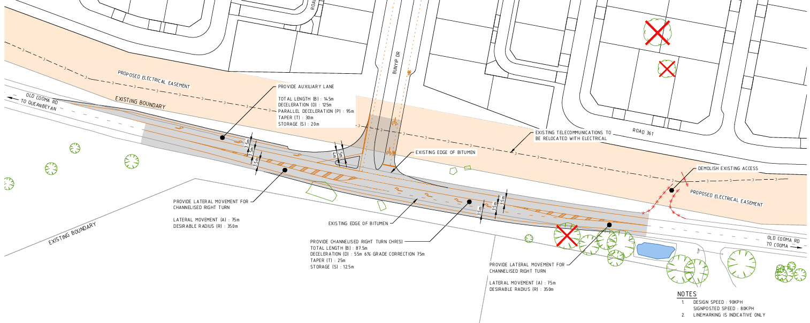Figure 40 - Intersection Detail by Spiire dated 9 September 2021 Ref 308534CA300 at Application lodgement
Given this would be the third intersection servicing the estate, Council Executive resolved in July 2021 to go out to public consultation on 5 design options for the Old Cooma Road / Bunyip Drive intersection. These were exhibited from October to November 2021. There were 188 submissions and the communities’ preferences will be presented to a workshop of Council on schedule for 3 August 2022.
There is no dispute by Council, the developer with supported traffic assessment, and Transport for NSW that an intersection in the location as shown on the proposed plans submitted for determination is required. However, the relevant parties are yet to determine the final form and design of the intersection.
Old Cooma Road is classified by Transport for New South Wales (TfNSW) as a Regional Road. It accommodates regional and local traffic travelling north – south to and from Queanbeyan City.
Council Engineers recommend the final form and design of the Old Cooma Road and Bunyip Drive intersection to be determined, subject to concurrence from Traffic for NSW occur following the determination of this consent.
The final form may include traffic signals however, given Council is not yet resolved on the most appropriate design to meet community expectations and concurrence for that style of intersection has not been provided by Transport for NSW at this stage, and reference to ‘signalised intersection’ has been removed from the proposed plans.
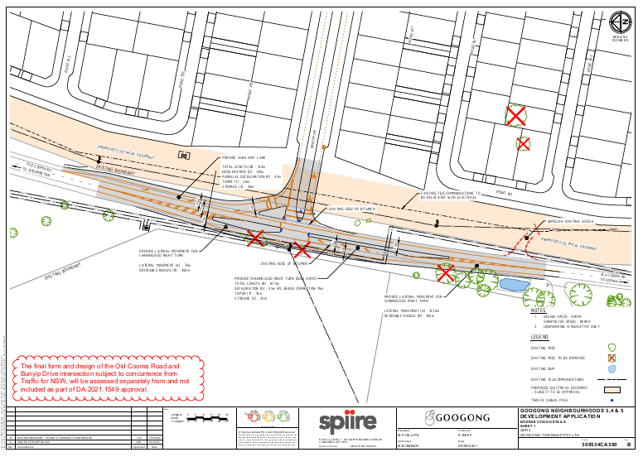Figure 41 - Intersection Detail by Spiire dated 15 June 2022 Ref 308534CA300 Revision B with red amendment note
There is no contention on the location of the intersection as shown on the DA plans. What is to be clarified is design elements including whether a bypass lane be provided at this intersection, whether traffic signals are proposed at this intersection, or whether a bypass lane at the existing intersection of Old Cooma Road and Googong Road north of the subject site be arranged.
As these considerations are being sought by Council to ensure the development fits appropriately within the context of existing road traffic and to meet community expectations, it would be an unreasonable impost on the developer to suspend or delay the processing of this application as a result.

Council, the developer and Transport NSW support an intersection as shown on the proposal plans. Detail on the design and form of the intersection of Old Cooma Road and Bunyip Drive will be determined, in consultation with Transport for NSW, as a condition of consent and prior to the issue of a Construction Certificate.
Transport for NSW raise no objection to the proposal with the imposition of conditions.
Local Environmental Plans
The proposed development has been assessed in accordance with the relevant requirements of the Queanbeyan Local Environmental Plan 2012 and no relevant draft LEPs apply to the land. A summary is provided as follows:
QUEANBEYAN LOCAL ENVIRONMENTAL PLAN 2012 COMMENTS | COMPLIES  (Yes/No)
Part 1 Preliminary
Clause 1.2 Aims of Plan
The aims of the Plan are as follows:  (aa) to protect and promote the use and development of land for arts and cultural activity, including music and other performance arts,  Not applicable  - To facilitate the orderly and economic use and development of land in Queanbeyan based on ecological sustainability principles;  The proposed development is able to progress in an orderly way. The development will be a significant contribution to residential land supply in the Queanbeyan area and South East NSW and the Applicant has demonstrated it can be developed to meet relevant ecological principles.  - To provide for a diversity of housing throughout Queanbeyan;  The proposed development will make a significant contribution to the residential land supply in the Queanbeyan area including for standard residential lots and opportunities for housing diversity.  - To provide for a hierarchy of retail, commercial and industrial land uses that encourage economic and business development catering for the retail, commercial and service needs of the community;  The proposed development will provide lots for local commercial development (subject to future development applications for those uses). Economic and business opportunities will be provided on the lots created in this subdivision application to service the needs of the local community.  - To recognise and protect Queanbeyan’s natural, cultural and built heritage including environmentally sensitive areas such as Queanbeyan’s native grasslands, the Queanbeyan River and Jerrabomberra Creek;  Environmentally sensitive areas have been identified by the Applicant. Significant value areas have been avoided and the proposal designed to be sympathetic to local natural and archaeologic values.  - To protect the scenic quality, views and vistas from main roads and other vantage points within Queanbeyan of the escarpment and Mount Jerrabomberra;  The proposed development will continue the urban edge of the existing estate towards the south. It will be visible from Old Cooma Road and local vantage points.  - To maintain the unique identity and country character of Queanbeyan; and  The proposed development will continue the urban edge of the existing estate toward large lot residential and rural land towards the south. The site will maintain open space areas associated with Googong Common and the foreshores. Conservation land will also be set aside to protect local biodiversity values. These open space areas and corridors will contribute to the country character of the locality.  - To facilitate the orderly growth of the urban release area in Googong in a staged manner that promotes a high level of residential amenity and the timely provision of physical and social infrastructure through appropriate phasing of the development of land.  The proposed development will facilitate the orderly growth of the Googong urban release area. The Applicant will stage the delivery of the lots in stages to promote the orderly delivery of residential lots with the timely provision of local facilities. The development will continue to operate under an approved voluntary planning agreement which will guide the delivery of large infrastructure works.  The relationship between the development edge of the estate and adjoining rural / rural residential development to the south has been considered. Larger lots are proposed on the southern extent of the Googong lots which will act as a buffer to the urban and rural edge.  The amenity of existing and future residents is anticipated to be suitably protected through conditions of consent should the proposal be approved.  The proposed development is considered to be generally consistent with the relevant aims of the QLEP 2012. | Yes

Clause 1.4 Definitions
The proposal is for the subdivision of land and associated works to create residential lots and ancillary development works.  The proposed development is defined in the QLEP’s dictionary as being for earthworks, drainage, roads and recreation area:  Earthworks means excavation or filling.  Road means a public road or a private road within the meaning of the Roads Act 1993 and includes a classified road.  Recreation area means a place used for outdoor recreation that is normally open to the public, and includes:  (a) a children’s playground, or  (b) an area used for community sporting activities, or  (c)a public park, reserve or garden or the like, and any ancillary buildings but does not include a recreation facility (indoor), recreation facility (major) or recreation facility (outdoor).  Subdivision is permitted under Clause 2.6 of the LEP and is discussed later in the report. Drainage and earthworks are not separately identified as a land use type but are considered to be ancillary to the subdivision works, roads and future residential development that are permissible with development consent. | Yes
Clause 1.6 Consent authority
As provided for under Schedule 4A of the Environmental Planning and Assessment Act 1979, the Southern Regional Planning Panel is the consent authority for the proposed development. | Yes
Clause 1.9A Suspension of Covenants, Agreements and Instruments
There are no covenants, agreements or instruments restricting the development identified. The site is being developed under a Voluntary Planning Agreement.  The Googong Urban Development Planning Agreement applies to land known as the Googong Urban Release Area. It was originally executed on 12 January 2012 between the then Queanbeyan City Council, Googong Development Corporation and CIC Australia Limited. The objective of the Googong Urban Development Planning Agreement is to provide for the carrying out of works, the dedication of land, and the provision of other material public benefits for the provision of infrastructure, facilities and services to meet the Development on the Land. This agreement is ongoing. | No

Part 2 Permitted or Prohibited Development
Clause 2.1 Land Use Zones
The applicable zones as listed in Clause 2.1 and identified on the Land Zoning Map (see Figure 17 below) referred to in Clause 2.2 are:  - R1 – General Residential;  - RE1 – Public Recreation;  - C2 - Conservation zone.  Most of the site is zoned R1 – General Residential. Part of the site is also zoned RE1 Public Recreation and C2 Environmental Conservation.  All of the proposed residential lots are located entirely within the R1 zoned part of the site.  Googong Common will be within RE1.  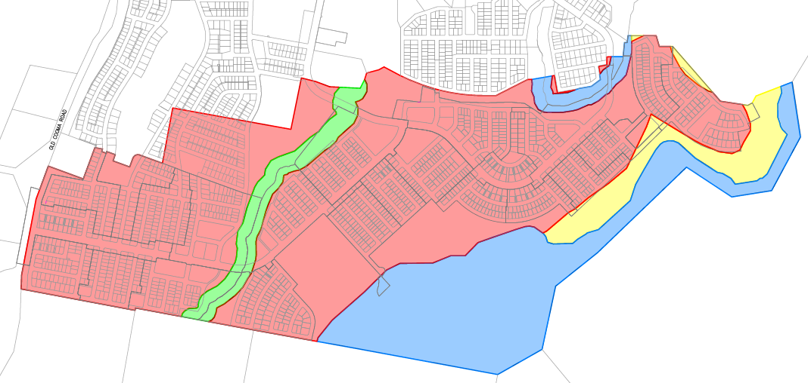Figure 42 – Zoning map and subdivision layout | Yes
Clause 2.3 Zone Objectives and Land Use Tables
Zone R1 – General Residential  The objectives of the R1 – General Residential zone are:  - To provide for the housing needs of the community.  - To provide for a variety of housing types and densities.  - To enable other land uses that provide facilities or services to meet the day to day needs of residents.  - To ensure that buildings with non-residential uses have a bulk and scale that is compatible with the zone’s predominantly residential character.  - To promote walkable neighbourhoods and a sense of community.  - To ensure that where possible, development maintains existing bushland.  - To encourage medium to high density housing located in close proximity to the town and village centres.  The development proposes Torrens Title subdivision to create 1398 new residential lots, 14 superlots for future small lot housing, 3 Neighbourhood Centres over 5 lots and public reserves.  Neighbourhood centres will be located within each of the three neighbourhoods to provide for convenience retailing, community and business services to meet the daily needs of local residents (refer light blue NC3, 4 and 5 below)  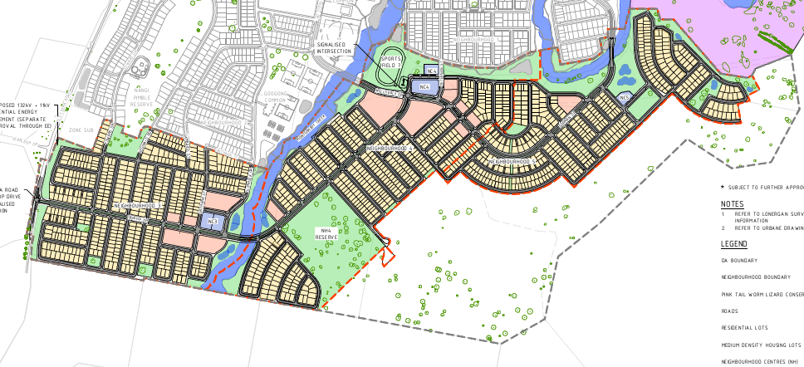  Figure 43 – Neighbourhood Centres  The proposal also involves subdivision works to prepare the land for the future development, comprising site preparation and grading, stormwater and drainage works, road construction, tree removal, public domain landscaping including car parking, signage and utilities augmentation. Also, the removal and relocation of the shearing shed to retain its local heritage values within a future park setting.  Dwellings and other buildings on the proposed lots will be subject to future development applications.  It is considered that the proposed development generally satisfies the objectives of the zone, specifically, the proposal provides for the housing needs of the community through the provision of lot releases in accordance with the Googong DCP.  The varying lot sizes will provide for a variety of housing types and densities. All residential lots for future dwelling houses are located within the R1 zone.  As part of this DA a number of open space areas and formal parks are proposed which will provide recreational opportunities to meet the day to day needs of residents. The proposed network of public open space will also promote walkable neighbourhoods which will contribute to a sense of community. Existing trees will be maintained where possible within the public open space networks.  The subdivision of land including the construction of roads and recreation areas and ancillary structures is permitted with consent in this zone. | Yes

Zone RE1 – Public Recreation  The objectives of the RE1 – Public Recreation zone are:  - To enable land to be used for public open space or recreational purposes.  - To provide a range of recreational settings and activities and compatible land uses.  - To protect and enhance the natural environment for recreational purposes.  There are bioretention basins and recreation areas located within the RE1 land which form part of the greater area known as “Googong Common”. The biodiversity basins will form part of the estate's stormwater management and will be able to be supported by Council’s Engineer.  Open space, walking tracks and pathways are proposed. This will enable public use of the land and are seen as a compatible use which suits the natural landscape. Active and passive recreational opportunities include footpaths, bridges and cycleways, sport fields in Googong Common with car parking and passive surveillance of activities and open space areas including park bench seating at regular intervals along walking paths.  The impacts on the Montgomery’s Creek riparian corridor have been considered by both Council staff as being acceptable and able to be satisfactorily minimised, managed, and mitigated.  The proposal involves appropriate riparian zone planting and/or rehabilitation that could be required under a Controlled Activity Approval under the Water Management Act 2000.  Given the above, the proposed development is therefore considered to be generally consistent with the objects of the RE1 zone. | Yes
Zone C2 –Conservation Zone  The application as lodged included lots within the C2 Environmental Conservation Zone.  The objectives of the C2 – Conservation zone are:  - To protect, manage and restore areas of high ecological, scientific, cultural or aesthetic values.  - To prevent development that could destroy, damage or otherwise have an adverse effect on those values.  - To protect threatened species and rivers, creeks and gully ecosystems within Queanbeyan.  - To identify and protect escarpment areas that enhance the visual amenity of Queanbeyan and possess special aesthetic or conservational value.  - To protect water quality by preventing inappropriate development within catchment areas.  The development has been designed to avoid areas of high ecological values in order to maintain their values. Threatened species and ecological communities have been identified and avoided where possible. The values of the local area will be maintained by avoiding areas of high ecological values identified in the BCAR. The Biodiversity Certificate Order issued under Part 8 of the Biodiversity Conservation Act provides that an assessment of likely biodiversity impacts is not required under Part 7 of the Biodiversity Conservation Act.  Following Council’s Information request the applicant has amended the proposal to ensure no development is within the C2 zone as shown in blue in the images below.  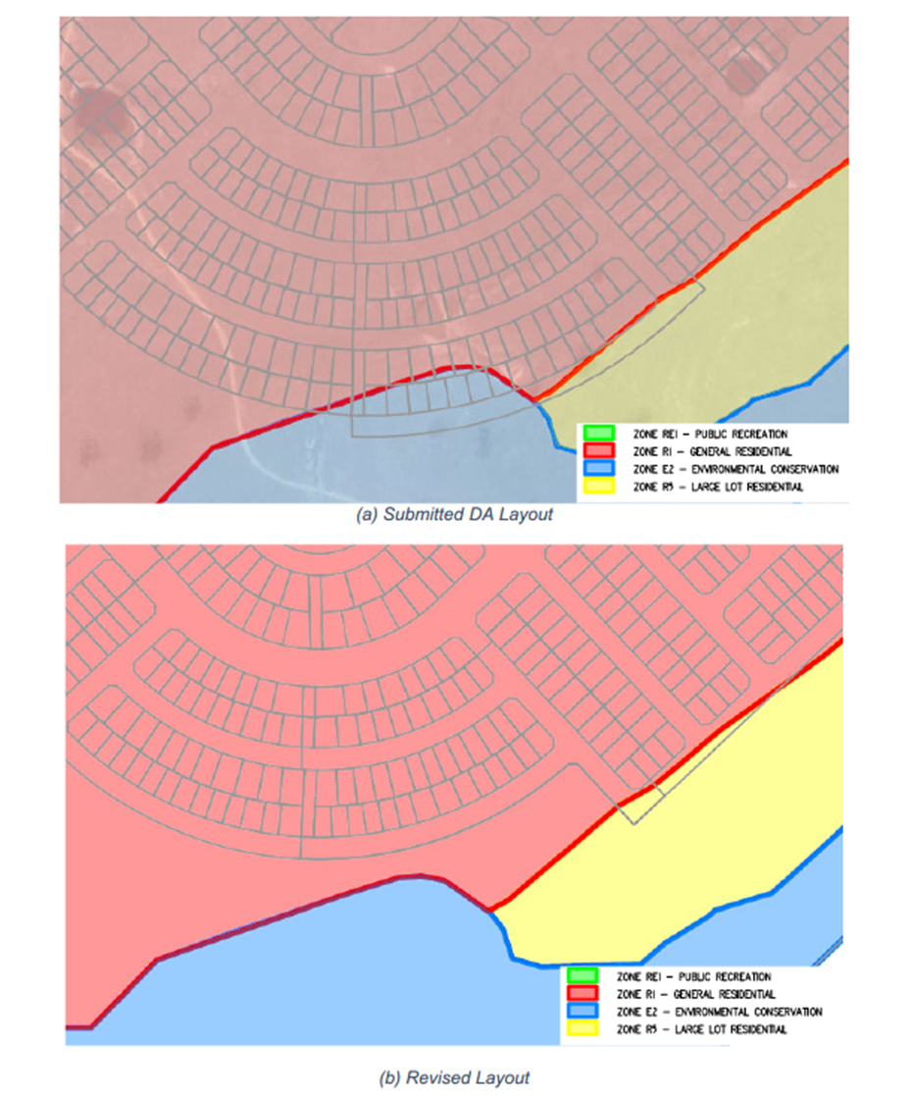  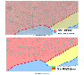  Figure 44 – Revised Lot Layout Clear of C2 (Formerly E2) Zone Boundary | Yes

Clause 2.5 Additional permitted uses for particular land
Pursuant to Schedule 1 – Additional permitted uses, part of the land is identified on the Googong Map as “Additional Development Area” and “Googong Common” (See Figure 16 – zoning map).  The additional permitted uses for Additional Development Area are “development for the purposes of advertising structures, business identification signs, business premises, food and drink premises, hotel or motel accommodation, kiosks, markets, office premises, service stations and shops.”  The Neighbourhood Centres are subject to the Additional Development Area controls. Future development applications will seek consent for a range of permitted uses.  The additional permitted uses for the Googong Common are “development for the purposes of cellar door premises, depots, entertainment facilities, function centres, garden centres, horticulture, landscaping material supplies, plant nurseries, resource recovery facilities, viticulture, waste or resource transfer stations and water recreation structures.”  The proposed development does not propose any of those permitted land uses at this stage. | Yes
Clause 2.6 Subdivision – Consent requirements
This clause states that the subdivision of land requires development consent. The proposed development includes the subdivision of land to create 1398 Torrens Title Lots for the purpose of future dwelling houses, 14 residue lots for future residential development and 5 Neighbourhood Centre lots across 3 Neighbourhood Centres.  This plan applies to the subject site and therefore subdivision is permitted with development consent on this land. | Yes
Clause 2.7 Demolition requires development consent
The proposal does not include consent for demolition. A structure will be dismantled for reuse. | Not applicable

Part 4 Principal Development Standards
Clause 4.1 Minimum subdivision lot size
This clause provides for a minimum lot size for the subdivision of land as identified on the Minimum Lot Size Map.  The objectives of Clause 4.1 are as follows:  - To ensure subdivision is sensitive to land, heritage and environmental characteristics (including water quality, native flora and fauna and places or items of Aboriginal and European heritage value);  - To ensure subdivision does not adversely impact on the functions and safety of main roads;  - To provide lots with areas and dimensions that enable the appropriate siting and construction of a building and associated works to minimise and avoid the threat of natural hazard (including bush fire, soil instability and flooding) and to protect significant vegetation and prominent or significant landscape qualities;  - To ensure new lots have an adequate water supply and can be provided with an effective means of disposal of domestic waste and adequately serviced; and  - To create lots that are compatible with the existing predominant lot pattern or desired future character of the locality and to minimise the likely adverse impact on the amenity of adjoining developments.  The proposal has been assessed against the objectives of Clause 4.1 as being satisfactory. Due regard has been given to the environmental constraints on the land, lot sizes and dimensions are appropriate for siting of structures, lots can be adequately serviced, and the proposal is generally compatible with the desired future character of the locality.  A variety of lot sizes are proposed to provide choice of densities and housing choice. The subdivision pattern creates a ‘sense of neighbourhood’ and promotes walking and cycling. Residential precincts are in good proximity to services and community facilities. The neighbourhood pattern utilises the residential development areas efficiently, promotes natural attributes and clearly defines public domain.  The majority of Googong Township, including the majority of the subject site, is identified on the LEP’s Lot Size Map as having a minimum lot size of 330m² except for the land within the southern boundary of NH3 must have a minimum lot size of 600m² and 80ha for the land zoned C2 – Environmental Conservation.  Pursuant to subclause 4.1(3) the size of any lot resulting from the subdivision of land is to be not less than the minimum size shown on the Lot Size Map.  The proposed residential lots range in size from 331m² to 1145m² and the proposed residue lots size are between 1810m² to 1.914ha.  The application as lodged included 2 lots partly within a 15,000m² minimum lot size area.  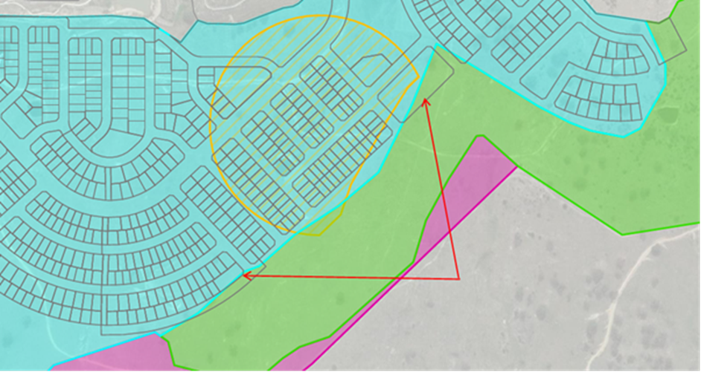  Lots proposed when application submitted partially within 15,000m2 lot size area.  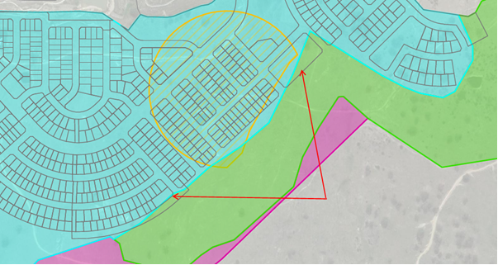  Figure 45  The Applicant amended the application to ensure no lots are within the 15,000m² minimum area.  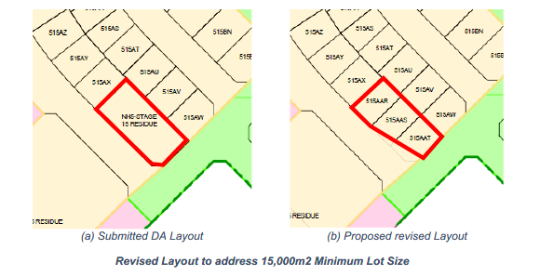  Figure 46 – Revised layout to address 15,000m² minimum lot size  A variation is sought for some lots to the southern edge of the estate as discussed below. | Yes
Clause 4.1D Variation to Minimum Lot Size
As mentioned above, the majority of Googong Township, including the subject site is identified on the Minimum Lot Size Map as having a minimum lot size of 330m². However, Clause 4.1D – Variation to minimum lot size, allows for certain land in Googong Township to be subdivided to create lots that are less than 330m² despite what is shown on the Minimum Lot Size Map.  The objective of Clause 4.1D – Variation to minimum lot size, is to provide opportunities for affordable medium density housing in appropriate locations.  The clause applies to the following land:  - Land within 200 metres of any land within Zone B2 Local Centre,  - Land identified as “Additional Development Area” on the Googong Map.  Sub-clause 4.1D (3) states:  (3) Despite clauses 4.1, 4.1AA and 4.1A, development consent may be granted for the subdivision of land to which this clause applies if:  - there will be at least 4 lots resulting from the subdivision, and  - the minimum lot size of each lot resulting from the subdivision is 130 square metres, and  - the development application for the subdivision includes a dwelling design for each lot.  The “Additional Development Areas” on the Googong Map are located in areas that are zoned R1 – General Residential which usually have a minimum lot size requirement of 330m². Within the “Additional Development Areas” and “land within 200 metres of Zone B2 Local Centre”, lots are permitted to have a minimum size of 130m². These have been identified to allow for a transition zone of medium density residential development, (lots between 130m² and 330m²), in close proximity to Neighbourhood Centres. | Yes
Part of the subject site is located within the mapped Additional Development Area and within 200 metres of Zone B2 Local Centre.  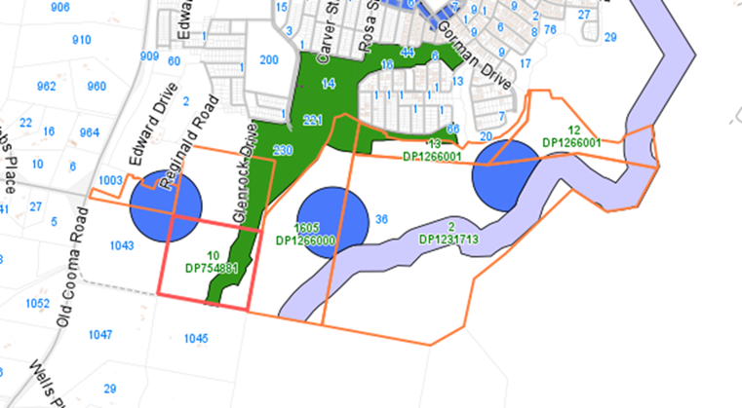  Figure 47 – Additional Development Areas (blue circles)  The proposal involves the creation of superlots that will allow further subdivided for small lot housing purposes. Approvals for those lots are subject to future development applications.  It is considered that the proposed development generally satisfies the requirement of this clause. | Yes
Clause 4.3 Height of building
The height of any building is not to exceed the maximum height shown for the land on the Height of Buildings Map. The proposed development does not involve the erection of any buildings. The proposed development complies with this clause. | Not  applicable
Clause 4. 4 Floor Space Ratio
The maximum floor space ratio (FSR) for a building on any land is not to exceed the FSR shown for the land on the Floor Space Ratio Map. No buildings are proposed as part of this application. Floor Space Ratio will be considered in future applications for land uses at that time. | Not  applicable
Clause 4.6 Variation – Minimum Lot Sizes
The proposal incorporates a request pursuant to clause 4.6 of the QLEP 2012 to vary the minimum lot size requirement under clause 4.1 – minimum subdivision lot size for 81 lots.  The subject lots are located on the southern boundary of Neighbourhood 3. The variation reduces lot sizes down from a minimum of 600m² to 330m².  The development still retains 600m² minimum lots on the edge of the subdivision site to serve as a buffer to the rural zoned land to the south.  This variation is discussed in additional detail at the end of the QLEP tables below.  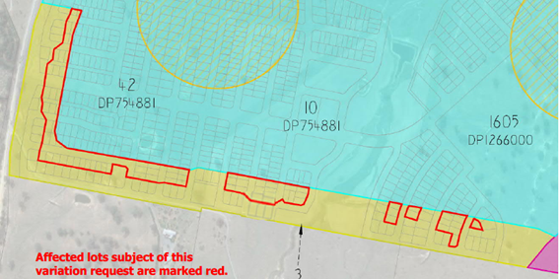  Figure 48 – Lots proposed less than the minimum lot size in red outline | Yes
Part 5 Miscellaneous Provisions
Clause 5.3 Development near zone boundaries
The objective of this clause is to provide flexibility where the investigation of a site and its surroundings reveals that a use allowed on the other side of a zone boundary would enable a more logical and appropriate development of the site and be compatible with the planning objectives and land uses for the adjoining zone. This clause applies to so much of any land that is within the relevant distance of a boundary between any 2 zones. The relevant distance is 20 metres.  The clause does not apply to land in the R1 General Residential Zone and no residential development is proposed within the recreation or conservation zones subject to this application. | Not  applicable

Clause 5.10 Heritage conservation
The objectives of this clause are as follows:  - To conserve the environmental heritage of Queanbeyan,  - To conserve the heritage significance of heritage items and heritage conservation areas, including associated fabric, settings and views,  - To conserve archaeological sites,  - To conserve Aboriginal objects and Aboriginal places of heritage significance.  Environmental Heritage  Heritage items and archaeological sites are listed in Schedule 5 of the LEP and heritage conservation areas are shown on the LEP Heritage Map.  The Shearing Shed Complex at Googong was originally listed as a local heritage item when Queanbeyan Local Environmental Plan 2012 (QLEP2012) was notified (gazetted) and was informed by a Heritage Study previously undertaken in 2003. At that time, the shearing shed and a number of other related structures on the site were largely intact and collectively identified as the ‘Shearing Shed Complex’. These included the shearing shed, a shearers quarters, kitchen/cottage, meat safe, sheep shelter and shed.  The listing citation notes that the site is representative of a range of activities from the late nineteenth century through to the present day. The shearing shed, the largest surviving item on the site, is still in use and has fair integrity. The citation dates it to the middle of the 20th century when it replaced an earlier shed in the same location that burnt down in 1950/51.  As a result of the loss of most of its significant attributes and context it is considered the listing now falls below the listing threshold. Council recently agreed to delist the shearing shed from the QLEP.  The approximate location of the shearing shed is shown below in Figure 50. 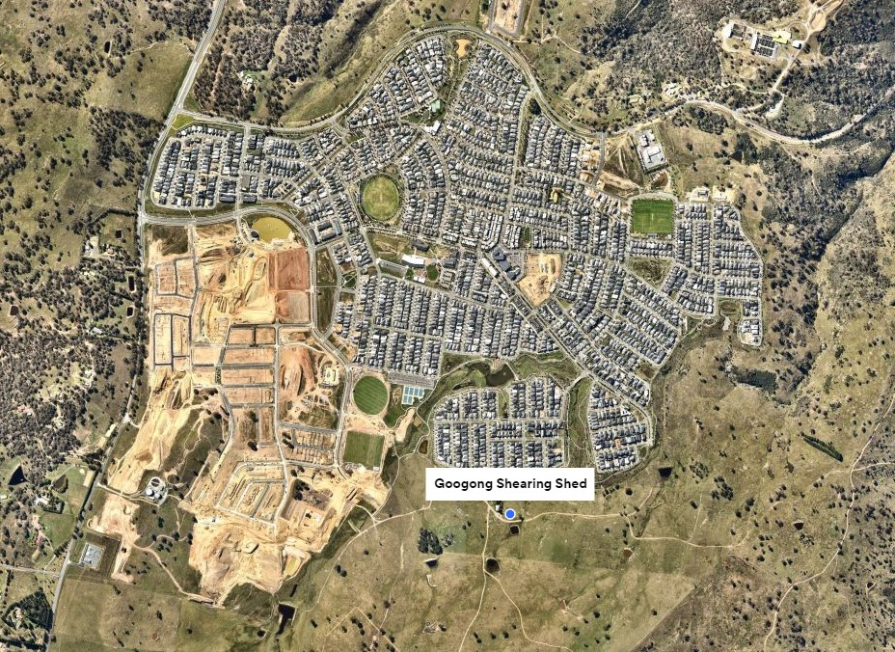  Figure 49 - Shearing Shed Location (aerial)  Council is to consider the heritage significance of the heritage item including its fabric, settings and views prior to a determination.  Council’s Heritage Advisor recommends:  - An interpretation feature is located in the Common close to the current position of the shearing shed and yards, and  - To relocate the shearing shed and develop it for communal use including as a children’s play structure.  These are sought through conditions. | Yes – conditions
Archaeological Sites  Sub-clause 5.10(7) - Archaeological Sites requires the consent authority, before granting consent for the carrying out of development on an archaeological site, to:  - Notify the Heritage Council of its intention to grant consent, and  - Take into consideration any response received from the Heritage Council within 28 days after the notice is sent.  archaeological site means a place that contains one or more relics.  relic means any deposit, artefact, object or material evidence that:  - relates to the settlement of the area that comprises New South Wales, not being Aboriginal settlement, and  - is of State or local heritage significance.  Archaeological investigations have been carried out for Neighbourhood 3, 4 & 5 and reports submitted for the proposed development.  The Archaeological Assessment and Aboriginal Cultural Heritage Assessment (ACHAR) prepared by Navin Officer dated September 2021 found that Aboriginal items of significance were found within the subject site. Eight previously unrecorded Aboriginal sites were located during the survey of the study area and five previously recorded sites were again identified during the current investigation.  These sites are located within the area proposed to be impacted by the proposed development. The proposed management actions recommended in the submitted ACHAR and as conditioned by National Parks & Wildlife are considered appropriate. | Yes
The ACHAR recommended that the management and mitigation strategies outlined in the table below be adopted and that:  - Where possible all sites should be avoided;  - Approval for an AHIP should be sought prior to the commencement of the proposed works;  - No further actions required at GAPAD20 and GAPAD22  - Where an Aboriginal site is within or adjacent to the footprint of proposed works, and these works are judged to have the potential to inadvertently impact the site, the boundary of this site should be marked as a ‘no-go zone’ on all maps used by Googong Township Pty Ltd and their contractors during construction.  - Where the potential for inadvertent impacts is high, physical fences should be placed on the boundaries of the no-go zones.  - Information in this report relating to the exact location of Aboriginal sites should not be published or promoted in the public domain;  - A program of archaeological salvage (collection) should be conducted for surface Aboriginal sites listed in Table 9-1 prior to the commencement of the construction of Googong Neighbourhood 3-5.  - The methodology for site collection provided in Appendix 3 should be implemented for this collection;  - The research program into surface site impacts from farming activities detailed in NOHC 2016a and implemented as part of AHIP No. C0001687 should be continued for the Googong project;  - The protocols for the unanticipated discovery of archaeological material and suspected human remains (presented in Appendix 5) be implemented as necessary during activities involving ground surface disturbance and excavation; and  - This report should be provided to DPIE for its information and records.  Sub-clause 5.10(8) requires the consent authority, before granting consent for the carrying out of development in an Aboriginal place of heritage significance to:  - Consider the effect of the proposed development on the heritage significance of the place and any Aboriginal object known or reasonably likely to be located at the place by means of an adequate investigation and assessment (which may involve consideration of a heritage impact statement), and  - Notify the local Aboriginal communities, in writing or in such other manner as may be appropriate, about the application and take into consideration any response received within 28 days after the notice is sent. | Yes
Archaeological investigations relating to Aboriginal Cultural Heritage have been carried out for Neighbourhood 3, 4 & 5. Archaeological Assessment and Aboriginal Cultural Heritage Assessment (ACHAR) prepared by Navin Officer Heritage Consultant (NOHC) dated September 2021 was submitted for the subject application.  Any work that will impact on known Aboriginal objects requires an Aboriginal Heritage Impact Permit (AHIP) to be issued under the National Parks and Wildlife Act 1974.  Pursuant to Section 91(2)(a) of the Environmental Planning and Assessment Act 1979 the application was referred to Department of Premier and Cabinet (Heritage NSW) as Integrated Development. Given there are known Aboriginal objects on the site. General Terms of Approval (GTAs) were sought.  The Department issued their GTAs for the proposed development on 25 January 2022 subject to a number of conditions. A condition will be imposed on the development consent (if granted) requiring compliance with the GTAs. | Yes
Part 6 Urban release areas
Clause 6.1 Arrangements for designated state and Territory public infrastructure
This clause requires satisfactory arrangements to be made for the provision of designated State and Territory public infrastructure before the subdivision of land in an urban release area.  The Development Application was therefore referred to the NSW Planning and Environment requesting the issue of a Satisfactory Arrangements Certificate.  A Secretary’s Certificate - Satisfactory Arrangements for designated State Public Infrastructure has been issued on 14 April 2022 for the proposed subdivision of Neighbourhoods 3, 4 & 5. | Yes

Clause 6.2 Public utility infrastructure
This clause states that development consent must not be granted for development on land in an urban release area unless the Council is satisfied that any public utility infrastructure that is essential for the development is available or that adequate arrangements have been made to make that infrastructure available when it is required.  Council’s Development Engineer has assessed the provision of public utilities as being satisfactory. The site is able to be serviced with reticulated potable and recycled water, sewer and stormwater. Electricity and telecommunications supply will be available for each stage. These services and other infrastructure must be completed prior to the release of any Subdivision Certificate for the proposed lots.  Work on Stage D of the Water Recycling Plant and Stage D of the water reservoirs has commenced, and Council’s Engineer confirms the completion of these facilities will correspond with need as the estate develops. Council will not issue subdivision certificates until the relevant works are completed and the facilities commissioned in accordance with the existing Local Planning Agreement (LPA). |  | Yes
Clause 6.3 Development control plan
The objective of this clause is to ensure the development on land in an urban release area occurs in a logical and cost effective manner, in accordance with a staging plan and only after a development control plan that includes specific controls has been prepared for the land.  Development consent must not be granted for development on land in an urban release area unless a development control plan that provides for matters specified in the clause has been prepared.  Googong Development Control Plan came into effect in November 2010, with several amendments made since then. It contains the Googong Master Plan (Part 3) and Structure Plan for Neighbourhoods 3, 4 & 5. Refer to the Development Control section of this Report for further commentary. |  | Yes
Clause 6.5 Development near Googong Dam Foreshores
This clause is considered relevant given the subject site is mapped as being close to the Googong Dam Foreshores (refer purple in image below).  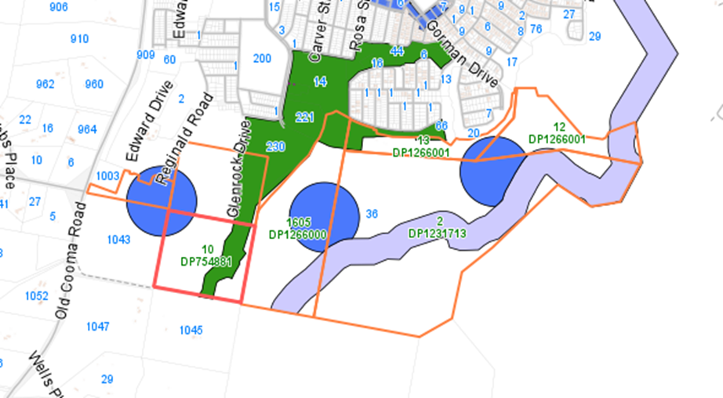  Figure 50 - Googong Dam Foreshores (purple)  The objective of this clause is to protect the Googong Dam water supply catchment from inappropriate development that may compromise water supply and quality.  (2) Development consent must not be granted to the erection of a building on land identified as “Googong Foreshore Buffer Area” on the Googong Map unless the consent authority is satisfied that—  (a) the building and associated infrastructure envelope identified for each lot will be appropriate, having regard to the land capability and objective of this clause, and  (b) the development will incorporate an appropriate management regime relating to bush fire control, vegetation clearing, access provision, fencing controls, recreational uses, feral animal and weed control, management of grazing, keeping of animals and landscaping with indigenous species.  Approximately 40 lots are shown within the mapped buffer area.  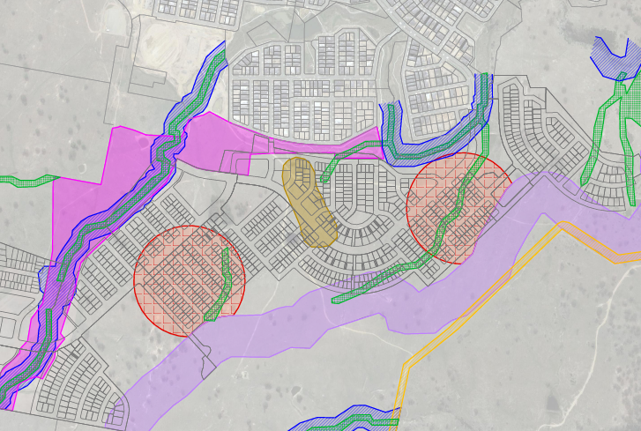  Figure 51  As a condition of the Environment Protection and Biodiversity Conservation Act for Googong the Applicant was required to prepare an interface management strategy for approval by the Minister for the Environment. The Googong Foreshores Interface Management Strategy (GFIMS) was prepared and approved accordingly.  The GFIMS divides the Googong foreshores buffer area into two zones, or Management Areas MA3 and MA4. Residential development is not permitted in the MA3 area but is permitted in the MA4 area subject to certain controls. The subject application proposes lots within the MA4 area only.  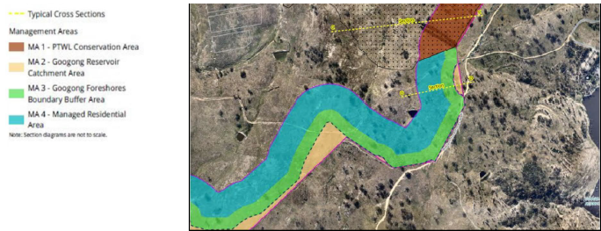  Figure 52  Council is satisfied that compliance with the GFIMS satisfied this clause. |  | Yes
Part 7 Additional Local Provisions
Clause 7.1 Earthworks
The objective of this clause is to ensure that any earthworks will not have a detrimental impact on environmental functions and processes, neighbouring uses or heritage items and features of the surrounding land.  Earthworks will be associated with site preparation and grading, and infrastructure construction works including roads construction works within the proposed residential lots and open spaces. Based on the submitted SEE, batter grades are typically 1 in 6 or less to permit driveway access with cut/fill on residential blocks typically less than 2m.  Some lot regrading is proposed to eliminate inter allotment or back of lot drainage. Final design of the grading and earthworks will be resolved in detail design and subsequent subdivision works certificate approval.  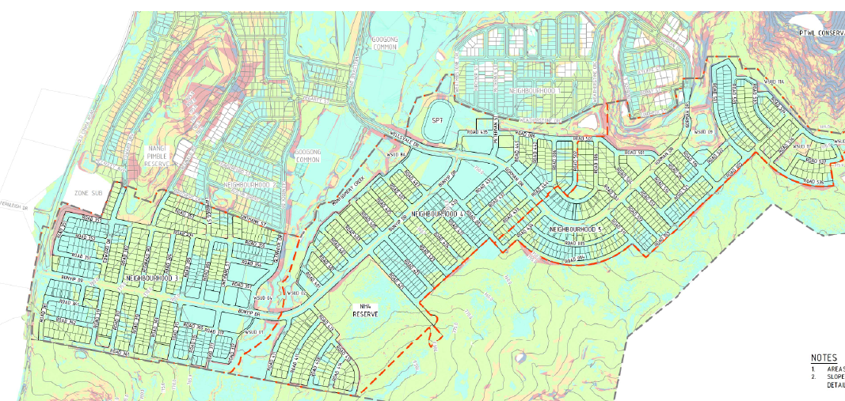  Figure 53 – Grading Plan  This development application was accompanied by a geotechnical assessment, stormwater management and drainage report, engineering designs for stormwater management, site grading plans, riparian corridor offset plans, existing slope plans and proposed design contours plans post earthworks.  Provided recommended conditions of consent are complied with (if granted), the proposed development generally satisfies the objective of this clause. |  | Yes – conditions
Before granting development consent for earthworks the consent authority must consider the following matters:  - The likely disruption of, or any detrimental effect on, drainage patterns and soil stability in the locality of the development,  The existing slopes within the site are generally between 0 - 15%. The residential lots will not exceed the maximum 15% as per Googong DCP requirements, except for one lot in Neighbourhood 3 shown at 15.16%.  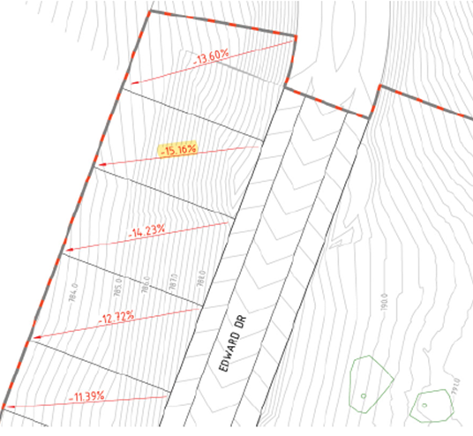  Figure 54 - Slope grade with one above 15% in Neighbourhood 3  Proposed site preparation and earthworks will not have an adverse impact on soil stability. A Stormwater Report prepared by Spiire dated September 2021 advises:  “The site produces stormwater run-off which flows to Neighbourhood 1A (NH1A) and associated NH1A stormwater infrastructure as well as surrounding future neighbourhoods.  The hydrological and hydraulic modelling has shown that the proposed residential subdivision and supporting roads can be constructed while meeting QPRC requirements for stormwater quantity and quality management. The objectives and performance targets (quantity and quality) are achieved by using stormwater quality improvement devices throughout the subdivision, with a large pond, bio-retention basins, bio-swales and rainwater tanks.”  If development consent is granted conditions will ensure protection of drainage patterns.  - The effect of the development on the likely future use or redevelopment of the land,  The proposed development is consistent with the identified future urban use of the land.  - The quality of the fill or the soil to be excavated, or both,  A Geotechnical Investigation Report prepared by Geotechnique was submitted for the proposed development. The quality of the soil to be excavated has been identified in the Report as being satisfactory. No visual signs of salinity or salinity indication vegetation were observed during the site investigation as per Douglas Partners’ statement. Previous stages of the Googong residential development have not encountered saline soils. Therefore, it is considered that provided best land development practice is adopted (as for the other stages of Googong) that there would be no significant risk of salinity.  The soil has some potential for re-use on site as fill, however, there will be a need for the use of imported fill material for the engineering works. The recommendations of the Report will need to be adhered to and will be conditioned should development consent be granted. |  | Yes
- The effect of the development on the existing and likely amenity of adjoining properties,  The site works are unlikely to impact on the existing and likely amenity of adjoining rural and residential properties provided that appropriate conditions are imposed and complied with.  - The source of any fill material and the destination of any excavated material,  The source or destination of any fill material will be considered at the final engineering design stage.  - The likelihood of disturbing relics,  The site accommodates items of Aboriginal Heritage. Subdivision works have the potential to disturb relics. The application has been supported by an Aboriginal Heritage Assessment which determined that the proposed development is able to be supported without significant impact to local heritage values.  Also, the NSW Office of Environment and Heritage (OEH) have issued an Aboriginal Heritage Impact Permit (AHIP) (25 January 2022) to permit the disturbance or moving Aboriginal objects identified in the AHIP. If any additional artefacts or objects are identified during excavation, a Construction Management Plan will provide guidance on the management of these finds.  - The proximity to, and potential for adverse impacts on, any waterway, drinking water catchment or environmentally sensitive area,  Groundwater seepage was encountered in 3 pits during the field investigations by Douglas Partners. The seepage in one pit was entering from the direction of an adjacent pond. No groundwater was observed in the remaining test pits. It is noted that the test pits were backfilled immediately following excavation precluding longer term monitoring of groundwater levels.  The NSW Department of Primary Industries – Water has issued General Terms of Approval for works in the vicinity of Montgomery’s Creek. Impacts on this waterway will be further assessed and managed as part of a Controlled Activity Approval required to be obtained under the Water Management Act 2000. As stated above, the Calibre Consulting’s Stormwater Management and Drainage Report advises that the development can meet standard stormwater quantity and quality management guidelines to ensure no adverse impacts will occur on any watercourse, drinking water catchment or environmentally sensitive area.  - Any appropriate measures proposed to avoid, minimise or mitigate the impacts of the development,  Appropriate measures will be conditioned should development consent be granted. |  | Yes
- The proximity to and potential for adverse impacts on any heritage item, archaeological site, or heritage conservation area.
The site includes an item currently listed as having heritage significance identified in the QLEP 2012. Despite Council agreeing to remove it from the QLEP that process has not yet concluded.
The NSW Office of Environment and Heritage (OEH) have issued an Aboriginal Heritage Impact Permit (AHIP) on the April 2022 to disturb or move the Aboriginal objects identified in the AHIP. If any additional artefacts or objects are identified during excavation, a Construction Management Plan will provide guidance on the management of these finds.
In summary, the proposed earthworks will not have any detrimental impact on environmental functions and processes, neighbouring uses or heritage items and features of the surrounding land provided that any recommended consent conditions are complied with.

Clause 7.2 Flood Planning
This clause is not considered relevant to the proposed development as the site is not identified on the flood planning map and is not land that is at or below the flood planning level. | N/A
Clause 7.3 Terrestrial biodiversity
Based on the submitted Biodiversity Assessment prepared by Capital Ecological (originally April 2021, amended October 2021) with the implementation of the proposed measures to avoid, minimise and mitigate impacts upon biodiversity values as outlined in an Agreement between the landowner and Minister for Planning and Environment the impact on any threatened species, populations or ecological communities listed pursuant has been deemed to be acceptable. As a result, approval has been issued under Part 8 of the Biodiversity Conservation Act by the Minister for Planning and Environment with compliance also sought through a condition of consent. | Yes
The proposal identified 5 trees classified as having “exceptional value”. These are all proposed to be retained. Fourteen (14) of the 21 ‘high quality’ trees identified will be retained with 7 proposed to be removed. Of the 26 trees identified as having either high or exceptional value, 19 will be retained with 7 removed.  Trees proposed to be retained are shown in the Landscape Master Plan for each Neighbourhood.  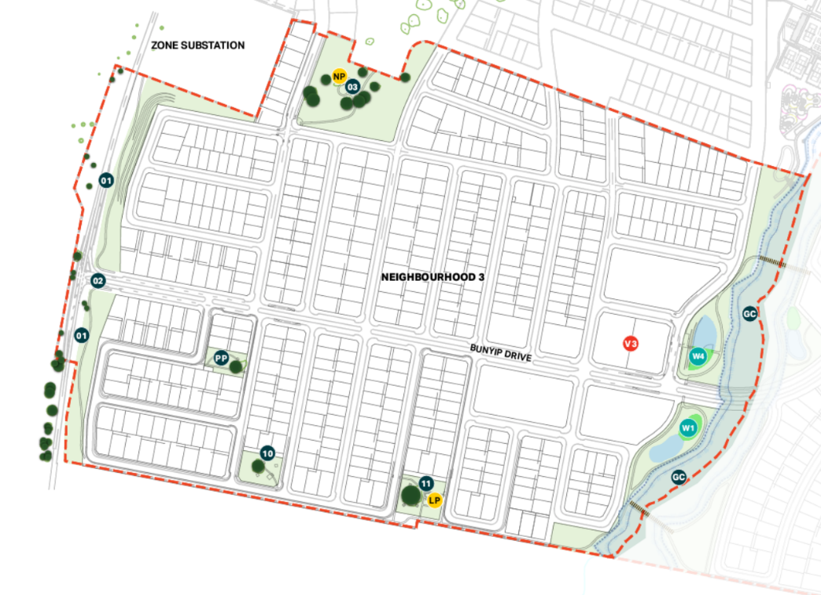  Figure 55 - Landscape Master Plan Neighbourhood 3  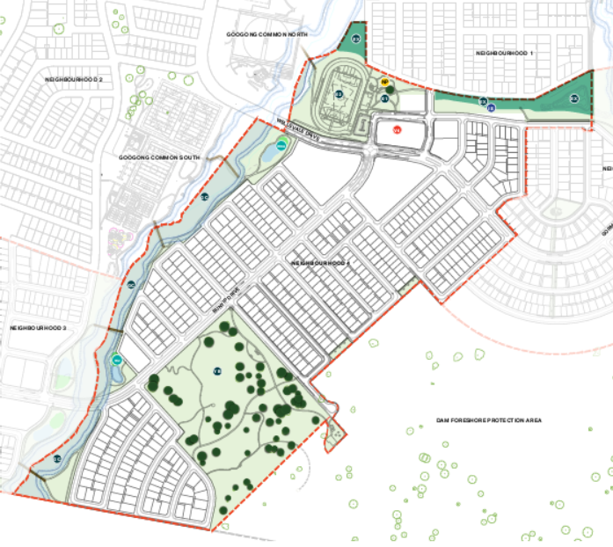  Figure 56 - Landscape Master Plan Neighbourhood 4  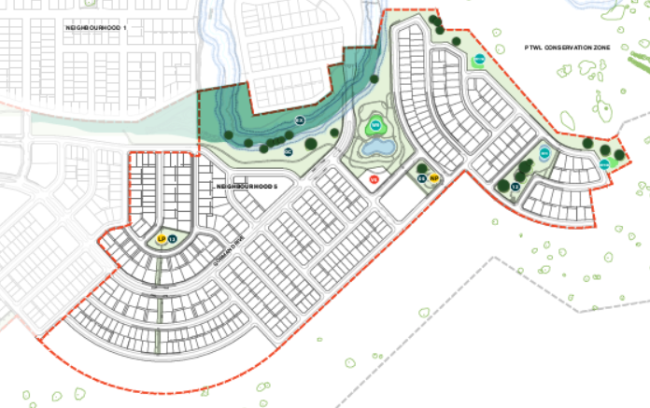  Figure 57 - Landscape Master Plan Neighbourhood 5  Street trees will be both natives and exotic species. According to the Street Tree Masterplan the main thoroughfares will include Acers with Eucalyptus alba. The tree species selected with the retention of existing trees will contribute to the aesthetic values of the estate. The planting will integrate with the existing Googong development and will be appropriate to its use including for avenue planting, recreational areas and riparian corridor or other water elements including biodetention or sedimentation basins.  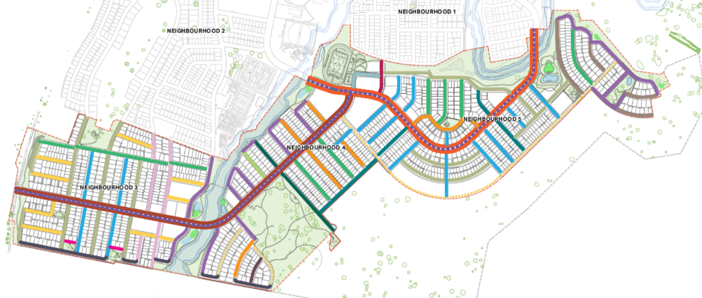  Figure 58 – Street Tree Masterplan  Council’s Tree Management Officer has confirmed the proposed planting will meet the Street Tree Principles in the Googong DCP. | Yes

The proposed development is considered to have been designed and sited to avoid any significant adverse environmental impact. The development of Neighbourhood 3-5 of Googong Township has been informed by numerous environmental studies and technical reports which have identified the subject site as being suitable for the proposed development. Conditions of consent (if granted) will be imposed to ensure that the development is managed to avoid any adverse environmental impacts from subdivision works. |  | Yes
Clause 7.4 Riparian land and watercourses
The objective of this clause is to protect and maintain the following:  (a) water quality within watercourses,  (b) the stability of the bed and banks of watercourses,  (c) aquatic and riparian habitats,  (d) ecological processes within watercourses and riparian areas.  Part of the site is identified as “Watercourse” on the Riparian Lands and Watercourses Map and is within 40 metres of Montgomery’s Creek, which runs through the south-east corner of the site (See Figure 18 below). Therefore the proposal was referred as Integrated Development to the NSW Department of Primary Industries (DPI) – Water under Section 91 of the Water Management Act 2000 for works within 40 metres of Montgomery’s Creek. The Water Management Act 2000 allows for works within riparian corridors provided they undergo the required assessment and obtain the necessary approvals / licenses.  DPI – Water issued their General Terms of Approval for the proposed development. Should development consent be granted these are to be included as an attachment to the consent and conditioned to be complied with.  Before determining the development application the consent authority must consider:  - Whether or not the development is likely to have any adverse impact on the following:  - the water quality and flows within the watercourse,  - aquatic and riparian species, habitats and ecosystems of the watercourse,  - the stability of the bed and banks of the watercourse,  - the free passage of fish and other aquatic organisms within or along the watercourse,  - any future rehabilitation of the watercourse and riparian areas.  It is considered that the issuing of General Terms of Approval by the DPI Water for works within the Montgomery’s Creek riparian corridor indicates that it is unlikely that the proposed development will have any adverse impacts on the items listed above.  - Whether or not the development is likely to increase water extraction from the watercourse.  The proposed development does not include or require any extraction of water from Montgomery’s Creek.  - Any appropriate measures proposed to avoid, minimise or mitigate the impacts of the development.  The applicant will have to obtain a Controlled Activity Approval under the Water Management Act 2000 before any works will be able to commence. Such an approval will contain appropriate mitigation and management conditions. |  | Yes – conditions

Further, development consent must not be granted unless Council is satisfied that:
- The development is designed, sited and will be managed to avoid any significant adverse environmental impact, or
- If that impact cannot be reasonably avoided—the development is designed, sited and will be managed to minimise that impact, or
- If that impact cannot be minimised—the development will be managed to mitigate that impact.

The proposed development is considered to have been designed and sited to avoid any significant adverse environmental impact. The development of Neighbourhoods 3-5 has been informed by numerous environmental studies and technical reports.

The impacts of the proposed works on the riparian corridor can be adequately minimised and mitigated through the administration of the Water Management Act 2000.
Clause 7.5 Scenic protection
This clause is not considered relevant to the proposed development as the site is not identified as “Scenic Protection Area” on the Scenic Protection Map. | N/A
Clause 7.6 Airspace operations
This clause states that if a development application is received and the consent authority is satisfied that the proposed development will penetrate the Limitation or Operations Surface, the consent authority must not grant development consent unless it has consulted with the relevant Commonwealth body about the application.  The ground level of the site penetrates the Operations Limitations Surface of the Canberra Airport. The application was therefore required to be referred to the Commonwealth Department of Infrastructure and Regional Development and the Canberra Airport. A Controlled Activity Approval under the Commonwealth Airports (Protection of Airspace) Regulations 1996 has been issued by the Commonwealth dated 21 January 2022 subject to the following conditions:  - The structures in the subdivision must not exceed a maximum height of 822 metres AHD or 20 metres AGL, inclusive of all lift over-runs, vents, chimneys, aerials, antennas, lightning rods, any roof top garden plantings, exhaust flues etc.  - Separate approval must be sought under the Regulations for any construction equipment (i.e. cranes) or other structures within this Googong site which will exceed the height of 822 metres AHD or 20 metres AGL. | Yes
Clause 7.7 Development in areas subject to aircraft noise
This clause is not considered relevant to the proposed development as the site is not located near the Canberra Airport or within an ANEF contour of 20 or greater. | N/A
Clause 7.8 Active street frontages
This clause is not considered relevant to the proposed development as the site is not identified as “Active street frontage” on the Active Street Frontages Map”. | N/A
Clause 7.9 Essential services
Development consent must not be granted to development unless the consent authority is satisfied that any of the following services that are essential for the development are available or that adequate arrangements have been made to make them available when required:  a) the supply of water,  b) the supply of electricity,  c) the disposal and management of sewage,  d) stormwater drainage or on-site conservation,  e) suitable vehicular access.  Council’s Development Engineer has assessed the proposed development and confirmed that adequate services are available (or can be made available) subject to the imposition of recommended conditions.  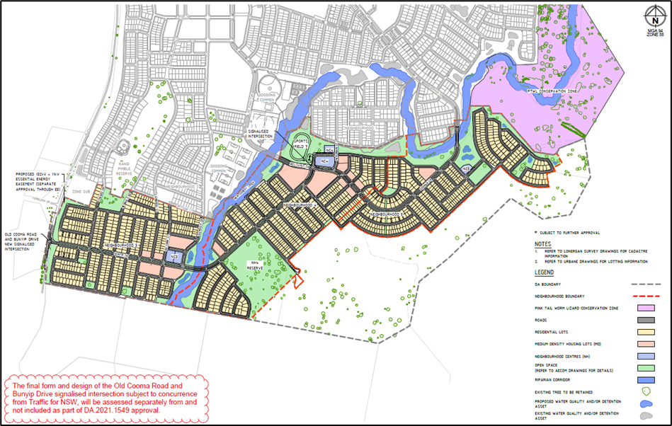  Figure 59  Water  There is a water supply agreement in place with the ACT Government for the supply of water to Googong and the Queanbeyan area more broadly. The supply of water is consistent with the memorandum of understanding on cross border region settlement signed by the ACT and NSW governments.  The proposal includes integrated water cycle management and reticulated non-potable water supply consistent with the existing Googong development.  The application was referred to the Natural Resources Regulator who supports the proposal with conditions. Water quality will be maintained to NRAR’s and Council’s satisfaction through those conditions.  Referring to Section 8 of the Civil Infrastructure Design Report as prepared by Spiire dated 14 September 2021, there is provision for a designed water reticulation network for NH3, NH4 and NH5.  Reservoirs  Water Reservoirs supplying the Googong Township are located on Hill 800 in the Nangi Pimble Reserve. The potable water tanks are supplied by the Icon Water trunk water supply main via the Googong Bulk Water Pump Station. The recycled water tanks are supplied by the Googong Water Recycled Plant (WRP) located along Googong Road, north of NH1B. The design parameters of the final upgrade of the Nangi Pimble water reservoirs to accommodate the total Equivalent Population (EP) of 18,850 has been outlined in the following table;  Hill 800 Reservoir details Potable Reservoir 1 Potable Reservoir 2 Recycled Reservoir  Full Operating Volume 1.9ML 4.0ML 8.5ML  Minimum Operating Level RL 798.86 RL 798.87 RL 799.10  Top Water Level RL 804.59 RL 804.61 RL 805.00  The Water Recycling Plant is expected to undergo its final stage of upgrades to accommodate the ultimate EP of 18,850 during the progression of NH3, NH4 and NH5.  Pressure Zones  The water reticulation network consists of three separate pressure zones; reduced pressure zone, intermediate pressure zone and boosted pressure zone. The three pressure zones are detailed in the following table;  Pressure Zone parameters Elevation Range Location Zone Serviced By  Reduced Pressure Zone RL 790 to RL 760 NH1 & NH5 Pressure Reducing Valves  Intermediate Pressure Zone RL 760 to RL 725 NH1, NH2 & NH4 Direct Connection to Reservoirs  Boosted Pressure Zone RL 725 to RL 710 NH2, NH3 & NH4 Booster Pumps Located at Reservoirs  The three pressure zones have been designed to comply with Council’s Water Reticulation Design standards.  The booster pumps required to supply the boosted zone located within NH2, NH3 and NH4 have been designed with the following parameters:  - Potable Water Pump – 30L/s at 25m Head  - Recycled Water Pump – 60L/s at 25m Head  A total of three Pressure Reducing Valves (PRV) are required to supply the reduced pressure zone located within NH1 and NH5. Two existing below ground chamber PRV’s have been constructed and are currently operational with the third and final below ground chamber PRV proposed in NH5.  Reticulation  The reticulation system for NH3 is located wholly within the boosted zone and is serviced via connections to the existing NH2 infrastructure. A distribution main along Lambrigg Road has been designed to supply the proportion of boosted zone located within NH4. No zone valves are required within NH3.  The reticulation system for NH4 consists of both the boosted and intermediate pressure zones. The boosted zone is supplied by the distribution main along Bunyip Drive from NH3 with the pressure boundary being configured to eliminate the need for zone valves and dead-end mains. The intermediate zone is supplied by a distribution main that is connected to the Nangi Pimble Reservoirs which is located along Hungerford Street and Glenrock Drive in NH2. This distribution main will cross Montgomery Creek and run along Road 401, supplying NH4. The second connection proposed for the intermediate zone is at Wellsvale Drive with main feeders running along Bunyip Drive and Gorman Drive to service the zone. A non-return valve is required along McTernan Street to promote water flows servicing the existing NH1B Stages 4, 6 and 8 (Montgomery Rise) from the currently constructed NH1B Gorman Drive mains and not via the Wellsvale Drive connection.  The reticulation system for NH5 consists of both the intermediate and reduced pressure zone boundary. Neighbourhood 5 will connect to the reticulation main connected to an existing PRV along Gorman Drive in NH1B. A second connection to the proposed reduced pressure zone within NH5 is located along Road 003 via the third and final PRV underground chamber. The location of the pressure reduced zone boundary requires one zone valve located on Road 501. The intermediate zone will be connected to existing infrastructure supplied from distribution mains located along Bunyip Drive and Gorman Drive.  For lots located within the vicinity of the proposed zone boundaries there is the possibility of achieving pressures greater than permitted at the meter. It is at the lot purchaser's discretion on whether a PRV at the meter is preferred to reduce the pressure.  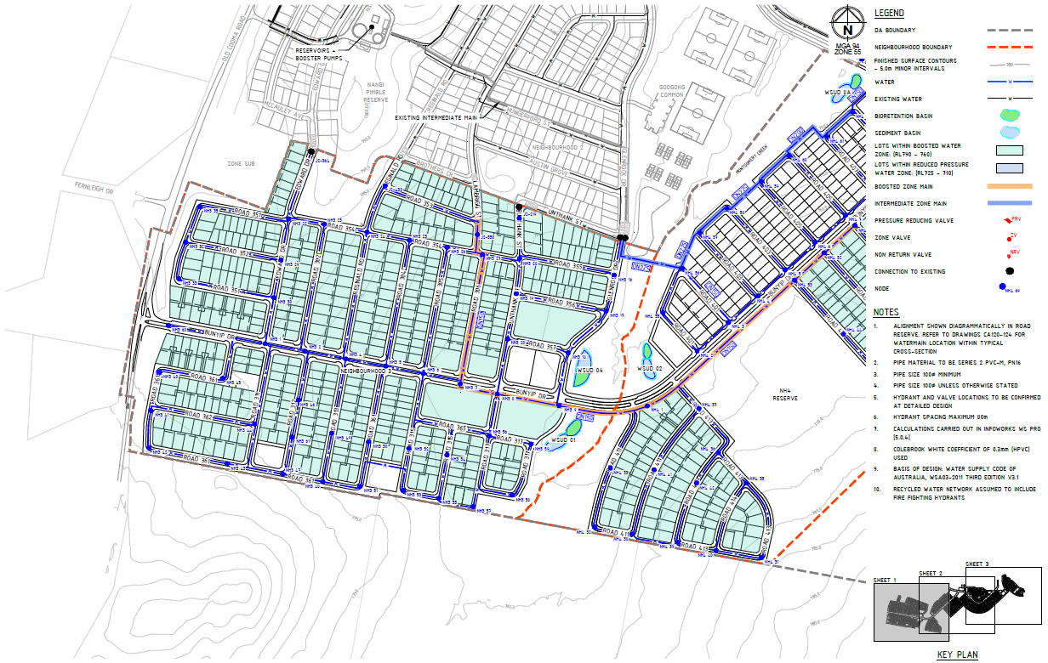  Figure 60 - Potable Water Concept Plan Network NH3 and NH4  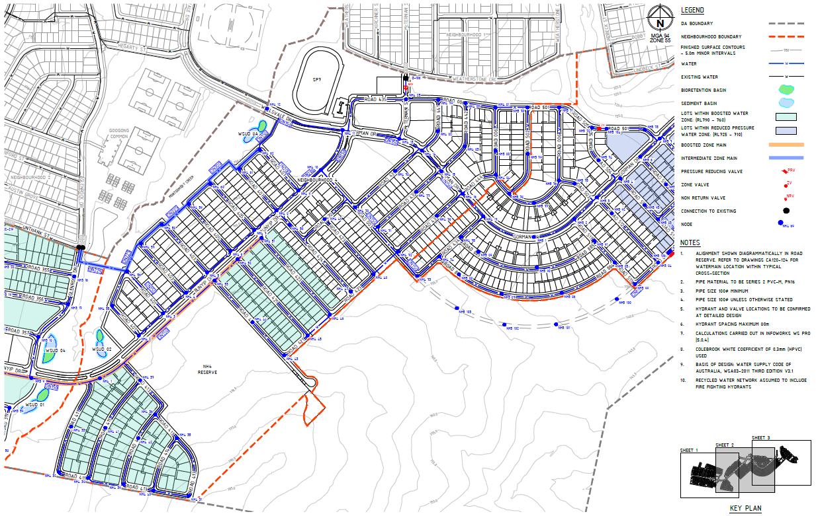  Figure 61 - Potable Water Concept Plan Network NH3, NH4 and NH5  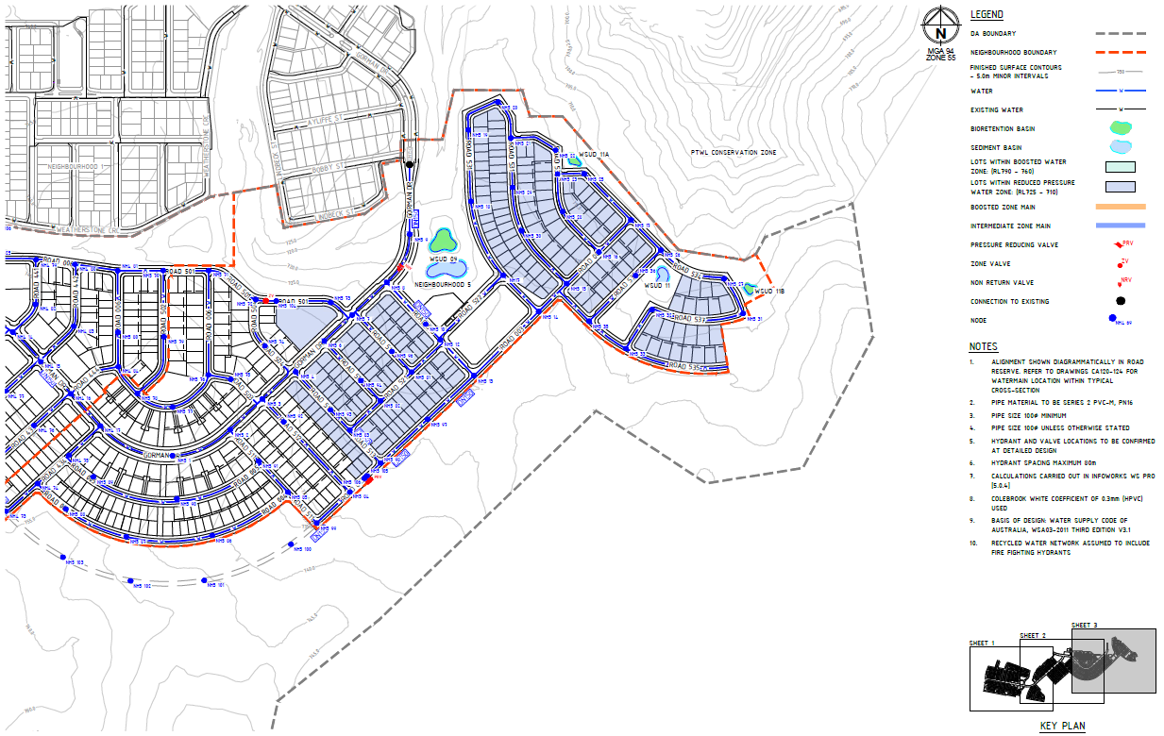  Figure 62 - Potable Water Concept Plan Network NH5  A Fire-fighting connection will be required at the end of Fernleigh Drive by extending the 150mmØ reticulated water main along Road 351 to approximately node NH3-35 and then provide a crossing to the western side of Old Cooma Road landscaping for future connection. This was confirmed in GTPL/PEET letter dated 1 April 2022.  The main heavy vehicle access to the reservoirs will be via Bunyip Drive onto Edward Drive (ingress and egress). Reservoir access must allow manoeuvring of a 60T crane up around the bend to get up. Articulated vehicle (semi-trailer) access will also be required along this access road, noting the main vehicle will be a 12.5m HRV. This was confirmed in GTPL/PEET letter dated 1 April 2022.  All services to be copper. All stop valves to be Clockwise Close (CC).  Water reticulation for NH3, NH4 and NH5 shall be designed and constructed in accordance with the requirements specified in Council’s Water Reticulation Design and Construction Specifications, and where specified, the relevant requirements of the Water Supply Code of Australia. |  |  | Yes – conditions

Sewer
Referring to Section 7 of the Civil Infrastructure Design Report as prepared by Spiire dated 14 September 2021, the NH3, NH4 and NH5 sewer network is proposed to connect into the existing Googong sewer system at four separate locations;
- NH3 catchment is proposed to connect into the existing network through the 300mmØ main running along the west side of Montgomery creek.
- Catchments NH4-A, B & C are proposed to connect into the existing network through the 300mmØ main on the eastern side of Montgomery Creek which continues through to NH1B.
- NH4-D catchment is proposed to connect into the existing network through the 225mmØ main which extends south of NH1B.
- NH5 catchment is proposed to connect to the existing network at the 225mmØ main within NH1B. To enable connection into the existing network the proposed carrier main will cross the Gorman Drive bridge. The main is proposed to be located within the services void with a tie-rod and cradle pipe support under the bridge deck.
A series of nodes through NH3, NH4 and NH5 have been used to calculate and confirm the size and grade of the proposed sewer mains. The total flow to Sewer Pump Station SPS2 has been calculated and are also shown in the submitted drawings (CA360). The calculations have been compared to previous calculations completed during the NH2 DA (123-2017) submission and the most recent NH1B Stage 4D DA submission. It was found that the total peak wet weather flow at SPS2 in the NH3, NH4 and NH5 combined DA calculations was 124 L/s which is less than the predicted flow calculated during the NH1B Stage 4D DA submission of 172.73 L/s. All flows from the catchments in NH3, NH4 and NH5 ultimately flow to SPS2 within NH1.
The proposed sewer network of NH3, NH4 and NH5 will be comprised of PVC pipe with 150mmØ pipes servicing majority of the area with 225mmØ trunk mains within NH3, NH4-B & C and NH5 catchments. The proposed sewer is designed with the minimum allowable grade for achieving self-cleansing which will also reduce the depth of sewer enabling better accessibility for any future maintenance as required.
Council requests the sewer rising main run along the southern side of Road 536 for ease of maintenance with the proposed park also on the southern side.
The sewer network for NH3, NH4 and NH5 shall be designed and constructed in accordance with the requirements specified in Council’s Sewer System Design and Construction Specifications, and where specified, the relevant requirements of the Sewerage Code of Australia.
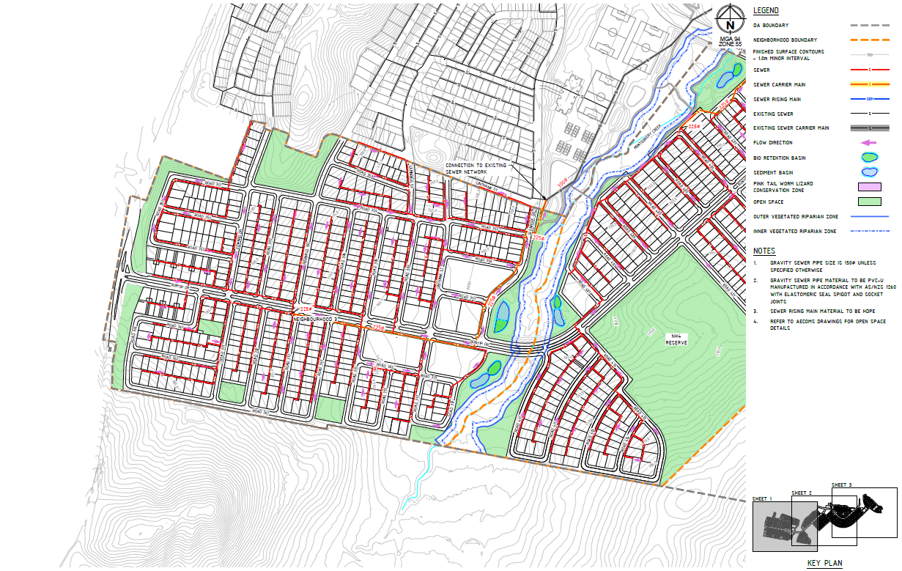
Figure 63 - Sewer Network Concept Master Plan NH3 and NH4
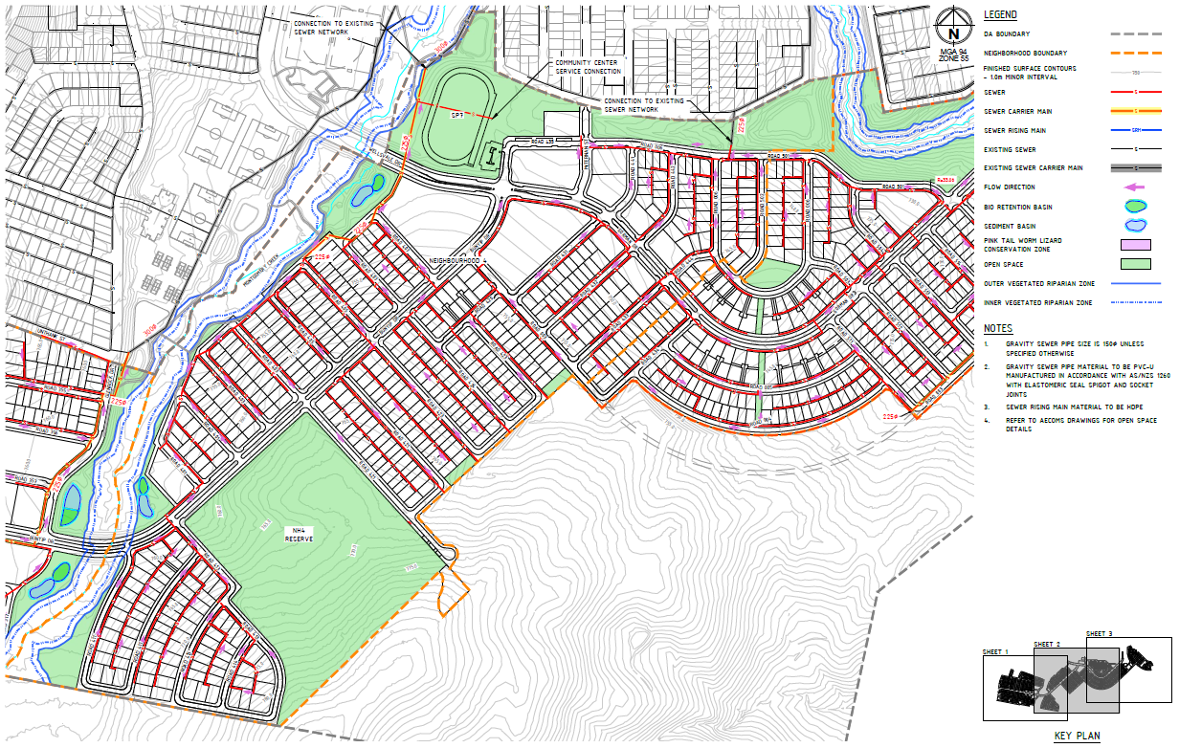
Figure 64 - Sewer Network Concept Master Plan NH3, NH4 and NH5

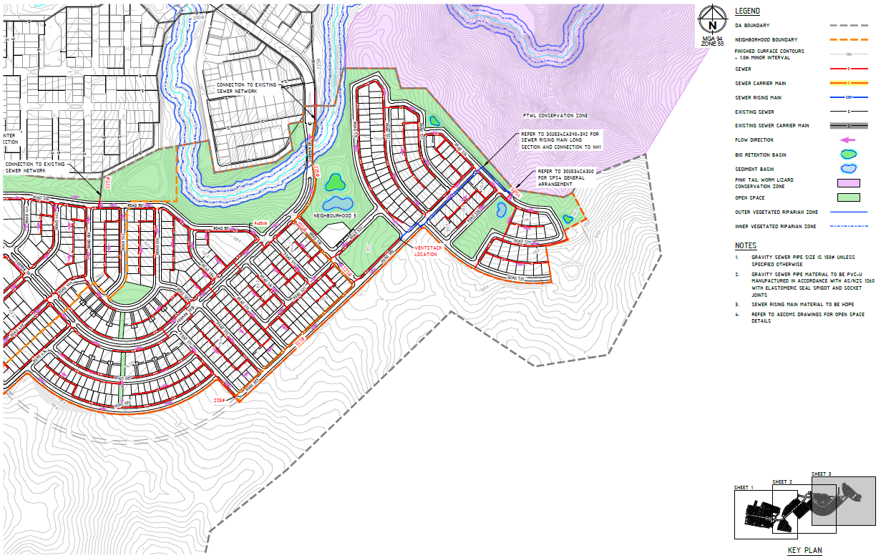
Figure 65 - Sewer Network Concept Master Plan NH4 and NH5
Storm Water
Googong NH3, NH4, and NH5 covers land on both sides of Montgomery Creek, located high within the overall Montgomery Creek catchment. The area of proposed development covers approximately 193ha of the overall 235ha site of typically hilly farmland terrain and facing generally inwards towards the creek. The Montgomery Creek catchment upstream of Googong NH3, NH4 and NH5 is approximately 226ha, and the overall creek flow direction is south to north.
Methodology
Referring to Section 5 of the Stormwater Report as prepared by Spiire dated 8 September 2021, the stormwater drainage networks have been sized using a RORB model with ARR datahub parameters to calculate flows at various locations within the catchment for NH3, NH4 and NH5, including incoming external flows. The RORB catchment plan and resulting flows can be found on the submitted DA drawings.
The 20% AEP flows are conveyed through the pipe network. However, several roadways will have upsized pipes to reduce overland flows for the purpose of meeting velocity / depth of flow or freeboard requirements.
Pipe sizes were calculated for flows requiring 600mmØ pipes or larger. Drainage Concept Masterplan drawings showing the expected pipe sizes and directions of overland flow. The proposed minor and major drainage networks will be refined in the next phase of design.
Any proposal to position stormwater pipes under the centre of the road pavement is not supported.

Pipe Network
The stormwater pipe network for NH3, NH4 and NH5 follows the same strategy adopted through NH1 and NH2 of utilising sub-arterial roads and their central median to convey both the trunk stormwater pipes and overland flow through the site where possible.
Kerb inlet pits are proposed throughout NH3, NH4 and NH5 with the majority of stormwater pipe being accommodated under the kerb. Any proposal to position stormwater pipes under the centre of the road pavement is not supported.
Lot connections are proposed to be directly to stormwater mains located under the kerb or through back of lot servicing with stormwater pipes contained within easements. Where kerb side pits are not required, sub-mains will be introduced to service individual lots. In locations where direct connections to stormwater pipes are not feasible, kerb outlets will be provided.
Neighbourhood 3
The majority of the NH3 catchment will flow towards the central swale of Bunyip Drive with trunk pipe work collecting and discharging this flow to Montgomery Creek. Interallotment drainage will be located within the standard easement arrangement adopted through Googong to date.
The upstream catchment on the interface of NH3 will be captured in a cut off drain along the boundary and conveyed to Montgomery Creek.
Neighbourhood 4
A trunk stormwater line is located parallel to Montgomery Creek conveying flows to Water Sensitive Urban Design (WSUD) 8A with high flows diverting to Montgomery Creek at a diversion structure. An additional trunk stormwater line is located along the Bunyip Drive central swale and discharges into the existing WSUD 8B. A third trunk main connects to the existing NH1B WSUD asset, with a diversion structure to redirect high flows away from the treatment asset.
Neighbourhood 5
Management of the upstream catchment is controlled via a trunk stormwater line along Road 003. Any proposal to position stormwater pipes under the centre of the road pavement is not supported.
Bunyip Drive Culvert
Referring to Section 4 of the Stormwater Report as prepared by Spiire dated 8 September 2021, the proposed Bunyip Drive culvert crossing is proposed to be four cell 2.4m x 0.9m box culvert which is intended to convey Q_{1%AEP} = ~26m³/s with a minimum freeboard of 600mm and approximate head loss in the Q_{1%AEP} event of 900mm. Culverts will be generally aligned with the direction of creek flows and appropriate scour protection on upstream and downstream interfaces to the culvert wingwall and headwalls.
Gorman Drive Bridge
The proposed Gorman Drive bridge is proposed to have a span of 28 metres outside main flow channel. The flow to convey is Q_{1%AEP} = ~26m³/s with a minimum freeboard to bridge soffit 600mm and appropriate scour protection around abutments and underneath bridge span.
Gross Pollutant Traps
Gross Pollutant Traps (GPTs) are proprietary products which are placed at the start of all NH3, NH4 and NH5 treatment trains, receiving flows prior to discharge to sedimentation basins or bioretention systems.
Sedimentation Basins
Sedimentation basins are proposed for all Googong NH3, NH4 and NH5 catchments where the estate catchment area is larger than 5ha, excluding those with existing NH1 water quality treatment assets.
Bioretention Systems
Referring to Section 6 of the Stormwater Report as prepared by Spiire dated 8 September 2021, bioretention systems are proposed for all but one of the NH3, NH4 and NH5 catchments.
The stormwater drainage and water quality management for NH3, NH4 and NH5 shall be designed and constructed in accordance with the requirements specified in Council’s Stormwater Drainage Design and Erosion Control and Stormwater Management Design Specifications.
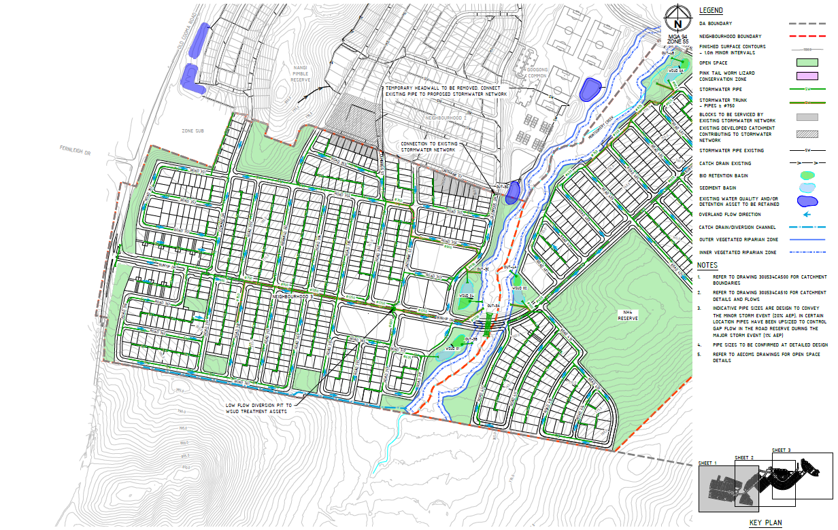
Figure 66 - Stormwater Concept Master Plan NH3 and NH4
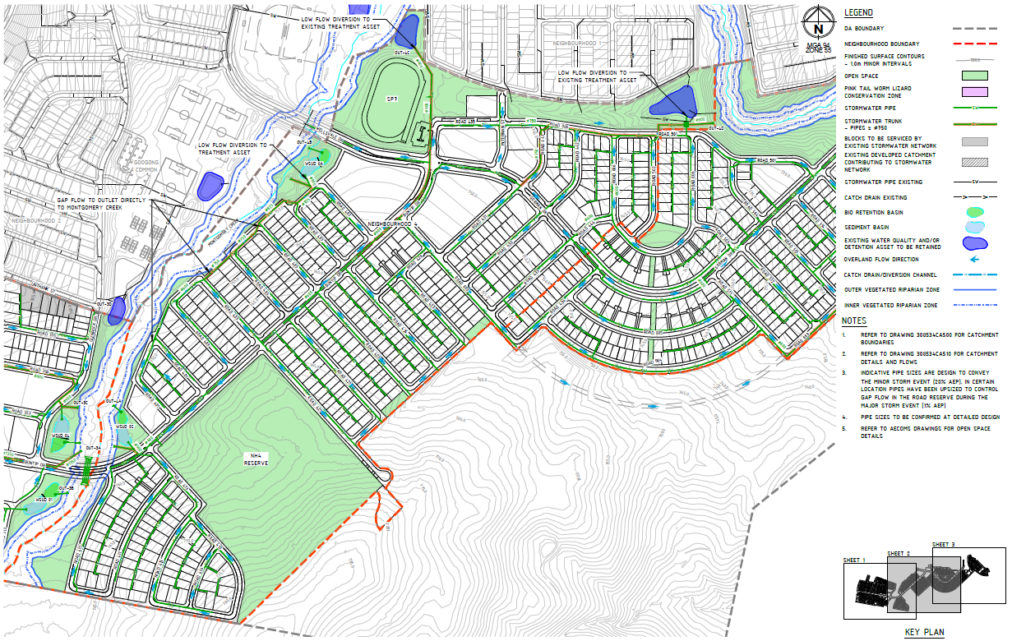
Figure 67 - Stormwater Concept Master Plan NH3, NH4 and NH5
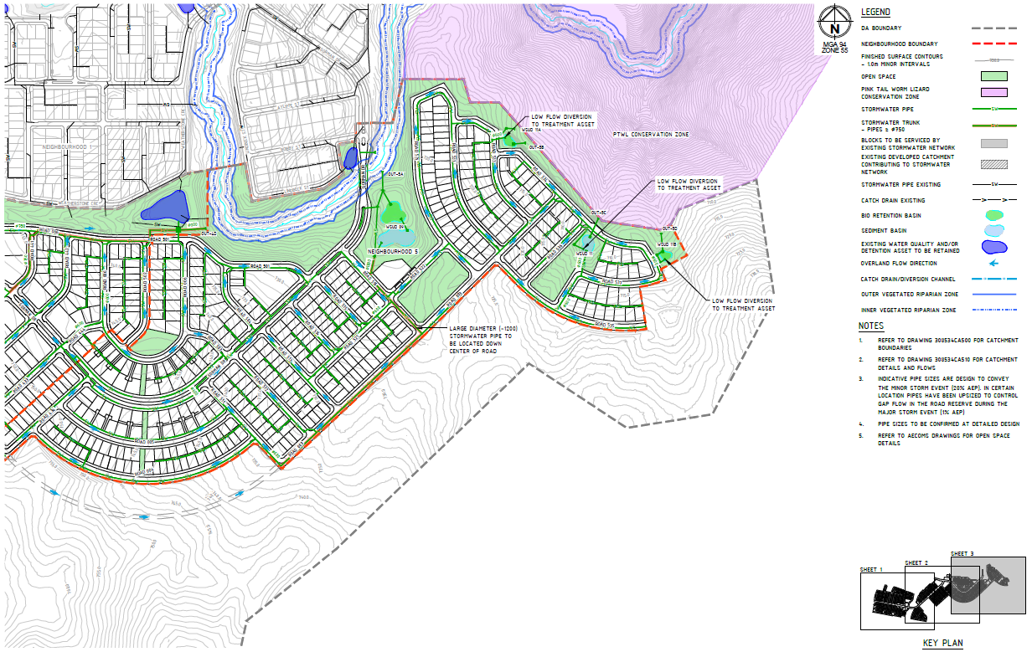
Figure 68 - Stormwater Concept Master Plan NH4 and NH5
Erosion and Sediment Control
Referring to Section 8 of the Stormwater Report as prepared by Spiire dated 8 September 2021, a concept Soil and Water Management Plan (SWMP) has been developed using Managing Urban Stormwater: Soils and Construction (NSW Gov, 2004), which is also known as the “Blue Book”.
An Erosion and Sediment Control Plan (ESCP) will be required for any works causing surface cover disturbance. An ESCP will be required to be submitted with any subdivision works certificate. A SWMP will be required to be implemented by the primary contractor for any works causing surface cover disturbance. This requirement applies for all stages of development.
Roads and Traffic
Reference is made to Section 4 of the Civil Infrastructure Design Report as prepared by Spiire dated 14 September 2021.
Road hierarchy, alignment and intersections shall be designed and constructed in accordance with requirements specified in Council’s Road Geometry and Pavement Design Specifications, and Council’s Earthworks, Flexible Pavement and Asphalt Concrete Construction Specifications.
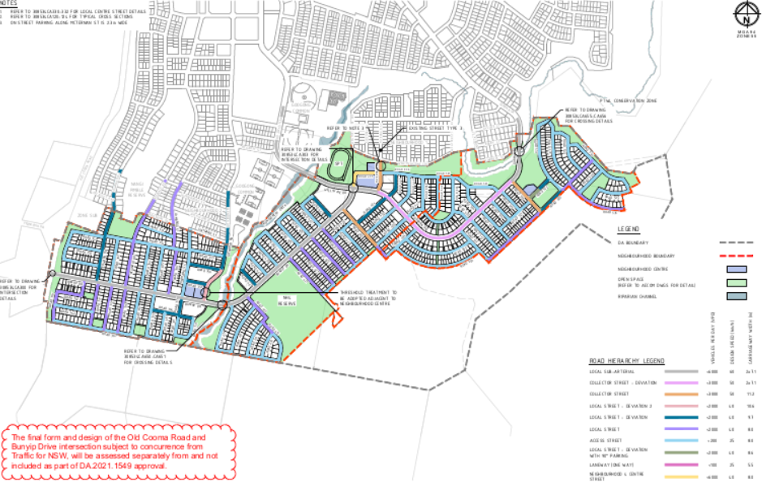
Figure 69 - Street Hierarchy Plan
Old Cooma Road
Old Cooma Road is classified by Transport for New South Wales (TfNSW) as a Regional Road.
Council Engineers have requested further information regarding traffic analysis for the Googong Road and Old Cooma Road intersection. Subject to GTPL/PEET providing traffic analysis for the Googong Road and Old Cooma Road intersection the following was agreed with Council;
- The location of Old Cooma Road and Bunyip Drive intersection in the submitted DA plans is acceptable to Council.
- The Old Cooma Road and Bunyip Drive intersection will be signalised subject to concurrence from Traffic for NSW.
- GTPL/PEET will fund a bypass at the Old Cooma Road and Googong Road intersection, with Council delivering the works.
- GTPL/PEET will not fund a bypass lane at the Old Cooma Road and Bunyip Drive but will provide an estimate of the “extra-over cost” for the bypass lane, to enable Council to decide whether or not to fund the bypass lane.

Council Engineers recommend the final form and design of the Old Cooma Road and Bunyip Drive intersection subject to concurrence from Traffic for NSW, be separated from this Development Application approval.
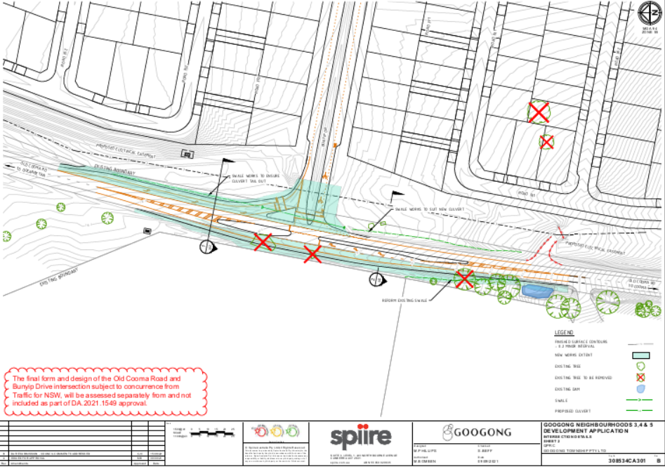
Figure 70 - Old Cooma Road and Bunyip Drive intersection
Local Sub-Arterial
The proposed Local Sub-Arterial has been designed in accordance with D1.07.7 in Council’s D1 Geometric Road Design Specification and is consistent with the existing cross sections of Gorman Drive and Wellsvale Drive in NH1 and NH2 respectively. Provision for width of on-street parking has been increased to 2.3m from 2.1m.
Collector Street
The proposed Collector Street has been designed in accordance with D1.07.6 in Council’s D1 Geometric Road Design Specification. The proposed Collector Street Deviation adopts the typical cross section of a Local Sub-Arterial, however, only experiences the traffic volumes of a Collector Street.
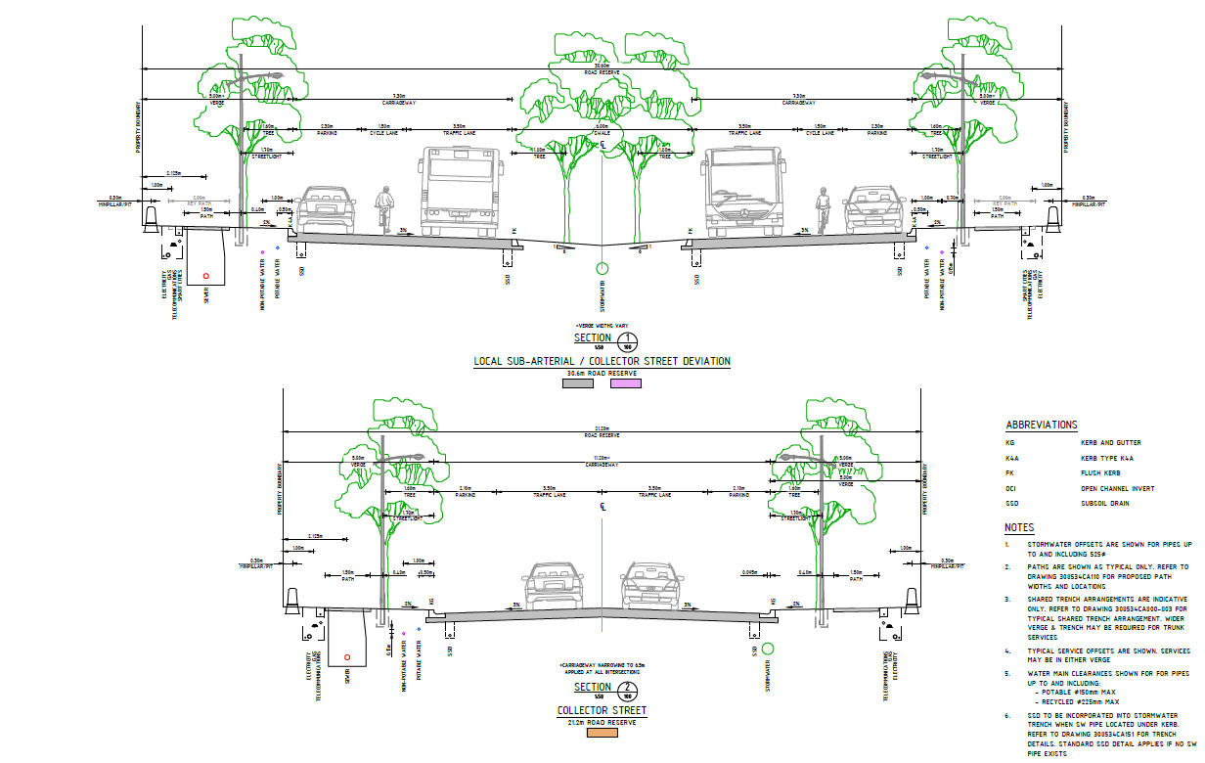
Figure 71 - Local Sub-Arterial and Collector Street Typical Cross Sections

Local Street
Four Local Street cross sections have been proposed and meet the minimum design requirements in accordance with D1.07.5 in Council’s D1 Geometric Road Design Specification. A summary of the four different cross sections is in the following table;
Typical Cross Section | Road Reserve Width | Carriageway Width | Changes between Cross Section
Local Street | 18.00m | 8.00m | -
Local Street Deviation | 19.70m | 9.70m | Wider to permit cars passing with informal
Local Street Deviation 2 | 20.60m | 10.60m | Formal parking added both sides
Local Street Deviation with 90˚ Parking | 23.00m | 15.50m | 90˚ parking added

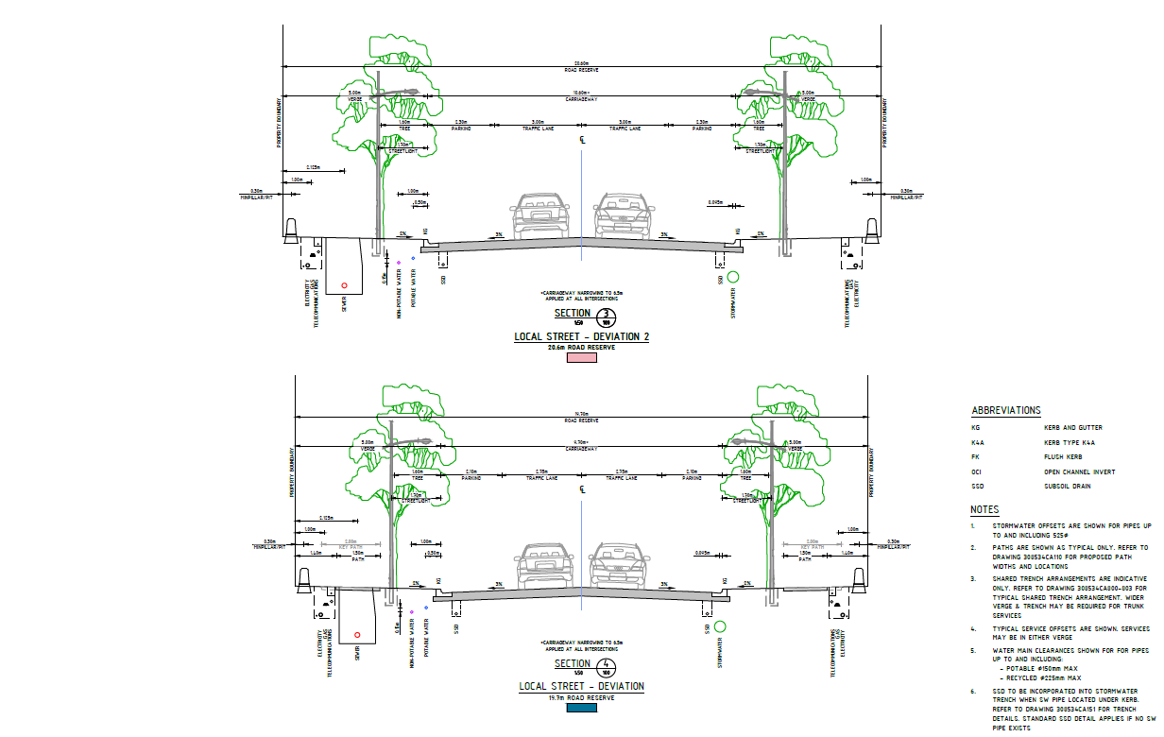
Figure 72 - Local Street (Deviation 1 and 2) Typical Cross Sections
Access Street
The proposed Access Street cross section has been designed in accordance with D1.07.5 in Council’s D1 Geometric Road Design Specification.
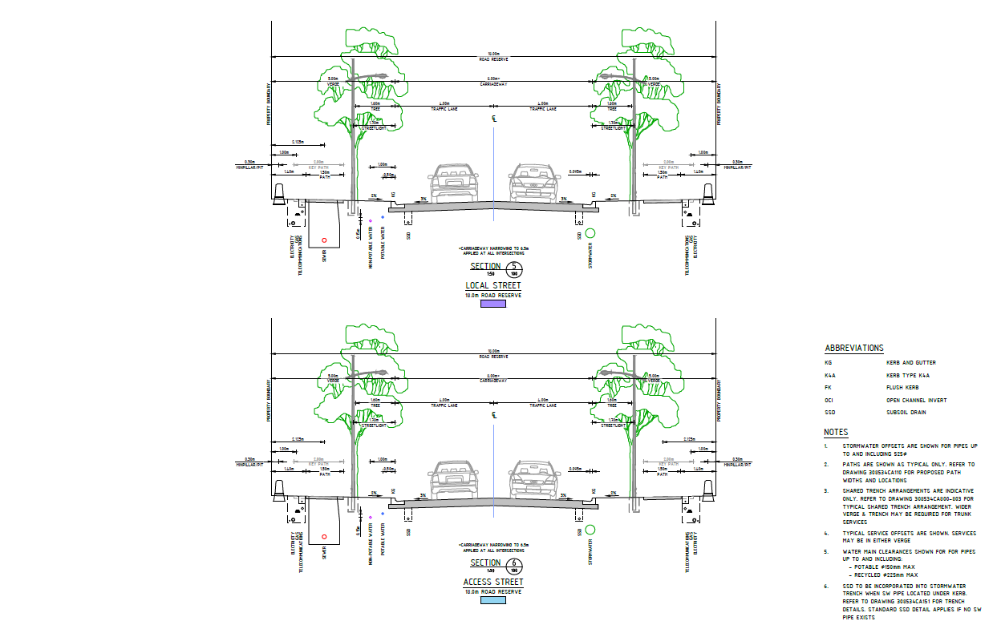
Figure 73 - Local Street and Access Street Typical Cross Sections
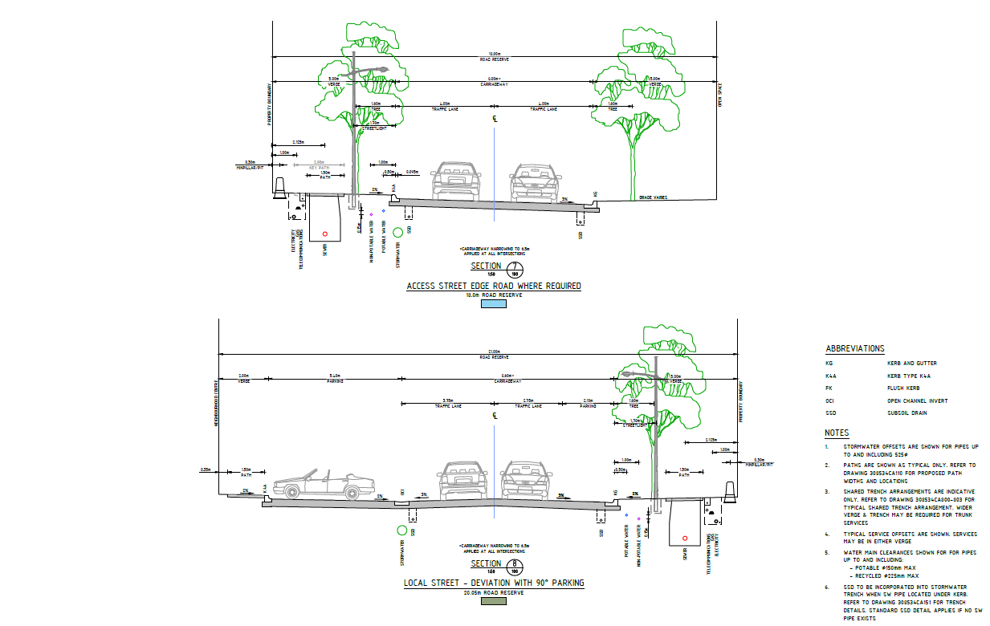
Figure 74 - Street Cross Sections

Laneway (Public)
The applicant initially proposed one-way public laneways Road 370 and 371 but were not supported by Development Engineering due to waste vehicles manoeuvring issues. Subsequently, GTPL have submitted a revised layout of Roads 351 and Road 361 which removes the Laneways but introduces sixteen battleaxe lots.
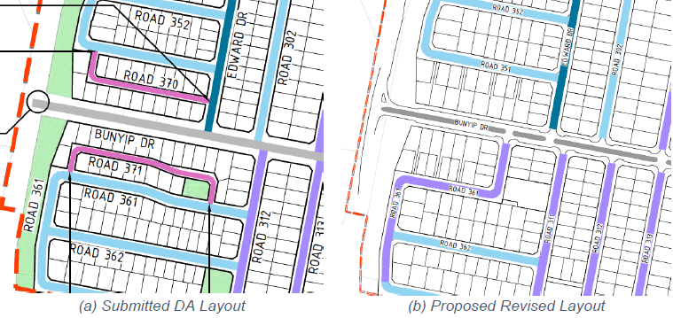
Figure 75 - Revised Layout with Laneways Removed
Neighbourhood Centre 4 Street
The proposed Neighbourhood Centre 4 Street incorporates the design elements of a Local Street with the addition of indenting parallel parking and 90˚ parking between the two NH4 centre blocks. This road also accommodates with the widening of kerbs the turning movements of a prime mover and semi-trailer to service the neighbourhood centre blocks.

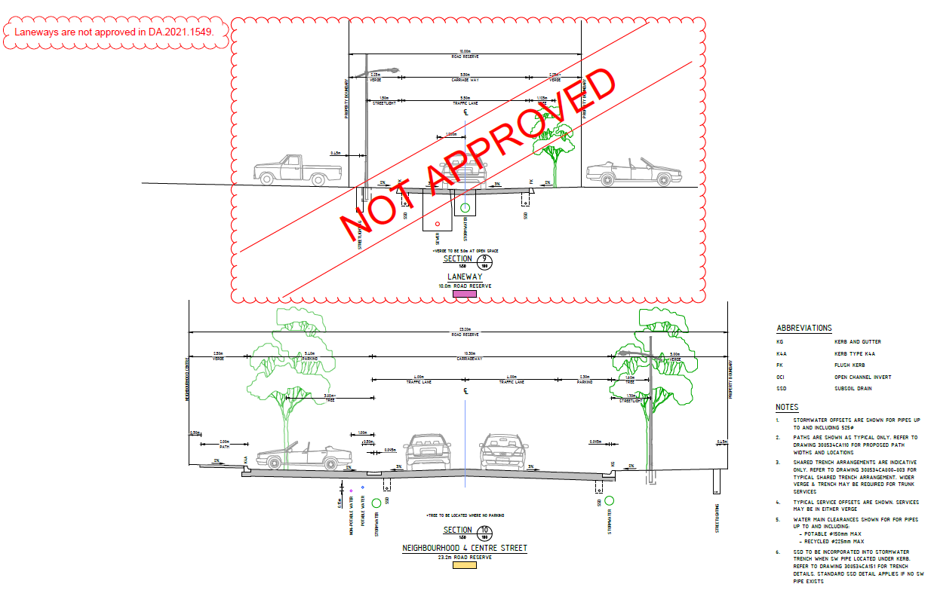
Figure 76 - Laneway and NH4 Centre Street Typical Cross Sections
Bunyip Drive Four-Way Intersections
Following a meeting with Council on 17 February 2022, GPTL/PEET reduced the number of four-way intersections on Bunyip Drive, but five of the seven four-way intersections remained in close proximity to each other creating potential for rear end collisions, congestion and the associate poor driver behaviour. Council requested a further reduction of the number of four-way intersections by another two along this stretch of Bunyip Drive.
Subsequently, GTPL/PEET have reviewed the street and intersection layout and proposed to reduce the number of four-way intersections by a further two, so that there are only five along the length of Bunyip Drive, out of 19. The grid road network proposed balances the desire to limit rat running with providing legibility and reducing the maximum number of turning movements required to reach each dwelling. This was confirmed in GTPL/PEET letter dated 1 April 2022.
Kerb Indentation
Kerb indents at intersections throughout NH3, NH4 and NH5 have been proposed. Kerb indents would be similar as adopted throughout NH1 and NH2. The methodology on the locations of indentation for NH3, NH4 and NH5 is as follows below;
- Adopted for left kerb return entry onto local and access streets,
- Carriageway width reduced to 6m at indent locations local and access streets,
- Indentation provided on both sides of the road to a carriageway width of 6.5m when formal parking proposed,
- Only adopted when required turning movements are accommodated,
- Kerbs indented for parking along Bunyip Drive, Gorman Drive and Wellsvale Drive.
Lots Fronting Gorman Drive and Bunyip Drive
The initial proposal to have lots accessing onto Collector Roads, Gorman Drive and Bunyip Drive, was not supported. Gorman Drive and Bunyip Drive feature on-road indented parking along this section adding a risk to lot access, especially when vehicles reversing and vehicles accessing driveways will increase the risks of rear end collisions and side-impact collisions.
Gorman Drive is also intended to be a bus route so driveway access on the main bus route is also an added risk for their servicing. The absence of driveways on Gorman Drive is viewed by Council as one of the positive design and development achievements of Googong.
Reference to AUSTROADS for guidance in achieving safe system speeds on urban arterial roads is a requirement for good road design to avoid operational and safety problems
On 27 April 2022 GTPL/PEET presented an alternative option which included battle-axe blocks accessing Road 005 and Road 006 instead for Gorman Drive fronting lots and Road 420 instead for Bunyip Drive. Council Development Engineers support this alternative option.
A compromise was requested by GPTL/PEET whereby the lots on the northern side of Gorman Drive would adopt battle axes and the lots on the southern side of Gorman Drive would remain as per the submitted DA. Council Development Engineers did not support this compromise.
GTPL/PEET advised they would support Council’s preferred option in order to present an agreed position to the Regional Planning Panel (SRPP) and confirmed it on 4 May 2022.

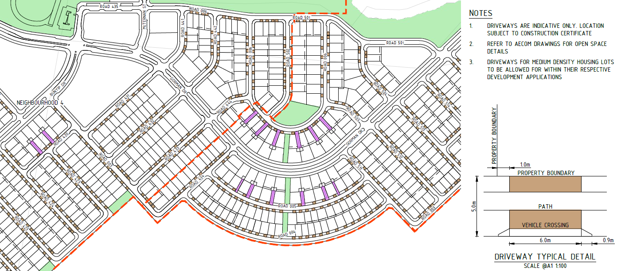
Figure 77 - Alternate Battle-Axe Lot Configuration
Local Street Linkage
Council was not supportive on the linkage of the local street on the other side of Montgomery Creek. McTernan Street was never intended for significant road use and is of the older design standard 7.5m wide. Should the local street linkage remain, the median on Gorman Drive must be extended to prevent/block right hand turns from the local street.
The linkage is as shown in the approved Structure Plan and is an important second point of access/egress for emergency vehicles to this part of NH1B. GTPL/PEET agreed to support the formation of a left in left out at the intersection of McTernan Street and Gorman Drive as recommended by Council and confirmed in GTPL/PEET letter dated 1 April 2022.

Small Medians – Bunyip Drive and Gorman Drive
The medians included along Bunyip and Gorman Drive are 6.0m wide and in accordance with Austroads Guide to Road Design Part 4A: Unsignalised and Signalised Intersections Table 6.2. This 6.0m width, adopted in the sub-arterial road cross section, is a suitable width to shelter turning vehicles. This length accommodates the 85th percentile car length of 4.91m with 0.9-1.0m clearance to both the front and back of the car. This was confirmed in GTPL/PEET letter dated 1 April 2022.

Parking
On Street Parking
A summary of where provision for on street parking has been provided based on the proposed road hierarchy in the following table;
 | Parking Provided | Parking Width | Linemarked
Local Sub Arterial | Yes – Parallel | 2.3m* | Yes
Collector | Yes - Parallel | 2.3m* | Yes
Local Street - Deviation 2 | Yes - Parallel | 2.3m | Yes
Local Street - Deviation with 90˚ Parking | Yes – Parallel & 90˚ | Parallel - 2.3m*  90˚ - 2.5m x 5.4m | Parallel - No  90˚ - Yes
Local Street - Deviation | Yes - Parallel | 2.1m | No
Local Street | Informal on-street parking |  | No
Access Street | Informal on-street parking |  | No
Laneway | N/A | N/A | N/A

* Increased from 2.1m to 2.3m as agreed by GTPL/PEET in letter dated 1 April 2022.
On-street parking has been carefully considered with specific road cross sections adopted around proposed local centres and multi-unit lots to cater for expected increased on-street parking demands. Locations within NH3, NH4 and NH5 that account for on street parking in addition to the indented parking located along Wellsvale Drive, Gorman Drive and Bunyip Drive.
Off Street Parking
Provision for off parking has been included for the NH4 Reserve and Sportsfield 7 with the total number of off-street spaces provided being;
- NH4 Reserve = 26 standard 90˚ car parking spaces and 2 disabled car parking spaces,
- Sportsfield 7 = 60 standard 90˚ car parking spaces and 2 disabled car parking spaces.

Public Transport
Consultation with QCity was conducted to confirm that the ultimate bus route for the Googong Township aligns with their servicing strategy. The proposed route and stops were endorsed by QCity on 9 September 2021 with the correspondence below.
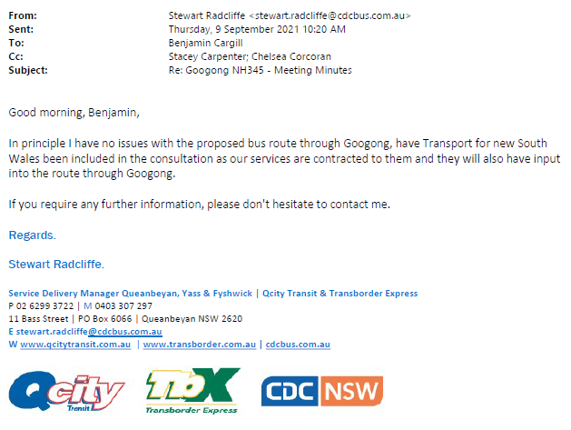
Figure 78 - QCity Buses Endorsement of Bus Route
The proposed bus stop dimensions align with Austroads Guide to Road Design Part 3: Geometric Design with an approach length of 26m and exit length of 10m for the kerbside stops. Bus Shelters are proposed for the three (arriving and departing) bus stop locations adjacent the Neighbourhood Centres.
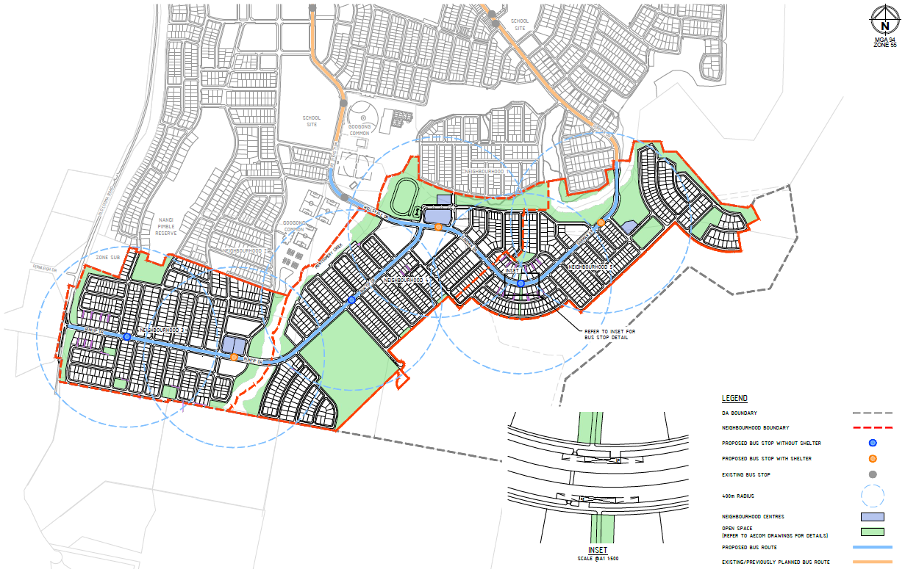
Figure 79 - Proposed Bus Route Plan
Traffic
Referring to the Traffic, Transport and Assessment Report as prepared by SCT Consulting dated 10 September 2021, the traffic study demonstrates that the NH3, NH4 and NH5 development is feasible and represents an improved proposal over assumptions made in the structure plan;
- The subdivision development application includes the following;
  - 1398 residential lots,
  - 19 lots for future subdivision of higher density housing and other uses including the Neighbourhood Centre sites,
  - Public reserves including, local parks, a sports fields and Googong Common,
  - Public roads and drainage reserves.
- The road hierarchy across the precinct has been refined from the structure plan to improve network accessibility and connectivity with NH1 and NH2.
- The proposed cross-section for the local sub-arterial road is generally consistent with what has been suggested in the QPRC Design Specification. There are minor deviations of the cross-section for the collector, local street and addition of access streets.
- The TRACKS modelling confirms that the proposed road network is feasible for the development. The traffic volumes generally adhere to the maximum loading criteria for each street type.
- The exceptions of the overloaded traffic volumes on Wellsvale Drive, Bunyip Drive and a road adjoining NH4 Neighbourhood Centre (Road 435) have been justified for various reasons.
- SIDRA intersection modelling was conducted for key intersections in Googong. A suite of options was developed for both Wellsvale Drive / Bunyip Drive / Gorman Drive and Old Cooma Road / Bunyip Drive acknowledging different design criteria.
- The SIDRA modelling confirms that all key intersections would operate satisfactorily (Level of Service B or better) during AM and PM peak hours in the future year scenario.
- The proposed Bus route remains consistent with the master plan in closing the loop on Gorman Drive and Wellsvale Drive. The completion of the loop will also provide an easy extension of the route for future Kinder-Year 12 school.
- Dedicated on-road cycle lanes are available on Bunyip Drive and Wellsvale Drive. The remaining road network within the precinct would expect relatively low vehicular traffic demand and slow traffic speeds, subsequently cycling friendly. With footpaths proposed on at least one side of all roads, active transport can be one of the most convenient modes for short-distance trips.
- Residential parking will generally be provided off-street while visitor parking demand is expected to be satisfied by on-street parking.
- There would be designated parking areas for the NH4 neighbourhood centre and the athletic track to satisfy the parking demand. It is expected that the parking for NH3 and NH5 neighbourhood centres would be provided on street. However, the final demand would be assessed at super lot DA stages.
The Traffic, Transport and Assessment Report concluded that the proposed subdivision is at a level able to be accommodated by the existing and planned infrastructure.

Footpaths
Referring to Section 6.2 of the Civil Infrastructure Design Report as prepared by Spiire dated 14 September 2021, all proposed footpaths within NH3, NH4 and NH5 will be provided on one side of the road. Footpaths will have various widths 1.5m to 2.5m. The extents of the proposed path network and crossing locations is shown in the submitted DA drawings.
An accessibility compliant footpath network has been considered to factor in road grading to maintain at a minimum, one accessible path of travel to key open space and local centre locations.

On Road Cycling
Referring to Section 6.2 of the Civil Infrastructure Design Report as prepared by Spiire dated 14 September 2021, within NH3, NH4 and NH5 on road cycling has been provided along Bunyip Drive, Wellsvale Drive and Gorman Drive. On-road cycling has not been provisioned for along Old Cooma Road due to the rural character of the existing road and the proposed shared use path adjacent the road.
The shared use path parallel to Old Cooma Road is a continuation from NH2 and is located along the electrical easement. It is proposed this path will continue along Old Cooma Road and along the Township’s southern boundary.
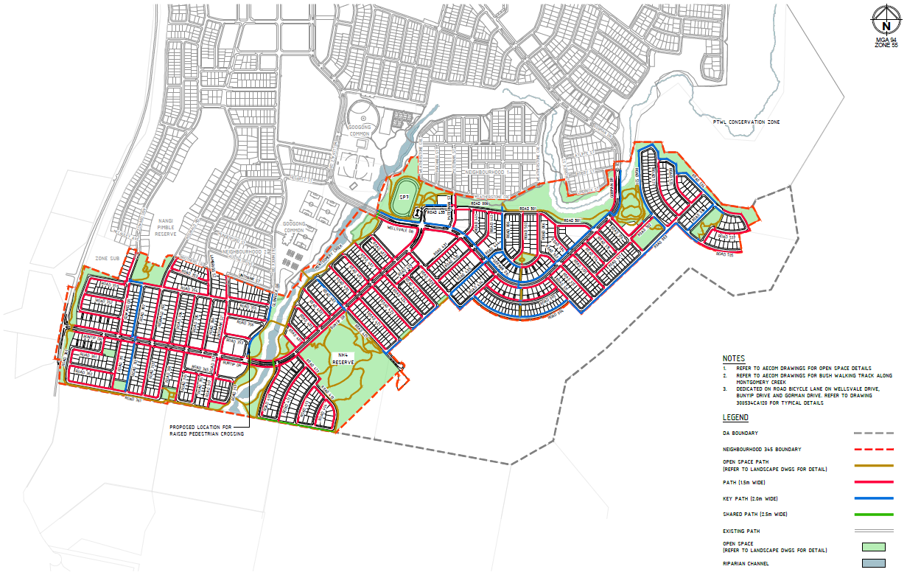
Figure 80 - Path Network Plan NH3, NH4 and NH5
Utilities
Referring to Section 10 of the Civil Infrastructure Design Report as prepared by Spiire dated 14 September 2021, NH3, NH4 and NH5 will be serviced by a reticulation network via a shared trench with gas, electricity and telecommunications in the road verges in accordance with typical configurations found in NH2.
NH2 Wellsvale Drive includes smart cities infrastructure to provide WIFI connectivity and smart streetlight systems to the residents of Googong and QPRC. Provision has been made in the typical cross sections and shared trench details for similar smart cities infrastructure. The design has assumed two trench types are required along Bunyip Drive, Gorman Drive and Wellsvale Drive;
- 1x one communications P100 conduit located on one side of the verge,
- 2x four (two communications and two electrical) P100 conduits located on the other side of the verge.

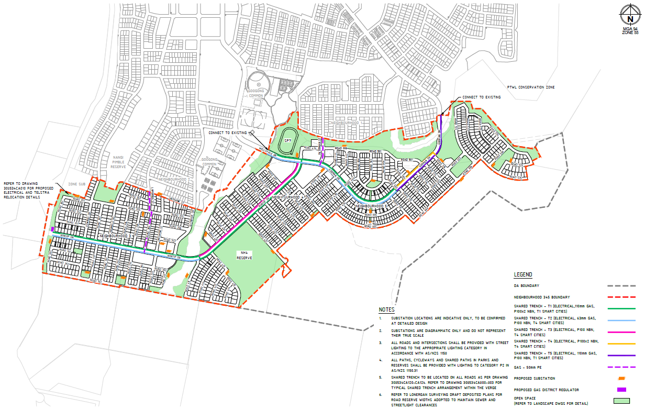
Figure 81 - Utility Concept Master Plan NH3, NH4 and NH5
Local Development Traffic Committee
Council Development Engineering staff received advice from Local Development Committee members and negotiated with the Applicant on issues relating to local road safety, traffic volumes, traffic calming, removal of laneways, stormwater and utilities, which were addressed to Council Engineers satisfaction.
Electricity
Electricity connections are also being made progressively available to each stage of Googong Township. These services and other infrastructure must be completed prior to the release of any Subdivision Certificate for the proposed lots.
Telephone connection / NBN
The Applicant has confirmed that they have entered into an Agreement with NBN Co for NH345 to provide fibre connection to the lot. This is consistent with how the previous estates have progressed in terms of the delivery of this infrastructure.
A standard condition is suggested which requires the service provider to confirm connection prior to the release of the subdivision certificate.

Clause 7.10 Development near Cooma Road Quarry
This clause is not considered relevant to the proposed development as the site is not identified as “Buffer Area” on the Quarry Buffer Area Map”. | N/A
Clause 7.11 Development near HMAS Harman
This clause is not considered relevant to the proposed development as the site is not located within 2 kilometres of HMAS Harman or within Zone IN1 General Industrial or Zone IN2 Light Industrial. | N/A
The proposal is considered to be generally consistent with the Queanbeyan LEP except for 81 lots which are seeking a clause 4.6 variation to be less than the minimum lot size.
Clause 4.6 Request
The development standard that is sought to be varied is Clause 4.1 of QLEP 2012, which establishes the minimum subdivision lot size in the R1 General Residential zone applicable to the subject site.
The area subject to this variation request is located in the south-west corner of NH345 and relates to the minimum lot subdivision requirement of 600m² shown in yellow in Figure 83 below.
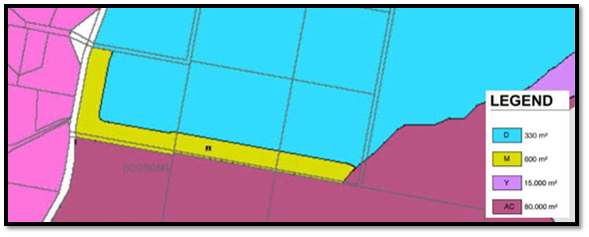
Figure 82 - Minimum Lot Size Controls QLEP
The 600m² area mapped is approximately 100m wide (yellow). The Applicant proposes to reduce the width of the buffer area to 35m, providing additional land where 330m² lots can be achieved (blue). The reduced lot size applies to 81 proposed new lots.

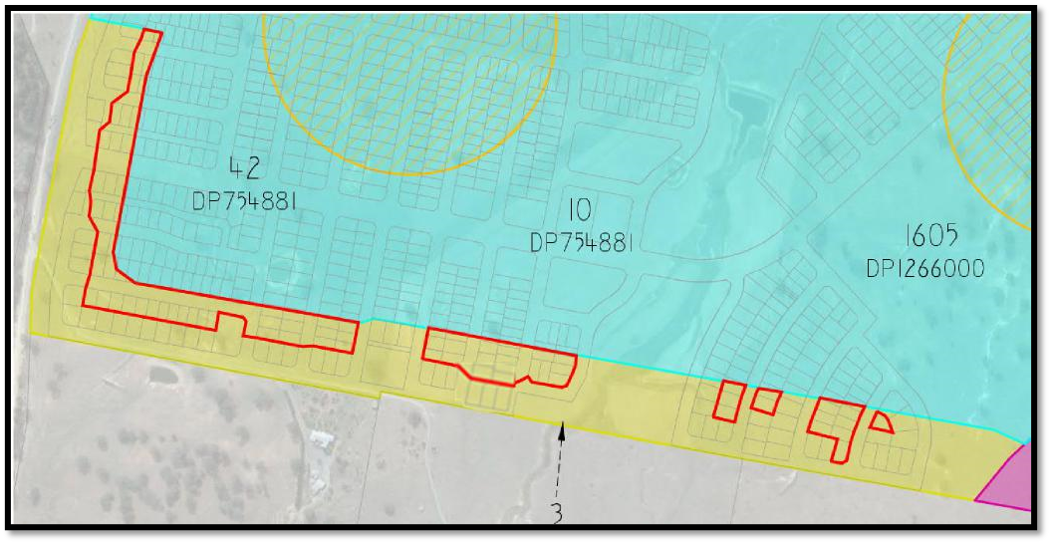
Figure 83: Lots Subject to Variation Request Marked Red.
Preconditions to be Satisfied
Clause 4.6(2) provides this permissive power to grant development consent for a development that contravenes the development standard is subject to conditions.
The Applicant has sought the opportunity for a variation to the development standard to be considered.
Clause 4.6(4) of the LEP establishes preconditions that must be satisfied before a consent authority can exercise the power to grant development consent for development that contravenes a development standard.
The two preconditions include:
- Tests to be satisfied pursuant to Cl 4.6(b) – concurrence of the Planning Secretary.
The Department of Planning and Environment confirmed the Southern Regional Planning Panel has the authority to determine this request.
- Tests to be satisfied pursuant to Cl 4.6(4)(a) – this includes matters under Cl 4.6(3)(a) and (b) in relation to whether the proposal is unreasonable and unnecessary in the circumstances of the case and whether there are sufficient environmental planning grounds to justify contravening the development standard and whether the proposal is in the public interest (Cl 4.6(a)(ii));

In accordance with Clause 4.6(3)(a) the applicant argues that the development standard is unreasonable or unnecessary. The Land and Environment Court identified ways a development standard can be varied and remain suitable, including where the objectives of the standard are achieved notwithstanding noncompliance with the standard. The objectives of the minimum subdivision lot size clause are:
(a) to ensure subdivision is sensitive to land, heritage and environmental characteristics (including water quality, native flora and fauna and places or items of Aboriginal and European heritage value)
Comment: The proposed subdivision arrangement responds to land, heritage and environmental characteristics of the site including bushfire with these lots within Vegetation Category 3, consistent with the rest of the estate. The difference between the proposed lot size and the development control size will not affect how the proposal satisfies these objectives and Council recognises this objective can be met.
(b) to ensure subdivision does not adversely impact on the functions and safety of main roads,
Comment: The proposed subdivision design has demonstrated to the Council’s satisfaction that it will not impact adversely on the functions and safety of main roads, noting one intersection’s design is yet to be approved in its final form.
(c) to provide lots with areas and dimensions that enable the appropriate siting and construction of a building and associated works to minimise and avoid the threat of natural hazard (including bush fire, soil instability and flooding) and to protect significant vegetation and prominent or significant landscape qualities
Comment: The development application has demonstrated to Council’s satisfaction that the future siting and construction of buildings can avoid natural hazard. Council notes that some proposed lots to the southern extent of the estate may require BAL 29 construction levels or higher, as referenced in RFS advice and included in a condition. This location is constrained by bushfire risk however, the proposed lot size as sought does not create a bushfire risk. The lots size as proposed is able to accommodate a future dwelling.
(d) to ensure new lots have an adequate water supply and can be provided with an effective means of disposal of domestic waste and adequate services
Comment: The proposed subdivision design has demonstrated to Council’s satisfaction that the proposed lots will have access to an adequate water supply and will be provided with waste disposal services.

(e) to create lots that are compatible with the existing predominant lot pattern or desired future character of the locality and to minimise the likely adverse impact on the amenity of adjoining developments.
Comment: The proposed subdivision pattern will be compatible with the existing predominant lot pattern. The estate already includes lots to the minimum of 300m² as sought and will maintain lots at 600m², also consistent with the mix of lot sizes in the estate. The larger lots will continue to operate as a buffer to rural and rural residential land to the south.
There are also sufficient environmental planning grounds to justify contravening the minimum subdivision lot size development standard as required by Clause 4.1 of the QLEP 2012. Council officers have formed the view that compliance with the objectives of Clause 4.1 is achieved notwithstanding the non-compliance with the lot size control in question.
In relation to Clause 4.6(3)(b), the Applicant suggests there are sufficient environmental planning grounds to justify contravening the minimum subdivision lot size development standard.
A 100m wide strip is shown in the QLEP as an interface with rural and rural residential land to the south. The proposal maintains a buffer, albeit reduced in width.
Also, reducing lot sizes in this location will remove the potential for Dual Occupancy lots, having a minimum of 600m². The proposed smaller lots will avoid further development on the southern edge of the estate.
Council officers are able to support the Applicants justifications relating to sufficient environmental planning grounds and support the variation under Clause 4.6(3)(b).
In terms of Cl 4.6(a)(ii), the Applicant argues that the public interest is maintained as a consequence of the variation. The objectives of the zone, outlined in the QLEP table above, continue to be met. This includes delivery of the estate to provide for the housing needs of the community, provide a variety of hosing types and densities, will not limit the provision of land for complementary services and facilities, to promote walkable communities and it maintains existing bushland areas. Council accepts that the objectives for the R1 zone can continue to be met despite any non-compliance with the development standard.

  - Section 4.15 (1)(a)(ii) - Provisions of any Proposed Instruments
There are several proposed instruments which have been the subject of public consultation under the EP&A Act, and which may be relevant to the proposal, including the following:
- Draft Queanbeyan Palerang Local Environmental Plan 2020
- Draft State Environmental Planning Policies
The draft Queanbeyan-Palerang Local Environmental Plan (QPLEP) 2020 was placed on public exhibition from 1 June 2020 to 20 June 2020 and as such requires consideration for the purposes of the subject application. The Draft QPLEP 2020 has not been adopted to date and is currently being finalised. The provisions of draft QPLEP 2020 relevant to the subject application remain relatively unchanged from that of the Queanbeyan Local Environmental Plan 2012. As such, the subject application is generally consistent with the provisions of the QPLEP 2020.
On 2 December 2021, the Department of Planning and Environment announced the consolidation of existing State Environmental Planning Policies to align with nine focus areas of the NSW Planning system. These came into effect on 1 March 2022 and are now in force.

  - Section 4.15(1)(a)(iii) - Provisions of any Development Control Plan
The Googong Development Control Plan 2010 (‘the DCP’) applies to the site.
The proposed development is consistent with the Master Plan in terms of location of neighbourhoods, neighbourhood centres, indicative road layout and extension to the Googong Common open space corridor.
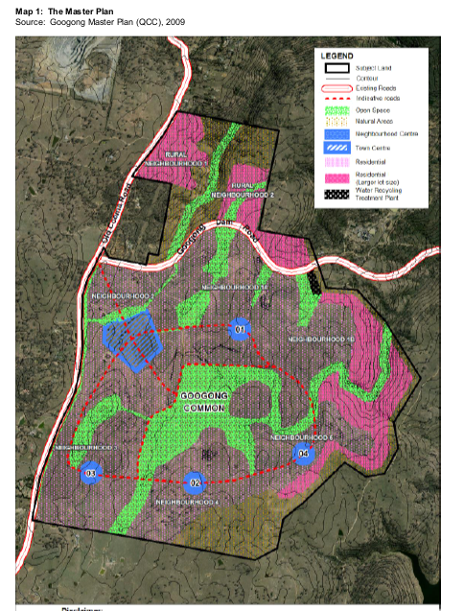
Figure 84: Googong Master Plan
Googong Township is being developed over 5 neighbourhoods. Figure 86 shows the overall Googong Neighbourhood Plan. Each is governed by a broader Neighbourhood Structure Plan embedded in the DCP that translated the Master Plan to a level of detail that shows the general location of developable areas, areas of open space and road layouts for each neighbourhood.

Figure 85 – Googong Neighbourhood Plan
The Googong DCP requires that a ‘Neighbourhood Structure Plan’ be prepared and approved prior to the subdivision and development of land.
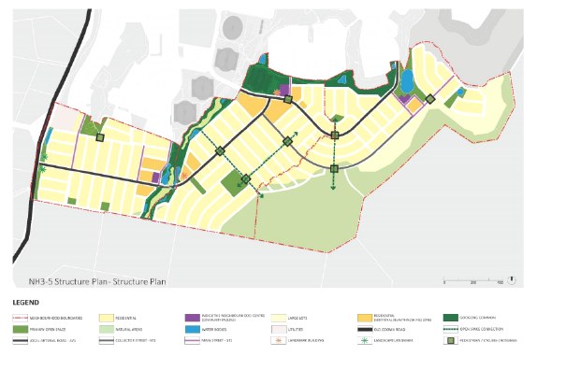
Figure 86 - Neighbourhood Structure Plan

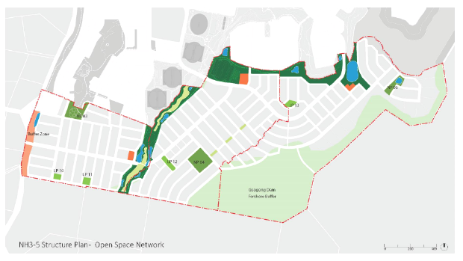Figure 87 – Open Space Network
Further discussion on compliance with the Structure Plan is included in the LEP assessment above. The proposed development is generally in accordance with the Googong Development Control Plan.
There are no Development Contributions Plans applicable to the site which operates under a Voluntary Planning Agreement.

  - Section 4.15(1)(a)(iiia) – Planning agreements under Section 7.4 of the EP&A Act
The Googong Urban Development Planning Agreement applies to the subject site and more broadly land known as the Googong Urban Release Area. It was originally executed on 12 January 2012 between the then Queanbeyan City Council, Googong Development Corporation and CIC Australia Limited.
The objective of the Googong Urban Development Planning Agreement is to provide for the carrying out of works, the dedication of land, and the provision of other public benefits for the provision of residential lots, infrastructure, facilities and services.
The delivery of the estate has been progressing in accordance with the agreement. Public benefits include playgrounds, dog parks, playing fields. tennis courts, indoor pool, commercial facilities, child care centre, health services and schools.
On 16 February 2015 it was amended by a Deed of Novation. This changed one of the entities who was a party to the Voluntary Planning Agreement for Googong being the Googong Development Corporation Pty Ltd to a new entity known as Googong Township Pty Ltd.

On 13 January 2020 Variation (No. 1) to the Googong Urban Development Local Planning Agreement was executed by the parties. This updated and varied the original planning agreement to alter definitions to maintain the currency of the Agreement, include clauses relevant to the development and provision of public recreation land to the Queanbeyan Rugby Union Football Club, amendments to the Development Contributions to be provided by the Developer under Schedule 1 of the Agreement and alteration of indices used for the indexation of Contribution Values for Offsite Road Contributions and updates to the works schedule for Offsite Local Roads.
On 14 May 2020 the Second Deed of Variation to the Googong Urban Development Local Planning Agreement was executed by the parties to dedicate approximately 5554m² of land to Council for a Council depot and carry out noise attenuation works to Stage D of the Googong Water Recycling Plant.
The proposal is consistent with this Planning Agreement as discussed in this report.

  - Section 4.15(1)(a)(iv) - Provisions of Regulations
Clause 92(1) of the Regulation applies to applications for demolition. The application includes the dismantling and retention of the shearing shed material to be reuse. This clause is not applicable.
  - Section 4.15(1)(b) - Likely Impacts of Development
The likely impacts of that development, including environmental impacts on both the natural and built environments, and social and economic impacts in the locality must be considered. In this regard, potential impacts related to the proposal have been considered in response to SEPPs, LEP and DCP controls outlined above and the Key Issues section below.
The consideration of impacts on the natural and built environments includes the following:
- Context and Setting - The development will integrate with the existing developing estate to the north. Large areas of conservation land will remain under management of the Department of Planning and Environment via a Biodiversity Certification Agreement. Scenic qualities and features of the landscape including views and vistas will be compatible with the developing character of the locality.
- Access, Transport and Traffic - The proposed development’s impact in relation to access, transport and traffic is considered to be acceptable noting the final form and design of the Old Cooma Road and Bunyip Drive to be agreed.
- Public Domain - The proposed development will positively contribute to public recreational opportunities, pedestrian links and access to public space through the ongoing delivery of commitments under the local planning agreement including sports fields, improvements to Montgomery Creek, bike and pedestrian paths and the linkages through to the Town Centre.
- Utilities - The site is able to be connected to water, sewer, electricity, roads, stormwater and communications infrastructure.
- Heritage - The proposed development will have a minimal impact in relation to heritage. Council recently agreed to delist the one item on site listed in the QLEP as having heritage significance. Items of Aboriginal significance have been identified and most are able to be retained.

- Other land resources – The proposed development will not affect the future use or conservation of valuable land resources such a productive agricultural land, mineral and extractive resources and water supply catchments with construction managed through appropriate conditions. The land has been designated for future urban development, is appropriately zoned and will be an extension to an existing residential development.
- Water – The proposed development will have minimal impact on the conservation of water resources and the water cycle. Both potable and non-potable recycled water is available to the site. Water conservation and management strategies have been incorporated into the design, supported by Council’s Engineers.
- Soils – The proposed development will have minimal adverse impact on soil conservation where managed in accordance with appropriate soil and erosion control measures. Further assessment of erosion controls will be assessed through the Subdivision Works Certificate process. .
- Air and microclimate – Construction activities have the potential for temporary impacts however are not anticipated to be ongoing. Following that, the proposed development will have minimal impact on air quality and microclimatic conditions. Conditions have been suggested to prevent air pollution (dust suppression) and soil and erosion control measures.
- Flora and Fauna / Biodiversity Assessment - The anticipated impact of the development has been subject to considerable review. A Biodiversity Certification Agreement and Order has been made between the landowner and Minister for Planning and Environment. Compliance is also sought through a condition. Council’s Tree Management Officer, Parks and Recreation, Environmental Health and Engineering Officers are able to support the proposed development. Proposed development will have a minimal impact in relation to the maintenance of biodiversity in the area. Please refer to the EP&A Act assessment and Clause 7.3 within the QLEP2012.
In 2021 Council adopted a cat containment policy to reduce the ability of cats to roam freely during the day or night to improve the safety off native fauna that have habitat around the fringes of the urban release area. The area proposed by this subdivision proposal is covered by that policy. As such conditions of consent have been recommended requiring the cat containment provisions to be noted as a section 88B constraint.
- Waste – Council’s Waste Management Officer is able to support the proposal.
- Energy – The lots have been designed to respond to site constraints. Subsequent development will need to demonstrate it achieves appropriate energy efficiency standards relevant at that time.
- Noise and Vibration - The subject site will be subject to road traffic noise. The Applicant has provided an acoustic assessment demonstrating that with suitable construction methods future dwellings on affected lots can achieve appropriate sound attenuation. This aspect of the development has been assessed by Council’s Environmental Health Officer who is able to support the proposal with the imposition of conditions.
- Natural Hazards – Bushfire management has been addressed with General Terms of Approval granted by NSW Rural Fire Service. Other natural hazard risks including slope management and water impacts are able to be managed through conditions.
- Technological Hazards - No technological hazards are known to affect the site.

- Safety, Security and Crime Prevention - The proposed development is for the subdivision of land only. Future higher density, commercial and community uses will address this aspect of their design through subsequent development applications.
- Social Impact in the Locality - The social impacts of the proposal are anticipated to be positive. The development will extend the Googong community providing a sense of place for residents, land for community and commercial uses and local neighbourhoods in demand by existing and future residents.
- Economic Impact in the Locality - The economic impacts of the proposal have been considered and are acceptable. The developer will deliver a significant number of residential lots to assist Council achieve continued residential growth.
- Site Design and Internal Design - The site design and internal design of the development has been assessed and considered to be satisfactory.
- Construction - The construction stage of the proposed development will have the potential to impact on adjoining properties and the environment for a short period of time. Any approval will be conditioned to ensure construction activities do not unreasonably impact on the adjoining properties and their occupants and the environment by way of noise, erosion and the like. Standard conditions are suggested to manage these impacts.
- Cumulative Impacts - Cumulative impacts relate to the small or collective impacts of developments in an area that when considered in unison can result in detrimental impact on the natural or built environment. It is considered unlikely that the proposed development will result in adverse cumulative impact.
This development application has been supported by relevant expert consultants reports. The assessment has found that the likely impacts of the development can be managed through the imposition of conditions.
Accordingly, it is considered that the proposal will not result in any significant adverse impacts in the locality as outlined above.

  - Section 4.15(1)(c) - Suitability of the site
The assessment of this application has demonstrated that the proposed development is suitable for the site.
As an extension to the existing estate, neighbourhoods 3, 4 & 5 will integrate seamlessly into the development. The land is appropriately zoned for the proposed development. The request to vary the minimum lot size for a number of lots to the southern edge will not compromise the delivery of the zone objectives.
Adequate services are able to be provided to service the estate and to cater for future resident's needs.
The natural hazards of the site have been substantially considered through previous investigations and approvals processes. The site attributes are now conducive to the proposed development. There are no adjoining uses that could constrain the development as proposed.

  - Section 4.15(1)(d) - Public Submissions
These submissions are considered in Section 4.3 of this report. The issues raised by submitters have been addressed by the Applicant.

  - Section 4.15(1)(e) - Public interest
It is considered to be in the public interest to approve the proposed development (with the recommended conditions). It is considered that the proposal will not have an adverse effect on the public interest.
The proposed development is consistent with the relevant statutory controls, development controls and the master plan for the estate. A variation to the QLEP is able to be supported.
The health and safety of the public is unlikely to be affected.
It is anticipated that the development will ultimately progress both economic and social benefits to the area including through job creation, home ownership and belonging to a large master planned community.
The proposal is for an extension to a developing residential estate. It will assist to satisfy demand for dwellings in the region and is consistent with the Googong Master Plan.
The application has been able to demonstrate that the development will be able to proceed meeting current relevant ecological standards. No impact on future generations is anticipated.
On balance the proposal is consistent with the public interest. Any impacts likely to arise from the development stage are to be managed through conditions.

- REFERRALS AND SUBMISSIONS

  - Agency Referrals and Concurrence
The development application has been referred to various agencies for consideration as required by the EP&A Act and outlined below in Table 5.
There are no outstanding issues arising from these concurrence and referral requirements subject to the imposition of the recommended conditions of consent being imposed. One issue regarding the ultimate form and design of one intersection is discussed in Key Issues above.

Agency | Concurrence/  referral trigger | Comments  (Issue, resolution, conditions) | Resolved
Concurrence Requirements (s4.13 of EP&A Act)
Minister for Planning & Environment | Part 8 - Biodiversity Conservation Act 2016 | The proposal is likely to significantly affect threatened species. The Applicant sought to progress the development through a Biodiversity Certification Agreement.  Agreement has been reached through an Order gazetted in the NSW Gazette of 15 July 2022. | Y
Referral/Consultation Agencies
Electricity supply authority | SEPP (Transport and Infrastructure)  Part 2.47 Development near electrical infrastructure | The proposal was referred to Essential Energy with a response received providing no objection to the development. | Y

Transport for NSW | SEPP (Transport and Infrastructure)  Part 2.119 Development with frontage to classified road  Part 2.120 Impact of road noise or vibration on non-road development  Part 2.122 Traffic generating development | The proposal required referral to Transport for NSW being development with frontage to a classified road (Old Cooma Road), for consideration of road traffic noise and given the development is “traffic generating development” . General terms of approval have been provided noting Council is yet to determine the final form and design of the intersection of Old Cooma Rd and Bunyip Drive. | Y
NSW Police | Crime prevention | Advice conditions relating to the design of future buildings and development. | Y
Commonwealth Department of Infrastructure and Regional Development | Airspace Approval | Approval with conditions | Y
Department of Planning, Industry and Environment | Satisfactory Arrangements | Confirmed satisfactory arrangements | Y
Integrated Development (S 4.46 of the EP&A Act)
Rural Fire Service | S100B - Rural Fires Act 1997  bush fire safety of subdivision of land that could lawfully be used for residential or rural residential purposes or development of land for special fire protection purposes | General Terms of Approval | Y
Natural Resources Access Regulator | S89-91 – Water Management Act 2000 water use approval, water management work approval or activity approval under Part 3 of Chapter 3 | General Terms of Approval | Y
National Parks & Wildlife Act 1974 | S90 – Aboriginal Heritage Impacts | General Terms of Approval | Y
Table 7: Concurrence and Referrals to Agencies

  - Council Referrals (Internal)
The development application has been referred to various Council officers for technical review as shown below.
Officer | Comments | Resolved
Engineering | Comments from Council’s Development Engineering Team have been incorporated in the assessment under Clause 7.9 – Essential Services of the Googong DCP earlier in this report. | Y
Strategic Planning | Council’s Strategic Planning team reviewed the application and provided support for the Clause 4.6 minimum lot size variation, relationship of this application with future proposals, de-listing the heritage item and ensuring lots subject to road traffic noise be identified on Council’s mapping to then be identified in Planning Certificates for future purchasers. | Y
Building | Council’s Building Surveyor has assessed the application and has raised no objection to the proposal subject to the imposition of relevant conditions. | Y
Health | Council’s Environmental Health Officer has reviewed the proposed development and has raised no objection to the proposal subject to the imposition of conditions to identify lots subject to road traffic noise, dust and erosion control and to manage potential contamination of land issues. | Y
Waste | Council’s Waste Management Officer raised concerns about large waste trucks having to navigate lane ways and future multiple dwelling developments. Lane ways have been removed from the application. | Y
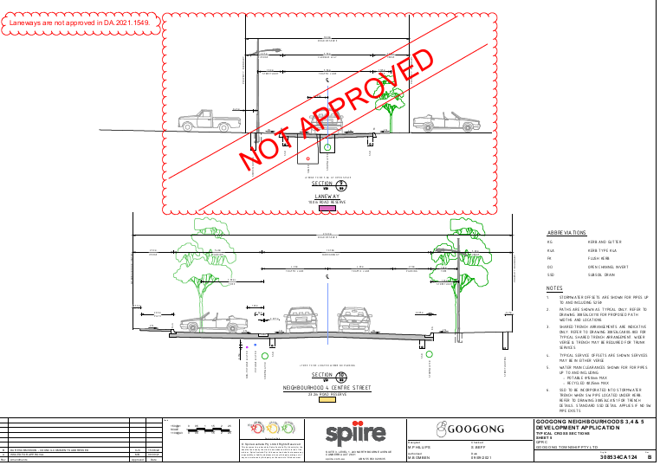

Waste management associated with future land uses will be assessed in development applications at that time.

Parks and Recreation | Council’s Park and Recreation Team reviewed the application in terms of public landscaping and for the management of trees within the developable area to be retained. | Y
Heritage | Council’s Heritage Advisor confirmed his support for the de-listing of the heritage item status for the shearing shed buildings which has recently been approved by Council. The relocation and adaptive reuse proposal is supported from a heritage perspective. | Y
Land Information Services | Council’s Land Information Services Team suggested conditions be imposed to ensure street addresses are provided appropriately. | Y
Table 8: Consideration of Council Referrals
There are no outstanding issues raised by Council officers.

  - Community Consultation
The proposal was notified in accordance with the Council’s Community Engagement Plan and Integrated Development requirements from 25 October 2021 until 22 November 2021 . The notification included notification letters sent to adjoining and adjacent properties and notification on the Council’s website. The Council received a total of four (4) unique submissions, comprising 4 objections plus a 60-signature petition. There were no submissions in favour of the proposal. The issues raised in these submissions are considered in the Table below.
Issue | No of submissions | Council Comments
Dilution of the vision for Googong | 4  With 60 signatories to petition | The proposal is consistent with the overarching strategic plan for the Googong area. The vision is maintained to Council’s satisfaction.
Location of a future childcare centre and potential noise impacts | 4  With 60 signatories to petition | Submitters were concerned about future noise associated with a proposed childcare centre (subject to future DA). In response the Applicant amended the indicative location. Council will have the opportunity to assess the noise impacts of the proposed childcare centre through the development application process for that future use. .
Plan inconsistencies | 4  With 60 signatories to petition | The applicant has discussed these with the submitters and clarified their issues. Council is able to support the proposal plans as listed in the draft consent.
Views from Montgomery Rise area | 4  With 60 signatories to petition | The Applicant has amended the design to increase lot sizes south of Montgomery Rise to provide a greater visual buffer from existing properties.
Traffic impacts, volumes and parking | 4  With 60 signatories to petition | Council’s Engineers have reviewed the information submitted by the Applicant and are able to support the proposal.
Noise - general | 4  With 60 signatories to petition | Council’s Environmental Health officer has considered noise within the estate and raises no objections to the proposed noise management arrangements.  These issues have been satisfactorily addressed subject to the imposition of relevant recommended conditions of consent.
Table 9: Public Submissions
The issues raised by submitters have been satisfactorily addressed by changes to the proposal by the applicant and by the imposition of relevant recommended conditions of consent. The issues raised do not warrant refusal of the application.

KEY ISSUES
The following key issues are relevant to the assessment of this application having considered the relevant planning controls and the proposal in detail:

  - Biodiversity Certification
The site is subject to a Biodiversity Certification Agreement under the Biodiversity Conservation Act. This is only the second of its kind currently operating in NSW. An Order was gazetted on 15 July 2022 by the Minister for Environment and Heritage which outlines biodiversity conservation measures agreed between the parties. Compliance with the Order and associated Agreement are sought through a condition of consent which is attached for the Panel’s reference.

  - Final Form and Design of Old Cooma Road / Bunyip Drive Intersection
Old Cooma Road is classified by Transport for New South Wales (TfNSW) as a Regional Road. Council is yet to determine its preferred form and design of the intersection. Public consultation and Councillor workshops are being undertaken. Council Engineers recommend the final form and design of the Old Cooma Road and Bunyip Drive intersection be subject to concurrence from Traffic for NSW subsequent to this Development Consent.
The 16 June 2022 plans by the Applicant shows the preferred design for a signalised intersection. Given this final design is yet to be endorsed by Council, nor forms part of the consent from Transport NSW, the relevant plans have been amended in red to show the design that has been approved by TfNSW.

  - Heritage Item Relocation
The site contains a heritage item (Shearing Shed). Council recently agreed to delist the item and remove it as a heritage item from the Queanbeyan Local Environmental Plan. The Council and Council’s Heritage Advisor support the dismantling of the shearing shed and relocation to the proposed new lot to accommodate it, which has been included as part of this application. The ultimate design and use of the building including investigation to confirm the structure is not contaminated will be subject to further assessment.
The site also accommodates an item of Aboriginal significance being a ‘scarred tree’. An arboricultural assessment of the tree revealed the tree was likely to be of Aboriginal origin due to the dimensions and age of the tree, depth of the wound margins, size of the initial wound and moderate weathering.
Unfortunately, the tree was knocked over and is no longer viable. The Applicant confirms they are working with Heritage NSW to ensure the physical scar carved into the trunk of the tree is maintained and displayed in present location. A condition has been imposed to ensure the values of the tree remain.

- CONCLUSION
This development application has been considered in accordance with the requirements of the EP&A Act and the Regulations as outlined in this report. Following a thorough assessment of the relevant planning controls, issues raised in submissions and the key issues identified in this report, it is considered that the application can be supported.
The subdivision of the super lots for higher density residential dwellings and the construction of all buildings will be the subject of future applications.
The development is “Regional Development” for the purposes of the State Environmental Planning Policy (Planning Systems) 2021 and the Southern Regional Planning Panel is the consent authority for the application.
The application was nominated as an Integrated Development requiring approvals under Fisheries Management Act 1994, National Parks and Wildlife Act 1974, Rural Fires Act 1997 and the Water Management Act 2000. General Terms of Approval have been issued by the relevant agencies to allow the development to proceed.
The development has been assessed under the relevant State Environmental Planning Policies, Queanbeyan Local Environmental Plan 2012, Queanbeyan Development Control Plan 2012 and Googong Development Control Plan. This assessment found that the development generally satisfies the controls and requirements of these instruments.
An exception to compliance with the Queanbeyan Local Environmental Plan 2012 is the minimum lot size for 81 lots to the southern extreme of the estate for which a variation was sought by the Applicant. This assessment has found sufficient merit to support the variation.
The other relevant matters for consideration under Section 4.15 of the Act have also been considered and the development is considered suitable for the site, it will have an acceptable impact on the site, local area and neighbouring properties. The submissions from agencies have been considered and conditions recommended where appropriate. The issues raised in submitter issues have also been satisfactorily addressed. There are no significant public interest concerns resulting from the development.
The development is recommended for conditional approval.
It is considered that the key issues as outlined in Section 5 have been resolved satisfactorily through amendments to the proposal and/or in the recommended draft conditions at Attachment A.

- RECOMMENDATION
That the Development Application for subdivision of land , being part of Lot 42 DP 754881, Lot 776 DP 1230282, Lot 2 DP 1231713, Lot 3 DP 1149329, Lot 10 DP 754881, Lot 1263 of DP 1283369, Lot 7 DP 1246784, Lot 996 of DP1276892, Lot 1605 DP 1266000, Lot 12 DP 1266001, Lot 13 DP 1266001 and is commonly known as 36 Googong Road, Googong, (Googong Neighbourhoods 3, 4 & 5) into 1398 Torrens title residential lots, 14 super lots for future residential development, 5 Neighbourhood Centre lots, boundary adjustment, all associated subdivision construction works, roads, tree removal, signage and landscaping and relocation of Shearing Shed be APPROVED pursuant to Section 4.16(1)(a) of the Environmental Planning and Assessment Act 1979 subject to the draft conditions of consent.
That Department of Premier and Cabinet (Heritage NSW), Department of Planning & Environment (Water), Rural Fire Service, Department of Planning, Industry and Environment (Satisfactory Arrangements), Department of Planning, Industry and Environment (Environment, Energy and Science), Transport for NSW and Essential Energy and be advised of the outcome of the determination.
The following attachments are provided:
- Attachment A: Draft Conditions of consent
- Attachment B: Approvals from State referral agencies
- Attachment C: Architectural Plans
- Attachment D: Clause 4.6 Request
- Attachment E: Biodiversity Certification Order

